Quality Improvement Toolkit
Primary Health Care
Strengthening Medicare
General Practice in Aged Care Incentive

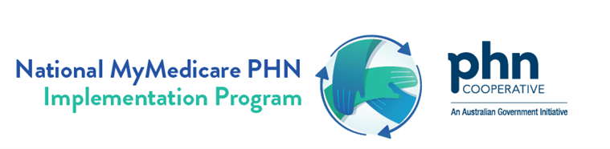


The aim of the General Practice in Aged Care Incentive (GPACI) Quality Improvement (QI) toolkit is to provide a simple and practical guide for implementing GPACI through continuous Quality Improvement (QI) activities. It focuses on enhancing continuity of care, improving patient outcomes, and increasing practice efficiency by shifting from volume-based care towards structured, regular care planning and preventative care model.
The QI toolkit also links to existing resources related to MyMedicare and the General Practice in Aged Care Inventive.
This QI toolkit seeks to enable general practice to determine readiness for participation in the General Practice in Aged Care Incentive, complete the registration process (if needed), and sets out actionable steps to assess and improve your practice’s model of care for residents in aged care homes.
This toolkit has been developed by Primary Health Networks through the PHN Cooperative, National Improvement Network Collaborative, and the National PHN MyMedicare Implementation Program.

Acknowledgement
Healthy North Coast acknowledges the Traditional Custodians of the lands across our region, and pays respect to Elders past, present and on their journey. We recognise these lands were never ceded and acknowledge the continuation of culture and connection to the land, sky and sea. We acknowledge Aboriginal and Torres Strait Islander peoples as the Land’s First Peoples and honour the rich diversity of the oldest living cultures.

This QI toolkit has been developed by PHN’s nationally through the PHN Cooperative, the National Improvement Network Collaborative (NINCo), and the National MyMedicare PHN Implementation Program. We acknowledge that some resources used or referenced within this toolkit are from organisations including the Department of Health and Aged Care, Services Australia, Royal Australian College of General Practitioners (RACGP); Best Practice; and Medical Director. These organisations retain copyright over their original work. Referencing of material is provided throughout.

Disclaimer and Recognition
While the Australian Government Department of Health and Aged Care has contributed to the funding of this material, the information contained in it does not necessarily reflect the views of the Australian Government and is not advice that is provided, or information that is endorsed, by the Australian Government. The Australian Government is not responsible in negligence or otherwise for any injury, loss or damage arising from the use of or reliance on the information provided herein.

The information in this toolkit does not constitute medical advice and Healthy North Coast, as operator of the North Coast PHN program, accepts no responsibility for the way in which information in this toolkit is interpreted or used.
Unless otherwise indicated, material in this booklet is owned by Healthy North Coast. You are free to copy and communicate the work in its current form, as long as you attribute NINCo as the source of the copyright material.

Due to constant developments in research and health guidelines, the information in this document will need to be updated regularly. Please contact Healthy North Coast if you have any feedback regarding the content of this document.

Resources included in this QI toolkit not developed by Healthy North Coast have been referenced throughout and these organisations retain copyright over their original work.

Table of Contents
Where to get help? 3
Overview 3
Section 1 - QI and GPACI Foundations 5
1.1 MyMedicare, Person Centred Care and GPACI 6
1.1.1 MyMedicare 6
1.1.3 General Practice in Aged Care Incentive 7
1.2 Preparing your practice team for GPACI quality improvement activities 9
1.2.1 Quality Improvement Activity Summary 10
1.2.2 Goal of Quality Improvement Activity 10
1.2.3 Quality Improvement Building Blocks 11
Section 2 – GPACI Registration and Participation 11
2.1. Accreditation Requirements 12
2.2 Eligibility requirements for GPACI 12
2.3 Develop accurate patient registers of people living in residential aged care 13
2.4 Registration for GPACI 14
2.4.1 Practice Registration 15
2.4.2 Patient Registration 15
2.4.3 Patient resources to explain MyMedicare and GPACI 15
2.4.4 Assisting Patients to complete MyMedicare Registration 16
2.4.5 Other important registration considerations: 16
Section 3 - Delivering care to meet GPACI service requirements 17
3.1 GPACI minimum care requirements 18
3.2 GPACI MBS User Guide 18
3.3 GPACI Services Australia compliance and forecasting tools 19
3.3.1 Forecasting Tools for GPACI 20
3.3.2 Checking quarterly compliance with GPACI for patients 20
3.3.3 Scheduling care for GPACI patients 20
3.4 Coordinated GPACI Service Delivery 20
3.5 Reviewing your GPACI delivery approach 22
Section 4 - Maintaining QI Momentum 23
Section 5 - Best Practice Care for Older Australians 25
5.1 Healthy North Coast Resources and Tools 25
5.2 RACGP Silver Book 25
5.3 HealthPathways 25
5.4 Department of Health and Aged Care GPACI Best Practice Resources 25
Appendicies 26
Appendix 1 – Getting Ready QI Checklist 27
Appendix 2 – Model For Improvement and PDSA Template 28
1.0 Model for Improvement and Plan-Do-Study-Act Cycle 29
1.2 Model for Improvement Template 30
1.3 PDSA (Plan-Do-Study-Act) Template 31
Appendix 3 - Improvement Ideas for GPACI 32
Quality Improvement 33
Model for Improvement 33

Where to get help?

Healthy North Coast

Ballina Head Office on Bundjalung Country

106-108 Tamar Street

Ballina NSW 2478

Phone (02) 6618 5400

Or enquire via our website here

Ask to be connected with the Primary Care coordinator for Residential Aged Care, Healthy Living and Ageing team.

Overview
This section provides an overview of the General Practice in Aged Care Incentive (GPACI) QI Toolkit, outlining its purpose, key components, and expected outcomes. It includes the executive summary, background on the GPACI initiative, incentive payments structure, and the toolkit’s aim to support general practices in delivering proactive, high-quality care to aged care residents.

Executive Summary
The General Practice in Aged Care Incentive (GPACI) QI Toolkit is designed to support general practices in implementing the GPACI to enhance care for aged care residents. This Quality Improvement (QI) toolkit provides practical resources and guidance to support planned, preventative care by outlining key steps for MyMedicare registration, care planning, coordination with multidisciplinary teams, accessing incentive payments, ensuring improved patient outcomes and continuity of care. Practices can utilise the toolkit to streamline their workflows, access relevant resources, and implement continuous Quality Improvement (QI) activities, ultimately fostering a patient-centred approach in aged care settings.

About this toolkit

This QI toolkit has been developed to support primary healthcare services in implementing quality improvement activities, offering practical tips, examples, and templates. The GPACI QI toolkit provides ideas for healthcare providers on how to use GPACI and MyMedicare Voluntary Patient Registration to enhance the quality of care for residents of Residential Aged Care Homes (RACHs) and strengthen care coordination between Residential Aged Care Homes, patients, and their primary care teams.

How to use this toolkit
The QI toolkit is organised into sections ordered to support your practice to get across the foundations before stepping into QI and care delivery. You are also encouraged to navigate forward to the section that is most relevant to your practice and work through activities in any order you prefer.
Section 1 - QI and GPACI Foundations
Section 2 - GPACI Registration and Participation
Section 3 - Delivering care to meet GPACI service requirements
Section 4 - Maintaining QI Momentum
Section 5 - Best practice care for older Australians

Outcomes of this QI toolkit
The QI toolkit provides a step-by-step approach to:
Provide practical instructions for understanding, implementing, and evaluating the GPACI initiative within general practices and Residential Aged Care Homes (RACHs).
Improve coordination of care between general practice teams, RACHs, patients and their carers.
Successful implementation of GPACI using Quality Improvement (QI) activities, leading to improved care delivery.
Make measurable and sustainable improvements to models of care
There are six steps to implement any successful QI activity.
STEP 1 - Planning and Preparation: Identify resources, define the scope, and set up the team to lead the QI activity.
STEP 2 - Use Data to Set Goals and Identify Suitable Patients: Leverage practice data to select eligible patients and establish clear care goals aligned with GPACI objectives.
STEP 3 - Implement Improvement Actions: Initiate care interventions, such as developing care plans and conducting regular patient reviews, in line with GPACI requirements.
STEP 4 - Regularly Review Your QI Activity: Continuously monitor progress against goals and adjust strategies as needed to ensure effectiveness.
STEP 5 - Sustain and Maintain Improvements: Develop a long-term plan to sustain the improvements made, ensuring continuous care and patient engagement.
STEP 6 - Document Your Activity: Keep detailed records of all steps and outcomes, ensuring compliance with GPACI guidelines and supporting future QI activities.

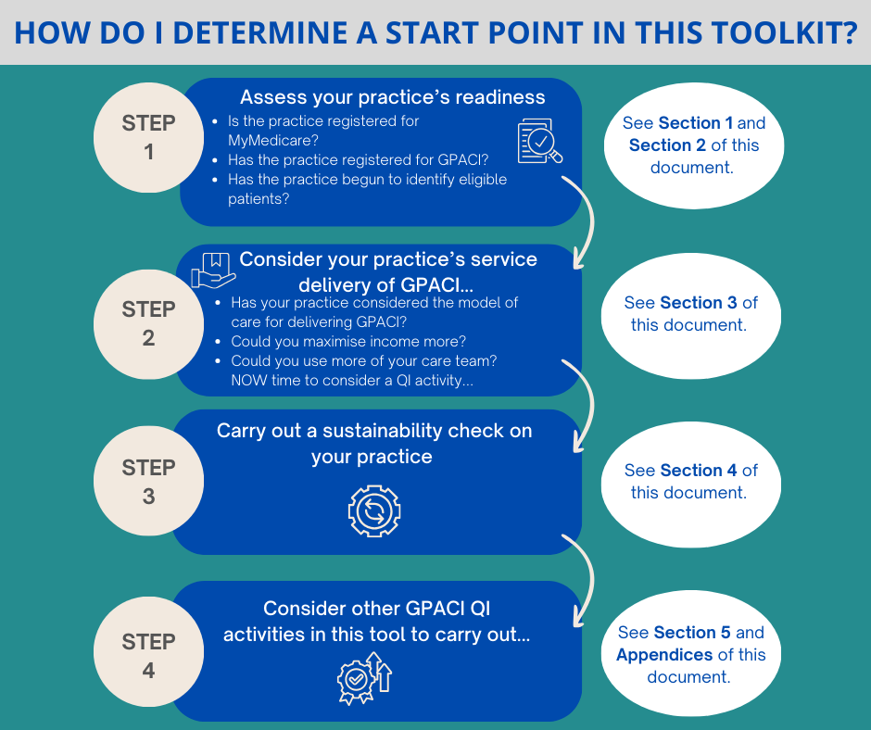

Section 1 - QI and GPACI Foundations

1.1 MyMedicare, Person Centred Care and GPACI
This section provides an overview of the General Practice in Aged Care Incentive (GPACI), including its purpose and structure. It covers key topics such as the MyMedicare initiative, incentive payments, and the principles of person-centred care. Additionally, it explores the relevance of GPACI within primary healthcare, detailing the roles and responsibilities of healthcare providers, practices, and aged care homes. Links to relevant resources are also provided to support implementation and understanding of the program.
Video links below provide a quick summary on GPACI from the perspective of a GP.
- MyMedicare and an overview of GPACI (2 minutes)- https://youtu.be/tFNUhZZpy9o
- Details of GPACI and service and eligibility requirements (5 minutes) - https://youtu.be/jlFYDB5D4T8
- Patient registration for GPACI (2 minutes) - https://youtu.be/xcPMx2jaRq8

1.1.1 MyMedicare
MyMedicare is a voluntary patient registration (VPR) model that aims to strengthen the relationship between patients, their general practice, GP, and primary care team. General practices can register through PRODA, and patients can register through Medicare Online or by completing a paper registration form. MyMedicare registration is voluntary for patients, practices, and providers, and supports practices to work to deliver more person-centred, comprehensive care.
Residents of Aged Care Homes have simplified eligibility for MyMedicare registration. More detailed information about MyMedicare, what it is, its benefits, eligibility requirements and how to participate are available here.

MyMedicare registration is an essential preliminary step that must occur before a practice or a patient can participate the General Practice In Aged Care Incentive.

Relevant Resources
- MyMedicare GP Communication Toolkit
- MyMedicare Fact Sheet
- MyMedicare information for practices and providers
- MyMedicare Resources for patients; general practices, providers; and translated resources

1.1.2 Person Centred Care
The General Practice in Aged Care Incentive (GPACI) emphasises a person-centred approach to care, defined by the Australian Commission on Safety and Quality in Health Care as ‘healthcare that respects the individual, their family, and carers, and responds to their preferences, needs, and values’ which leads to improved health outcomes. The four core principles of person-centred care include:
- treating individuals with dignity, compassion, and respect;
- providing coordinated care, support, and treatment;
- offering personalised care tailored to individual needs; and
- empowering people to recognise and build on their strengths to lead more independent and fulfilling lives.
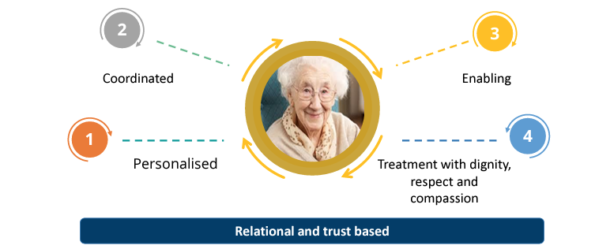
Reference: https://www.health.org.uk/sites/default/files/PersonCenteredCareMadeSimple.pdf

1.1.3 General Practice in Aged Care Incentive

For residents in Residential Aged Care Homes (RACHs), the General Practice in Aged Care Incentive (GPACI) seeks to enhance access to high-quality, proactive, ongoing, and person-centred care. General Practices can register to participate in GPACI and register providers and patients in the incentive through PRODA.
The incentive incorporates a team-based approach with some services able to be delivered by other practice team members, with the GP nominated as the Responsible Provider delivering the majority of care and assuming ongoing responsibility for care delivered by the practice.
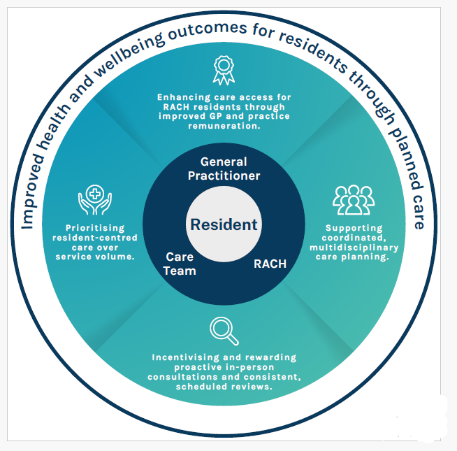
GPACI Benefits. Source: Eastern Melbourne PHN

Incentive payments
General practitioners (GPs) and practices registered with MyMedicare and meeting the eligibility and service requirements will receive quarterly incentive payments (rural loadings apply for MMM 4-7), in addition to standard Medicare Benefits Scheme (MBS) and Department of Veterans Affairs (DVA) rebates.
The payments include:
- $300 per patient, per year, for the responsible GP or provider.
- $130 per patient, per year, for the practice managing the patient’s care.
For more information on the General Practice in Aged Care Incentive please refer to the fact sheet provided by the Department of Health and Aged Care.
Fact Sheet - General Practice in Aged Care Incentive Fact sheet

GPACI Stakeholder Benefits and Responsibilities
The General Practice in Aged Care Incentive (GPACI) enhances primary care in aged care settings by improving coordination and continuity of care, benefiting residents, families, general practitioners, and aged care homes. Each stakeholder has an essential role in coordinated care to achieve better health outcomes and a more integrated approach to care in residential aged care settings.
Below is a summary of the key benefits and role for each stakeholder group.
Stakeholder | Benefits | Role
Residents, families and carers | Enhanced, continuous primary care within aged care homes.  Improved care coordination involving family, friends, and carers. | Register for MyMedicare  Collaborate in setting care goals  Benefit from proactive and continuous care
Residential Aged Care Homes | Collaboration with GPs and practices to enhance resident care and compliance with Aged Care Standards | Assist residents in registering for MyMedicare  Support GPs in delivering proactive care
General Practice | Payments for proactive care planning and regular care for registered aged care residents.  Strengthened relationships between GP, practice, patient, and care team.  Opportunities for practice team to deliver care directly to aged care residents.  Access to resources that improve patient outcomes and satisfaction, expanding scope of practice.  Develop specialised skills in aged care (e.g., dementia care, palliative care) while fulfilling Continuing Professional Development (CPD) requirements | Deliver eligible services to aged care residents  Support planning, coordination, and administration  Register residents in MyMedicare and GPACI

A detailed illustration of the key implementation partners and their roles in the General Practice in Aged Care Incentive (GPACI) is available here: GPACI Roles and Contributions

Other GPACI-relevant resources
Website - GPACI Website
Videos - My Medicare and GPACI overview
Practice Resources:
- GPACI FAQs for GPs and Practices
- MyMedicare Resources (available in 10 Languages)
- Social Media Tiles
- MyMedicare - Poster 1
- MyMedicare Poster 2
- MyMedicare Poster First Nations

1.2 Preparing your practice team for GPACI quality improvement activities
The actions outlined below are important steps to prepare your team and practice for participating in General Practice in Aged Care Incentive (GPACI) Quality Improvement activities. A coordinated strategy incorporating team engagement, practice accreditation, and well-defined care delivery procedures is necessary for successful participation.

1.2.1 Quality Improvement Activity Summary
This QI toolkit utilises the Model for Improvement (MFI) framework to plan the activity goal, activity measurement, and improvement ideas.
For more information on MFI: Weblink: How to Improve: Model for Improvement | Institute for Healthcare Improvement (ihi.org)

The improvement ideas in this toolkit are examples of practical steps to assist with the GPACI initiative. It is recommended to review each activity and select what may be appropriate for your primary health care service to consider undertaking and test using Plan Do Study Act (PDSA) cycles to make sustainable changes and record key learnings for your team.

1.2.2 Goal of Quality Improvement Activity
Defining the goal of any activity provides your primary healthcare team with a statement of what you are trying to accomplish. Review the goal below and adjust according to your primary healthcare service starting point and requirements.

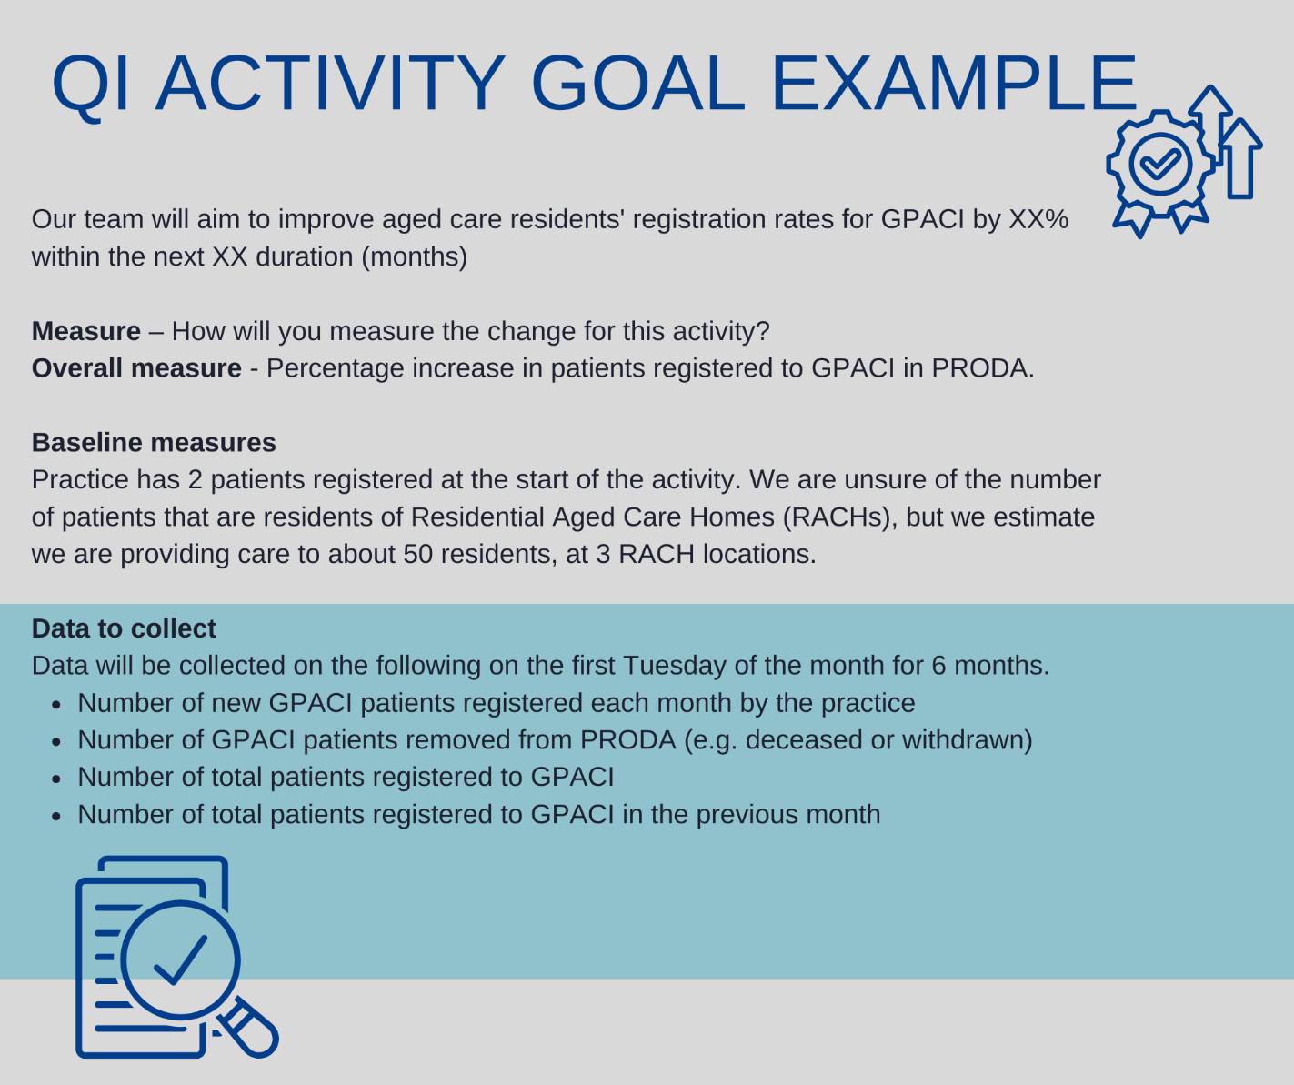

Regular review of activity measurement enables your primary health care team to assess progress and track if change(s) are leading to an improvement. It is best to measure at the beginning of the activity (baseline) and at regular intervals. Use the Model for Improvement (MFI) framework to methodically work through identifying a clear problem, and to explore solutions and take action.

1.2.3 Quality Improvement Building Blocks
Step 1: Identify your QI team and establish QI activity communication processes
Refer to Appendix 1 for a checklist template to help you with this activity.
- ☐ Identify your QI change team
- ☐ Identify your ‘why’
- ☐ Allocate QI team protected time
- ☐ Set up QI team meetings
- ☐ Setup your QI team collaboration zone
- ☐ Plan communication with the wider practice team
- ☐ Plan communication with other important stakeholders

Section 2 – GPACI Registration and Participation
This section provides information describing the requisites for your practice to participate in the General Practice in Aged Care Incentive (GPACI). It includes essential information on practice accreditation requirements, the process for registering your practice and patients, and key system details from Services Australia.

2.1. Accreditation Requirements
A key requirement for participation in the General Practice in Aged Care Incentive (GPACI) is for general practices, responsible providers, and patients to be registered with MyMedicare and linked to the GPACI program in the Organisation Register.
To qualify for MyMedicare, general practices must be accredited under the National General Practice Accreditation Scheme. An exemption allowing non-accredited practices to participate in MyMedicare, and the General Practice in Aged Care Incentive is in effect until 30 June 2025.
The definition of a "general practice" was amended by the Royal Australian College of General Practitioners (RACGP) in April 2024 to include ‘non-traditional practices’. As such general practices such as solo or mobile general practitioners providing essential visiting services to Residential Aged Care Homes are now eligible to participate in accreditation.
The RACGP Interpretative guide for non-traditional general practices for the purposes of accreditation provides general practices and accreditation assessors information to understand how the RACGP 5th Edition standards apply to non-traditional general practices. The interpretive guide outlines how indicators in the standards may apply differently to non-traditional practices and those without a physical clinic premises.
National General Practice Accreditation (NGPA) scheme
https://www.safetyandquality.gov.au/our-work/accreditation/national-general-practiceaccreditation-scheme

Approved accrediting agencies under the NGPA Scheme
https://www.safetyandquality.gov.au/our-work/accreditation/national-general-practiceaccreditation-scheme/approved-accrediting-agencies-under-ngpa-scheme

Healthy North Coast invites non-traditional practices, and non-accredited practices particularly those delivering essential visiting care services to Residential Aged Care Homes to contact us through our web page here or your associated Regional Manager, for information and to explore options for participating in accreditation and the General Practice in Aged Care Incentive.

2.2 Eligibility requirements for GPACI
The eligibility requirements for practices, providers and patients for GPACI are summarised below.
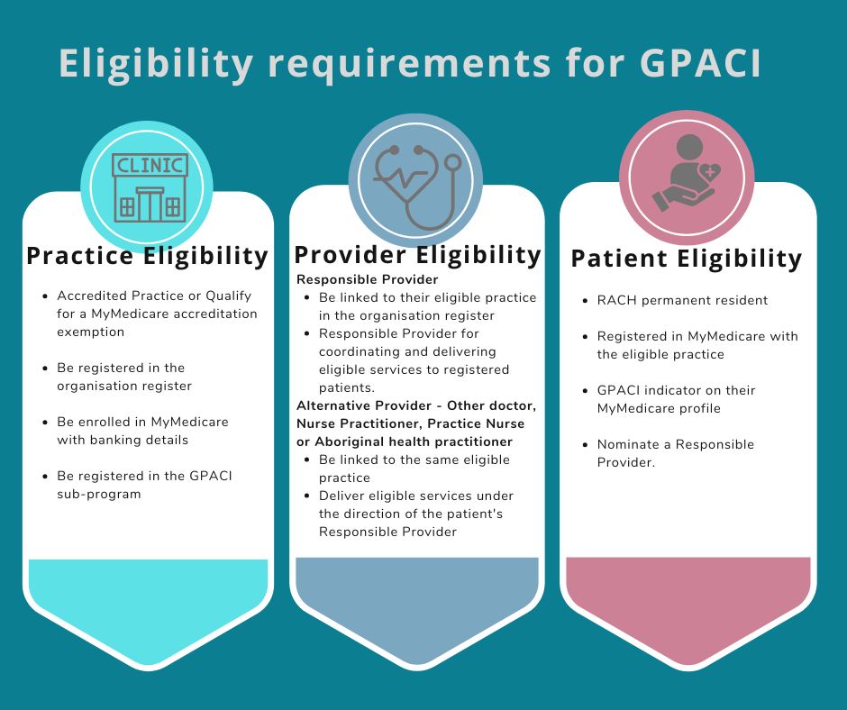
Resources: Services Australia Learning Module – MyMedicare and GPACI

2.3 Develop accurate patient registers of people living in residential aged care
This activity aims to support your practice to develop an accurate list of all patients that you care for that are residents of a Residential Aged Care home. There are two options outlined below to develop a list of RACH patients for your practice.

Option 1 – Existing RACH patient lists
Existing lists of RACH patients may already be available including:
  - Lists of RACH patients your practice has compiled, or
  - A list of patients that Residential Aged Care Homes (RACH) have, which provide a summary of all patients your deliver care to at that RACH.
If these lists are readily available and reliable then you may not need to use other data to develop a list.

Option 2 – Use your practice system data to create a patient list
You can also use data from your practice software, or data extraction tools provided by the PHN to develop a patient list.
Either way, you’ll need to use data to from these sources to track your progress and QI activities in a meaningful manner.
Baseline data provides a starting point of data that measures your current state. Having a baseline is essential to compare to in the future so that you can understand the impact of improvement activities. Baseline data for QI activities can be obtained from multiple sources, for example:
- Practice management software
- Data analytic tools, such as Primary Sense, PenCS CAT Plus or POLAR.

Data searches to identify Residential Aged Care Home (RACH) patients
Use your practice software to identify RACH MBS items billed by your practice.
Search your practice software for MBS items you have billed to develop a list of patients that have had these items claimed in the last 12 months. Review the list below and choose one or more MBS items you commonly bill and run searches for those items to develop patient lists. Document your approach using the Model For Improvement and PDSA template available at Appendix 2
RACH Care Plan MBS Items | Comprehensive medical assessments (701, 703, 705, 707)*  Contribution to, or review of, multidisciplinary care plan (731)*  Residential Medication Management Review (249, 903)  Veteran Health Check (MT701, MT703, MT705, MT707)*
Other RACH MBS Items | Attendance at a residential aged care home [B-E Consultation] (90035, 90043, 90051, 90054, 90093, 90095, 90096, 90098, 90188, 90202, 90212, 90215)  Non-Urgent After-Hours Attendance (772, 776, 788, 789, 2200, 5028, 5049, 5067, 5077, 5262, 5263, 5265, 5267)  Flag falls for GP attendance at residential aged care facility (90001, 90002, 90005, 90020 90035, 90043, 90051, 90054)  Telehealth Services (92027)
For the latest list of MBS items relevant to RACH care see MBS Online. A list of all GPACI MBS items is provided in the GPACI Program Guidelines.
*Note these MBS items are not exclusively for patients of RACHs.

2.4 Registration for GPACI
This section outlines the steps required to register your practice and patients for the General Practice in Aged Care Incentive (GPACI). It provides a summary on how to navigate the registration process, manage patient registration and extract necessary data to ensure effective participation in the initiative.
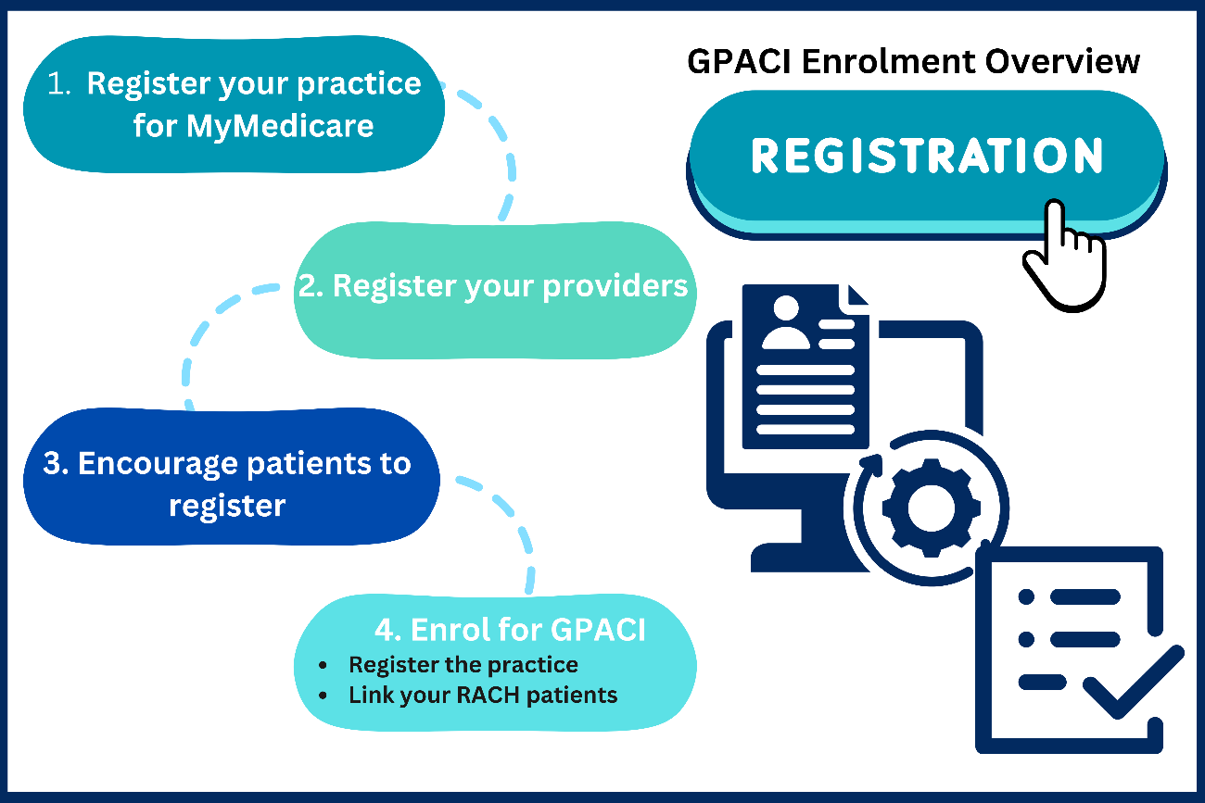

2.4.1 Practice Registration
Registering your practice for GPACI requires several steps. It is important you carefully read and follow the instructions in the resources for registration to update your practice information and register responsible providers. Once you’ve followed these steps, you can proceed with, registering patients for GPACI, assigning responsible providers, and de-registering patients (due to reasons like patient death, practice closure, or provider capacity).
Step-by-step guidance to register your practice and add patients to GPACI is available here: MYMEDINFO7-Steps required to add the MyMedicare General Practice in Aged Care Incentive

Resources for registration
- Adding the MyMedicare General Practice in Aged Care Incentive Indicator
- Service Australia – MyMedicare eLearning

2.4.2 Patient Registration
GPACI registration is completed by the practice but first requires the patient to be registered for MyMedicare. Therefore, the focus for practices engaging patients is to explain MyMedicare and ensure the patient completes their MyMedicare registration.
Step-by-step guidance to register patients for MyMedicare is available here: MYMEDINFO1-Checklist and steps to register for MyMedicare on the Organisation Register
Note that if you are registering a new GPACI patient late in the GPACI quarter (not in the first month of the quarter), you may opt set their date of registration for the GPACI incentive as the first day of the following quarter. This can ensure that your practice has sufficient time to deliver the required 2 visits in separate calendar months.

2.4.3 Patient resources to explain MyMedicare and GPACI
Patient Videos
Introducing MyMedicare | Australian Government Department of Health and Aged Care
Registering in MyMedicare | Australian Government Department of Health and Aged Care

Patient Brochures
mymedicare-dl-brochure.pdf (health.gov.au)
Aged Care Resident MyMedicare brochure

2.4.4 Assisting Patients to complete MyMedicare Registration
- Depending on practice staff capacity, one or more of the following processes may be implemented to assist eligible patients with MyMedicare registration:
- Pre-complete a MyMedicare Patient Registration form for each RACH patient prior to their next visit. Have them sign the form when you next visit them, or mail pre-completed forms to patients or their nominated carer or decision maker for signature.
- Have a conversation with your patients and their family when you visit the RACH. Provide a letter explaining MyMedicare and MyMedicare Registration form inviting them to participate.
- Engage with Residential Aged Care Homes you visit, and discuss the option of having them include the MyMedicare Patient Registration form in their resident on-boarding packs and admission checklists and processes to help streamline care access.
- Identify all RACH patients due to receive care in the next 2 - 4 weeks:
  - Initiate registration by sending a pending registration request to a patient. A pending registration request prompts a patient via the patient’s Medicare Online Account or Express Plus App to complete the registration with the practice digitally. Invitations are only valid for 30 days.
  - Invite patients via SMS to register with your practice using their Medicare Online Account or Express Plus App or complete a MyMedicare Patient Registration form.
Note that all MyMedicare Patient Registration forms completed by patients, are returned to the general practice they wish to register with, and need to be entered by the practice in HPOS.

2.4.5 Other important registration considerations:

Practitioner Capacity
Consider how many RACH patients your practice will register with each Responsible Provider. This will be informed by their RACH visit schedule, workdays and clinic days. This may increase if you use other members of the care team to support RACH visits such as other GPs, nurses, nurse practitioner or Aboriginal Health Practitioners.

Patient Journey
- At what point throughout the patient journey will the practice raise awareness about MyMedicare,
- Discuss the benefits and discuss patient registration (e.g., at patient check-in, with the clinical health care team at the time of the patient’s appointment)?

Staff Education and Awareness
- Ensure all practice staff including GPs are confident to discuss the benefits of registering for MyMedicare with patients.
- Ensure all GPs who are willing to participate in MyMedicare are registered in the Organisation Registered in PRODA so that patients can select them as their preferred general practitioner.
- Ensure your practice administration team are familiar with how to check GPACI compliance using PRODA, and have a good understanding of GPACI service requirements to support appointment scheduling for Responsible providers, patients and other members of the practice team

Patient Eligibility
- Ensure non-clinical staff understand patient eligibility requirements and the process to check patient eligibility prior to discussing GPACI and MyMedicare benefits with patients, and their carers or decision makers.

Section 3 - Delivering care to meet GPACI service requirements
This section focuses on the practical aspects of providing care under the General Practice in Aged Care Incentive (GPACI). It outlines the requirements for delivering eligible services to registered aged care residents, ensuring proactive, continuous, and patient-centred care.

3.1 GPACI minimum care requirements
Under the GPACI, general practices must deliver a minimum of two care planning items per year, along with eight regular visits in different calendar months each quarter. For more information about the requirements of the GPACI visit
General Practice in Aged Care Incentive | Australian Government Department of Health and Aged Care

3.2 GPACI MBS User Guide
Primary Health Networks (PHNs) have developed a user guide for Medicare Benefits for the General Practice in Aged Care Incentive (GPACI).

This resource can be used to inform and plan delivery of care and MBS billing to meet the service requirements for GPACI. Care planning items suggested for completion in the first billing quarters following patient registration in GPACI prioritise comprehensive care plans and include care planning items that trigger other MBS Items that support multidisciplinary team care/referral (for example practice nurses, aboriginal health practitioners, allied health and medicines reviews). Follow this link to access the https://ninco-primaryhealthinsights.talentlms.com/dashboard GPACI MBS User Guide can be found here.

Here are some ideas your practice can consider applying the MBS user guide for your patients that are permanent residents living in aged care homes:
- Identify the Sample Schedule and Example Annual Cycle billing scenario that best suits your practice team and setting. Print these or share them with your practice team to inform care planning for the General Practice in Aged Care Incentive.
- Review your historical use of MBS items for Residential Aged Care Home patients and use the guide to develop a quick PDSA (Plan – Do – Study – Act) to identify any improvements you could make to billing and care practices.
- Plan care for your residential aged care patients 3 – 6 months ahead by booking appointments for residential aged care visits each month using the Example Annual Cycle as a guide. Consider how you can group visits to a residential aged care home in your practice booking system to maximise the efficiency of clinician time.
- Meet with your practice team to reflect on the guide, and identify opportunities for practice nurses, Aboriginal health practitioners and other doctors to support or deliver care. For example, could practice nurses to work alongside doctors at aged care visits preparing documentation for care plans to make visits more efficient for your practice, residential aged care homes, and patients/residents?

A snapshot of the MBS User Guide is provided below.
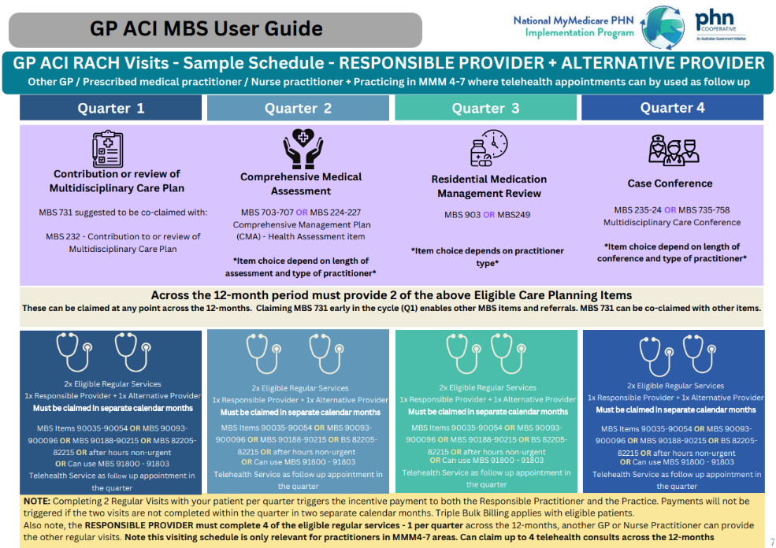

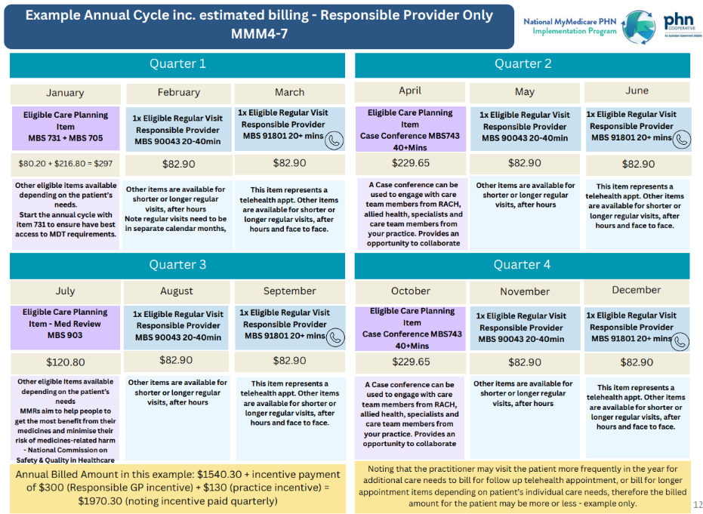

3.3 GPACI Services Australia compliance and forecasting tools

3.3.1 Forecasting Tools for GPACI
Access to forecasting tools provided by Services Australia helps monitor patient tracking and compliance under GPACI. You can find all of these infographics on the HPE MyMedicare page

Practices
- Forecast eligibility for MyMedicare Incentives for an Organisation site/Practice
- Search for and view eligibility assessments for MyMedicare Incentives for an Organisation site/Provider

Responsible Providers
- Forecast eligibility for MyMedicare Incentives as a Provider
- Search for and view eligibility assessments for MyMedicare Incentives as a Provider

The Patient Monitoring and Tracking Tool offers essential data for managing care efficiently.
Patient monitoring and tracking tool | Australian Government Department of Health and Aged Care

3.3.2 Checking quarterly compliance with GPACI for patients
Services Australia tools support practices to forecast eligibility and track quarterly compliance for MyMedicare Incentives. An education package is available explaining how to use these tools here:
MYMEDINFO5-Forecast eligibility for MyMedicare Incentives for an Organisation site (servicesaustralia.gov.au)

3.3.3 Scheduling care for GPACI patients
Coordinating care effectively is crucial under GPACI. Suggestions for care scheduling include:
- Practices should pre-book appointments for patients that include:
  - Notifications for family or carers if required with the dates/time of the appointment
  - Details of MBS items applicable to visits for each patient.
- Visit schedules may need to be adjusted depending on the unique circumstances of delivering care within each Residential Aged Care Homes (RACHs).
- Collaboration with RACH staff is essential for ensuring smooth care delivery and alignment with GPACI requirements.

3.4 Coordinated GPACI Service Delivery
Delivering care to meet the GPACI to patients living in Residential Aged Care Homes requires:
- clear team roles and responsibilities
- using data to monitor care delivery, billing and compliance
- care coordination
- information exchange, and

Use the following table to guide your GPACI service delivery and planning.
Team Roles
Responsible Provider | The Responsible Provider is the patient’s usual doctor and is accountable for overseeing the patient's care, coordinating with the practice team and RACH staff, and ensuring adherence to GPACI requirements. Responsible providers are required to complete care planing, and conduct RACH regular visits.
Administrative | Practice administration staff are crucial for managing appointment scheduling and changes. They serve as the first point of contact for inquiries regarding GPACI and ensure that appointments are arranged efficiently, facilitating communication between the practice, RACHs, and patients. They setup and populate clinician diaries to plan and schedule MBS items for each patient appointment at RACHs and maximise effective use of time. Admin staff also process the billing of MBS items related to GPACI services, and play a vital role in checking compliance with GPACI for each patient using forecasting tools.
Nurses and Other Visiting Providers | Other doctors, nurses and Aboriginal Health Practitioners (AHPs) in your practice team may also contribute to patient care as part of a multidisciplinary team.  Nurses and AHPs play a vital role in care planning support activities, assisting with patient assessments, and delivering routine care.
Care Planning Nurse Support Activities | Nurses and AHPs involved in care planning collaborate with GPs to develop and implement individualised care plans for residents, addressing their unique health needs.
Main Contact for GPACI Enquiries | Designate a primary contact person in your practice who will handle all GPACI-related inquiries from RACHs, ensuring a streamlined communication process.
Utilising extraction tools and reports
Data extraction | Familiarise your team with the extraction tools and reports available to monitor patient data effectively. These tools are essential for tracking compliance with GPACI requirements and assessing patient eligibility.
Care coordination and logistics
Coordinating Care with RACHs and Patients | Establish processes for collaborating with RACHs and patients to ensure continuity of care.  Develop agreements or coordination protocols that document expectations for both RACH’s and your practice.  This includes creating patient registers within your software to maintain accurate records of residents.
Appointment Scheduling | Focus on logistical aspects for appointment scheduling. Ensure clear contact and communication arrangements specific to outreach services.  Nominating a Primary RACH Contact: Agree on a primary contact with each RACH for all appointment scheduling matters, enhancing communication and efficiency.  Including Family Members and Carers: Involve family members and carers in appointments when relevant, especially in cases where the patient has diminished decision-making capacity. Discuss telehealth and face-to-face options to accommodate their participation.  Face-to-Face and Telehealth Visits: Coordinate patient appointments and visit rounds with the RACH's on-site clinical care team. Ensure clear communication of changes to care and provide updates after both planned and unplanned appointments.
Information Exchange and Communication
Ongoing Care and Care Planning | Establish mechanisms for regular information exchange about patients, using resources like the Silver Book to facilitate appointments, care planning and adjustments.
Coordination with Family/Carer Communications | Create standard communication protocols with RACHs, families, carers, and residents to ensure everyone is informed about care plans and changes.
My Health Record & Provider Connect | Leverage My Health Record and Provider Connect Australia to enhance how you share information with other care team members.
After-Hours and Urgent Care | Develop contact protocols for after-hours and urgent care situations, utilizing telehealth and other mechanisms to ensure timely access to care.
Collaboration with Other Healthcare Members | Maintain open communication with all members of the healthcare team to coordinate care effectively, ensuring that patients receive comprehensive and cohesive treatment.
Billing and Compliance
Checking Billing and Compliance: | Regularly review billing and compliance reports from Services Australia, Clinical Information Systems (CIS), and Health Data Management (HDM) systems to ensure adherence to GPACI requirements.

3.5 Reviewing your GPACI delivery approach
- There are many ways that practices can deliver care that meets the GPACI service requirements. Ideas you may like to consider include:
- Practice nurses and Aboriginal health practitioners can support the Responsible Provider to deliver a high standard of care to more patients, encouraging the efficient use of practice time and resources by coordinating visits with RACH’s, developing care plans and doing workups for patients at a RACH visit.
- Other clinicians (e.g. other doctors, nurses, nurse practitioners, Aboriginal health practitioners) at the practice can deliver regular services to share the workload amongst the practice team.
- Conduct visits as ‘ward rounds’ with RACH clinical staff or use clinical rooms available on site to improve the coordination of care and enhance care quality.
- Discuss ideas for improvement to care processes at RACH’s with your practice team, RACH’s and your patients - small improvements can make a big difference to patient outcomes.
- Case conferences provide a unique opportunity to coordinate care for patients with complex health or social needs, and enable the care team to learn from each other.
- We recommend you use the Model For Improvement to explore improvement ideas and you may wish to involve your Regional Manager who can help you work through change ideas and develop PDSA cycles to implement. Contact Heathy North Coast on (02) 6618 5400 and ask to be connected with the Primary CAre Coordinator for Residential Aged CAre from the

Section 4 - Maintaining QI Momentum
Use the following checklist of good change management tips to maintain your QI momentum.
Sustainability checklist to maintain change
Cyclical nature of PDSAs- Adopt, adapt, abandon​ | - Adopt: excellent work, embed that change.  - Adapt: determine if a change is needed to the plan and start a new PDSA.  - Abandon: Rethink the next PDSA  - Lessons can be learned from PDSAs that are abandoned. Keep a record of learnings.
Document your improvement activity: Record your completed QI activities to meet PIP QI guidelines and CPD requirements | - Record your completion.  - Documentation must be kept for 6 years for evidence of PIP QI if your practice is audited by the Department of Health and Aged Care.  - Clinical Audit QI activities can be recorded and contribute to RACGP Measuring Outcomes CPD Activities.
Sustaining project outcomes. Consider which practice documentation may need to be updated to include the change: | - Updates to Policy and Procedure manual.​  - Specific task procedures​.  - Local signs or instructions.  - Staff work practices.  - ​Position descriptions​.  - Staff induction.  - Staff skills development or education.
Communication is key to finishing a successful project. Consider: | - QI project outcome feedback to staff.  - Discuss project strengths and challenges.  - Feedback to patients, where appropriate.
Celebrate success | - Celebrate your outcomes and achievements by sharing morning tea with your team.  - Consider sharing your practice improvement activity efforts with your patients through practice newsletters, website or RACH’s you work with. E.g. displaying 'run charts' to demonstrate change over time.
Review and reflect | - Discuss project strengths and challenges.  - Annually review the PDSA outcomes to ensure activities are still being adhered to and completed  - Annually review and audit your data related to this activity. Identify gaps, areas for improvement and set new targets if needed.  - Where to next on your continuous QI journey?  - Consider potential topics for a new QI activity, and how your experience with this activity can help you to be more efficient and effective

Section 5 - Best Practice Care for Older Australians

5.1 Healthy North Coast Resources and Tools
Healthy North Coast have also produced other resources and information for general practices to support the delivery of best practice care for older people. These resources are available here. Relevant topics include
Ageing
- Developing systems of care in general practice for people diagnosed with dementia and their families
- Embed falls screening and prevention into general practice
- Improve recording of influenza immunisation for patients with COPD, diabetes and 65+
- Become a wound care champion

5.2 RACGP Silver Book
The RACGP Silver Book provides a comprehensive guide to primary care for older people.

5.3 HealthPathways
HealthPathways are available to support best practice care in your local area, including hospital and specialist service referrals. The following HealthPathways are particularly relevant to care for older people in residential aged care
- PHN to insert list of relevant health pathways for older people in residential aged care here

5.4 Department of Health and Aged Care GPACI Best Practice Resources
The Department of Health and Aged Care have produced a range of resources to support best practice care for older people, specific to the General Practice in Aged Care Incentive.
- GP and Practices Information Kit
- Care plan contribution template
- Patient front sheet template
- Patient monitoring and tracking tool
- GPACI Incentive Payment Structure

Appendicies

Appendix 1 – Getting Ready QI Checklist
- Task | - Subtasks | - Action Notes
☐ Identify your QI change team | - Identify the lead and practice team members to drive quality improvement work (e.g. one nurse, GP [operating as a Responsible Provider], admin, Practice Manager). Consider allied health, visiting clinicians and others that may form part of the team.  - Consider the roles of the team members, and assign roles and responsibilities according to staff skill, interest and position  - Ask yourself the question, what motivates a team member to want to be part of sustaining change and making improvements? This is an important step as team members have different skill sets, interests, scope of practice and levels of authority.  - Document your team in the Quality Improvement Template below.
☐ Identify your ‘why’ | - Document and discuss ‘why’ your team are doing this QI activity to ensure team members understand the importance and necessity.  - Use the Quality Improvement Template below to document your problem statement.
☐ Allocate QI team protected time | - Ensure each member of the QI team has dedicated time to perform required tasks for QI (1hr per week is a good start!).
☐ Set up QI team meetings | - Plan frequency of planning meetings for QI team and send out appointments and a standing agenda  - Distribute minutes/action points following any meetings held and ensure staff are aware of any follow-up needed.
☐ Setup your QI team collaboration zone | - Setup a workspace or folder/file structure for the QI team to document their work, where they can share files and collaborate on activities  - Provide access to project files and related policy and procedures
☐ Plan communication with the wider practice team | - Identify who will need to be kept informed.  - Identify the method(s) that will be used to inform and update all staff of any changes as a result of the QI activity e.g. staff/Clinical/Admin/Nurse meetings, email, noticeboard, group chat.  - Ensure all staff are advised of the chosen communication(s) method.  - Provide monthly updates to all staff of ongoing changes e.g. add QI to staff/Clinical/Admin/Nurse meetings.  - Allow staff to contribute ideas and provide opportunities for staff feedback.
☐ Plan communication with other important stakeholders | - Consider the GPACI Stakeholder Benefits and Responsibilities and consider the role that other stakeholders outside the practice team have in GPACI and what communication you may need to do to engage with them including:  - Residential Aged Care Homes  - Patients and their carers/family  - Medical Specialists and Allied Health providers  - Hospital and Ambulance Services

Appendix 2 – Model For Improvement and PDSA Template

1.0 Model for Improvement and Plan-Do-Study-Act Cycle
Start by documenting your practice QI team and define your problem and specified a robust Problem Statement using the Quality Improvement Template. Next, consider Model for Improvement.
In the Model for Improvement, the 'Thinking Part' focuses on the overall improvement strategy, while the 'Doing Part' implements changes through the Plan-Do-Study-Act (PDSA) cycle. This model uses PDSA cycles to test changes, ensuring measurable and sustainable improvements. Click here for a short video explaining the Model for Improvement and PDSA’s.

Step 1: Thinking Part - Model for Improvement
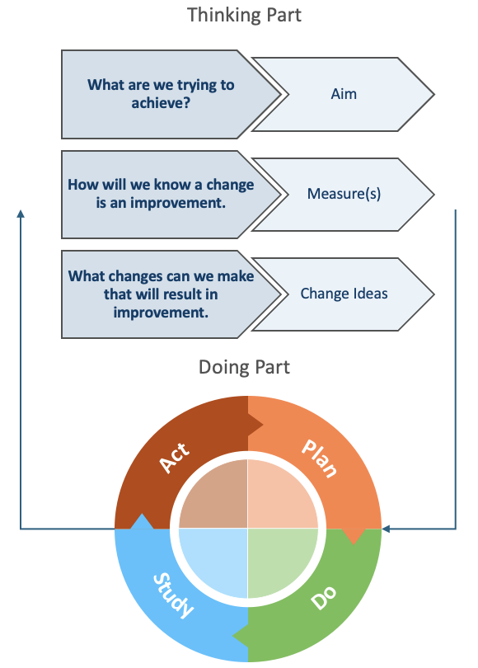
- AIM: What are we trying to accomplish? Develop a S.M.A.R.T. (Specific, Measurable, Attainable, Realistic, Time-bound) and people-crafted Aim Statement.
- MEASURE: How will we know that a change is an improvement? Identify what good looks like and develop a measure(s) of success.
- CHANGE IDEAS: What changes can we make that will result in an improvement? Engage the whole team in formulating change ideas using tools such as brainstorming, driver diagrams or process mapping. Each change idea may involve multiple small rapid PDSA cycles.

Step 2: Doing Part - Plan-Do-Study-Act (PDSA)
- PLAN: Describe the change idea (what, who, when, where). Predict outcomes and define the data to collect.
- DO: Carry out the plan. Collect data. Consider what worked well and why? Document any unexpected observations, events or problems.
- STUDY: Analyse results, compare them to predictions, and reflect on what you learned.
- ACT: Based on what you learned from the test, consider what you will do next (e.g., adopt, adapt or abandon)? How does this inform the plan for your next PDSA?
Source: Langley, G., Nolan, K., Nolan, T., Norman, C. & Provost, L. 1996, The Improvement Guide, Jossey-Bass, San Francisco, USA
For guidance and support in conducting quality improvement, contact Healthy North Coast practice support team.
1.1 Quality Improvement Template
Practice name: | Add your primary healthcare service name here | Date: | Add date of commencement here
QI team: | List the team members involved
Problem: | Describe why this work is strategically important. What problem is the team addressing? What does our data indicate about it, and what are the causes?
Problem Statement: | Document your succinct problem statement here

Once you have completed the QI template, move onto the Model for Improvement (the Thinking Part)
For guidance and support with practice improvement activies contact the Healthy North Coast Practice Support team.

1.2 Model for Improvement Template
Step 1: Thinking Part - Three Fundamental Questions
Complete the Model for Improvement (MFI) as a whole team.

AIM | - What are we trying to accomplish?
By answering this question, you will develop your GOAL for improvement. It important to establish a S.M.A.R.T (Specific, Measurable, Achievable, Relevant, Time bound) and people-crafted aim that clearly states what you are trying to achieve.
MEASURE(S) | - How will we know that a change is an improvement?
By answering this question, you will develop the MEASURE(S) you will use to track your overarching goal. Record and track your baseline measurement to allow for later comparison.
Tip: Use a Run Chart to plot trends.
Baseline: |  | Baseline date:
CHANGE IDEAS | - What changes can we make that will result in improvement?
By answering this question, you will develop IDEAS for change.
Tip: Engage the whole team in formulating change ideas using Institute for Healthcare Improvement QI tools such as brainstorming, driver diagrams or process mapping. Include any predictions and measure their effect quickly.
Idea 1
Idea 2
Idea 3
Idea 4
Idea 5 | Add other rows if needed.
Next steps: | Each idea may involve multiple short and small PDSA cycles.
Once you have completed the Model for Improvement, shortlist your ideas and start to put them into action using the Plan-Do-Study-Act (PDSA) cycle to plan, test, and review changes.

1.3 PDSA (Plan-Do-Study-Act) Template
Step 2: Doing Part - Plan-Do-Study-Act
Once you have completed the Model for Improvement (MFI), use the template below to document and track your PDSA cycles (i.e. small rapid tests of change).

Idea | Plan |  | Do | Study | Act
# | Plan the test | Prediction | Do the test on small scale | Analyse the results | Make a plan for next step
 | How will we run this test? Who will do it and when? What will we measure? | Prediction or hypothesis on what will happen. | Was the plan completed? Yes or No. Collect data. Consider what worked well and why? Document any unexpected observations, events or problems. | Analyse results, compare them to predictions, and reflect on what you learned. | Based on your learnings from the test, what will you do next (e.g., adopt, adapt or abandon)? How does this inform the plan for your next PDSA?
Change idea 1.1 | Specify
 | Keep adding rows and cycles as needed.
Change idea 1.2 | Introduce a new change idea is required.
 | Keep adding rows and cycles as needed.
Summary of Results

Appendix 3 - Improvement Ideas for GPACI

Quality Improvement
Practice name: | Bluey’s Family Practice | Date: | 4 November 2024
QI team: | Dr Chilli Heeler - Responsible Provider, GP  Bluey Heeler - Practice Nurse  Bandit Heeler - Receptionist  Bingo Heeler - Practice Manager  Lucky – Clinical Services Manager at New Tricks Park
Problem: | Bluey’s Family Practice are deeply committed to providing care for their ageing community that have recently taken up residence at New Tricks Park, the local Residential Aged Care Home.  Doreen, Mort, Bobba, Granny Gladys, Granny Janet, Madge, Chris and the Old Pug are all existing patients of the Blue’s Family Practice that have moved into New Tricks Park together to keep each other company and these new residents need ongoing primary care!  Blueys Family Practice need to work out how they are going to organise their care delivery to meet GPACI requirements for all the new residents New Tricks Park (visiting fortnightly at a minimum), whilst keeping up with delivering care to meet the needs of their regular patients at the general practice clinic.
Problem Statement: | Organise the practice to deliver services that meet GPACI requirements to eight existing patients of the practice that have moved into residential aged care.

Model for Improvement
Step 1: Thinking Part - Three Fundamental Questions
Complete the Model for Improvement (MFI) as a whole team.

AIM | - What are we trying to accomplish?
By the end of the month, Bluey’s Family Practice will implement a bi-weekly visiting schedule for Dr. Chilli Heeler, to provide primary care to all eight residents at New Tricks Park, ensuring 100% of visits are completed and GPACI requirements are met, while maintaining care for existing clinic patients, and assessing patient satisfaction regularly.
- Specific: Bluey’s Family Practice will establish a structured care delivery plan to ensure that all eight residents of New Tricks Park receive primary care from Dr. Chilli Heeler at least once every two weeks, while also maintaining adequate care for existing clinic patients.
- Measurable: Track the visits made to New Tricks Park bi-weekly, aiming for 100% completion of scheduled visits for all residents over the next six months. Each Quarter, each resident will receive one Care Planning GPACI MBS-eligible service, and a minimum of 5 GPACI MBS-eligible Regular Visits. Additionally, monitor patient satisfaction scores from both the new residents and existing clinic patients.
- Achievable: Coordinate with New Tricks Park to schedule visits, ensuring that Dr. Chilli Heeler, Bluey Heeler, and Bandit Heeler can effectively manage time and resources, allowing for seamless integration of care for both groups of patients.
- Relevant: This goal aligns with the commitment of Bluey’s Family Practice to provide comprehensive care to the aging community and meet GPACI requirements, ensuring that the needs of both new and existing patients are met.
- Time-bound: Implement the care delivery plan by the end of the current month, and review progress monthly for the next six months to make any necessary adjustments based on patient feedback and care needs.
MEASURE(S) | - How will we know that a change is an improvement?
By answering this question, you will develop the MEASURE(S) you will use to track your overarching goal. Record and track your baseline measurement to allow for later comparison.
Tip: Use a Run Chart to plot trends.
- Registration in MyMedicare and GPACI (number of patients)
- Bi-Weekly Visit Log
- Patient Satisfaction Surveys
- Care Needs Assessment (completion rates)
- MBS billing and GPACI compliance tracking
- Resource Utilization Tracking (staff time)
CHANGE IDEAS | - What changes can we make that will result in improvement?
The following are examples of IDEAS for change. Use ideas using Institute for Healthcare Improvement QI tools such as brainstorming, driver diagrams or process mapping.
Idea 1 | Registration in MyMedicare and GPACI:  - Action: Nurse Bluey Heeler to work with Lucky – Clinical Services Manager at New Ticks Park to explain benefits of MyMedicare and coordinate completion of MyMedicare forms. Bandit Heeler (receptionist) to register each resident in GPACI, designating Dr Chilli Heeler as Responsible Provider.  - Measurement: Registration of all eight residents in GPACI to be actioned on 2 October 2024, allowing the full GPACI quarter from 1 October to 31 December 2024 to meet GPACI Quarter service requirements.
Idea 2 | - Bi-Weekly Visit Log:  - Action: Receptionist Bandit Heeler to create a summary log to record each visit to New Tricks Park to be completed by Dr Cilli Heeler, including dates, MBS services delivered, the number of residents seen, and follow-up actions required for the practice and the RACH. All clinical and service information will continue to be recorded in the practice clinic software.  - Measurement: Before implementing the visiting schedule, Nurse Bluey Heeler will record the number of visits made to New Tricks Park over the past month to establish a baseline. Aim for 100% completion of scheduled visits for all eight residents every two weeks.
Idea 3 | Patient Satisfaction Surveys:  - Action: Bingo Heeler will distribute a Short Patient Satisfaction survey to both New Tricks Park residents and a sample of 20 regular clinic patients at the end of each quarter.  - Measurement: Conduct regular satisfaction survey for both new and existing patients every 3 months. Bingo will collate and document the responses and average scores at regular intervals. The practice team will include the scores at their monthly practice meeting and use the feedback from patients to identify and test new improvement ideas.  - Develop a question to use. For example- Did you have an opportunity to mention all of the concerns you hoped to discuss at your most recent visit? (1 = yes definitely, 2 = yes somewhat, 3 = no.). Aim for an average score of less than 2. Include an open follow up question “Please provide any further information explaining why you chose this score?” Ref- Developing Actionable Survey Questions to Improve Patient Experience - Jeffrey Millstein, Anish Agarwal, 2021
Idea 4 | Care Needs Assessment:  - Action: Dr Chilli Heeler will conduct an initial Comprehensive Medicare Assessment (705 or 707) with each of the eight residents in the first month (October) of the GPACI Quarter, documenting any chronic conditions, medications, important patient goals for health/life and any specific concerns or special care requirements.  - Measurement: Nurse Bluey Heeler will review the records each fortnight to monitor changes in residents’ health status and update their records after each fortnight’s visit.
Idea 5 | MBS billing and GPACI compliance tracking:  - Action: Bingo Heeler and Bandit Heeler will schedule MBS care items in the diaries of Dr Chilli Heeler (Responsible Provider) and Nurse Bluey Heeler in Best Practice 3 months ahead of visits.  - Measurement: Following RACH visits, Bandit will review the MBS billing for each resident using the GPACI tracking and forecasting tools monthly to identify any missed MBS care items, and document them. Bingo will meet with the practice QI team to review the findings, discuss the possible causes and identify improvement ideas.
Idea 6 | Resource Utilisation Tracking:  - Action: Bingo will monitor the time spent on visits to New Tricks Park versus regular clinic patients, tracking hours worked and resources used (e.g., travel time, staff time for each member of the practice team, equipment).  - Measurement: Bingo will review the workload for each member of the team to ensure the practice maintains a balanced workload, with no more than a 20% increase in time spent on the aged care home visits.
Next steps: | Each idea may involve multiple short and small PDSA cycles.


This resource has been created as part of the National MyMedicare PHN Implementation Program in partnership with National Improvement Network Collaborative (NINCo) Stream 3.


Level 1, 14 Edgewater Court Robina QLD 4226 | PO Box 3576, Robina Town Centre QLD 4230
P 07 5635 2455 | E ninco@gcphn.com.au | W www.ninco.com.au
Copyright 2024. Primary Care Gold Coast Limited (ABN 47 152 953 092), trading as National Improvement Network Collaborative.
All rights reserved. Content is correct at time of publication.
23042024/23042025

