Primary Health Care
Strengthening Medicare
Chronic Conditions Management

Quality Improvement Workbook

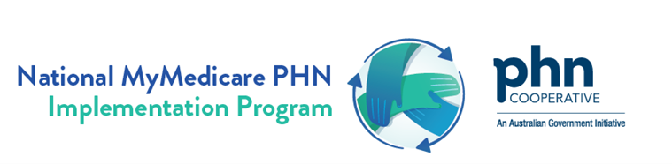


The aim of this workbook is to provide a practical guide to Chronic Conditions Management through continuous Quality Improvement (QI) activities. It focuses on enhancing continuity of care, improving patient outcomes, and increasing practice efficiency through structured management planning and preventative care.
The QI workbook also links to existing resources related to MyMedicare and the Chronic Conditions Management.
This workbook has been developed by Primary Health Networks through the PHN Cooperative, National Improvement Network Collaborative, and the National PHN MyMedicare Implementation Program.

Acknowledgement
https://www.health.gov.au/resources/apps-and-tools/primary-health-network-locator

This QI workbook has been developed by PHN’s nationally through the PHN Cooperative, the National Improvement Network Collaborative (NINCo), and the National MyMedicare PHN Implementation Program. We acknowledge that some resources used or referenced within this workbook are from organisations including the Department of Health, Disability and Ageing, Services Australia, Royal Australian College of General Practitioners (RACGP), Best Practice and Medical Director. These organisations retain copyright over their original work. Referencing of material is provided throughout.

Disclaimer and Recognition
While the Australian Government Department of Health, Disability and Ageing has contributed to the funding of this material, the information contained in it does not necessarily reflect the views of the Australian Government and is not advice that is provided, or information that is endorsed, by the Australian Government. The Australian Government is not responsible in negligence or otherwise for any injury, loss or damage arising from the use of or reliance on the information provided herein.

The information in this workbook does not constitute medical or business advice and the PHN Cooperative accepts no responsibility for the way in which information in this workbook is interpreted or used.
Unless otherwise indicated, material in this booklet is owned by the PHN Cooperative. You are free to copy and communicate the work in its current form, as long as you attribute NINCo and the PHN Cooperative as the source of the copyright material.

Due to constant developments in research and health guidelines, the information in this document will need to be updated regularly. Please contact your local PHN if you have any feedback regarding the content of this document.

All MBS billings must be for clinically relevant services. GPs should use their clinical judgement in relation to what individual patients require. Please refer to MBS online for the most current and detailed information on all MBS items. https://www.mbsonline.gov.au/
Resources included in this QI workbook not developed by the National PHN MyMedicare Implementation Program or NINCo have been referenced throughout, and these organisations retain copyright over their original work.
Where to get help?
- Kelli Babovic– Tweed Valley Region. E: kbabovic@hnc.org.au
- Charlotte Barry– Byron and Ballina Regions. E: cbarry@hnc.org.au
- Rowena Terone– Lismore, Richmond Valley, Kyogle, and Lower Clarence Regions: E: rterone@hnc.org.au
- Lauren Bugler– Coffs Harbour and South Grafton Regions. E: lbugler@hnc.org.au
- Ally Pope– Kempsey and Nambucca Regions. E: apope@hnc.org.au
- Victoria Bradford– Port Macquarie Region. E: vbradford@hnc.org.au





Navigating this Workbook

Section headings Page No.

Click on the section of interest or scroll through in the
Workbook in order.
A full list of appendices is at the beginning of this section.
Appendices
Resources - Best Practice Care for CCM
A full list of resources is at the beginning of Section 5.
A full list of activities is at the beginning of Section 4.
Activities - Implement in Your Practice
Pg 41 - 68
Pg 37-40
1
2
3
4
Pg 19-36
Pg 13-18
Pg 10-12
Pg 5-9
MyMedicare and Chronic Conditions Management Foundations
A
5
Preparing your practice for CCM QI Action
Delivering care to meet CCM MBS requirements

Navigation Suggestions
This workbook is designed to be applied practically. Navigate straight to the section that is most relevant to your practice and complete activities in any order you prefer.
- Start in Section 1 and 2 to assess your practice’s readiness. These sections cover: Practice MyMedicare registration; Tracking and creating registers of existing CCM patients with management plans; How CCM changes and person-centred care support care continuity with MyMedicare, and preparing your practice for CCM Quality Improvement action
- Section 3 covers the details of CCM MBS items and requirements, CCM MBS User Guide, and prioritising reviews with patients.
- Section 4 and 5 include QI activities and resources to enhance your delivery of CCM care. Use the checklist in this section as a tool to ensure you haven’t missed any important steps in your CCM QI journey!

About this workbook
This QI workbook has been developed to support general practices in implementing quality improvement activities, offering practical tips, examples, activities and templates. The CCM QI workbook provides ideas for general practices on how to use CCM MBS items and MyMedicare Voluntary Patient Registration to enhance the quality of care for patients with chronic conditions and strengthen care coordination.
This QI workbook employs the Model for Improvement to guide small, gradual improvements. It provides teams with tangible, tested ideas that they can implement utilising Plan-Do-Study-Act (PDSA) cycles. Teams are encouraged to select activities that are appropriate to their context, test them, and apply critical lessons to create long-term growth.
Practices can utilise the workbook to streamline their workflows, access relevant resources, and implement continuous Quality Improvement (QI) activities, ultimately fostering a patient-centred approach in chronic condition management.
Learn more: Model for Improvement – Institute for Healthcare Improvement (ihi.org)
Outcomes of this QI workbook
The QI workbook provides a step-by-step approach to:
- Provide practical instructions for understanding, implementing, and evaluating the CCM initiative within general practices.
- Improve coordination of care between general practice teams, multi-disciplinary teams, patients and their carers.
- Make measurable and sustainable improvements to models of care


Section 1 - MyMedicare and Chronic Conditions Management Foundations


Section 1 - MyMedicare and Chronic Conditions Management Foundations
Section Navigation
  - MyMedicare and MyMedicare Registration
  - Person centred care
  - Chronic Conditions Management (CCM)



This section introduces the MyMedicare initiative, person-centred care principles, and the Chronic Condition Management (CCM) framework. It also highlights the roles and responsibilities of healthcare providers, practices, and multidisciplinary teams in delivering CCM.
Links to practical resources and activities are included to support implementation.

1.1 MyMedicare and MyMedicare registration

MyMedicare is a voluntary patient registration (VPR) model that aims to strengthen the relationship between patients, their preferred general practice, GP, and primary care team. More detailed information about MyMedicare, what it is, benefits, eligibility requirements and how to participate are available here.
MyMedicare creates an identifiable bond in the digital health ecosystem between one general practice and a patient, that aims to enhance continuity of care and reduce fragmentation. MyMedicare registration is also a requirement for general practices' to claim some MBS Items or participate in a number of incentives.
General practices can register via the Organisation Register while patients can register through the myGov Mobile app, Medicare Online or by completing a paper registration form. Registration with MyMedicare is voluntary for patients, practices, and providers.


Patient
- By choosing their MyMedicare general practice, a patient is deciding which general practice can access CCM MBS Items to manage their long-term health conditions.
- MyMedicare Patient Registration here Information for MyMedicare patients | Australian Government Department of Health, Disability and Ageing
Practice
- By registering for MyMedicare, a practice and patient are making a commitment to working together into the future as the patient’s health and life needs change.
- MyMedicare Practice Registration resources here: MYMEDINFO1-Checklist and steps to register for MyMedicare on the Organisation Register
Practice
- By registering for MyMedicare, a practice and patient are making a commitment to working together into the future as the patient’s health and life needs change.
- MyMedicare Practice Registration resources here: MYMEDINFO1-Checklist and steps to register for MyMedicare on the Organisation Register

1.2 Person Centred Care
Person-centred care is the foundation of both Chronic Condition Management (CCM) and MyMedicare.
‘Healthcare that respects the individual, their family, and carers, and responds to their preferences, needs, and values’ which leads to improved health outcomes. (The Australian Commission on Safety and Quality in Healthcare)

The CCM framework aims to support general practices to develop proactive management plans tailored to each patient’s unique needs, preferences, and goals. MyMedicare creates a unique and identifiable link between a patient and a general practice to improve continuity of care. By putting patients at the centre, both initiatives aim to strengthen engagement, to achieve better health outcomes.
The four core principles of person-centred care include:
- treating individuals with dignity, compassion, and respect.
- providing coordinated care, support, and treatment.
- offering personalised care tailored to individual needs; and
- empowering people to recognise and build on their strengths to lead more independent and fulfilling lives.

Person-centred care begins by asking your patients "What matters to you?" rather than "What’s the matter with you?" This approach builds a stronger understanding between patients and providers, connecting patients’ life goals with their health goals. It fosters greater patient engagement in the management planning process and supports tailored, meaningful care.

1.3 Chronic Condition Management (CCM)
Why it is important
Australia is facing a rising burden of chronic disease, alongside growing patient expectations and evolving digital tools that support connected, multidisciplinary care. Among people of all ages, an estimated 15.4 million (61%) were living with at least one long-term health condition in 2022. This ranged from 28% of people aged 0–14 to 94% of people aged 85 and over (AIHW). Living with chronic conditions can have a substantial impact on an individual’s health and requires considerable investment in Australia’s health system.
The terms chronic disease, preventable chronic diseases, chronic conditions, long term disease/conditions are commonly used interchangeably. In this workbook, the term ‘chronic conditions’ is used as an overarching term.

Chronic conditions are expected to persist and impact a person’s health for a longer period. Some Chronic Conditions can have a shorter duration, whilst others can persist for the remainder of a person’s life. Chronic conditions are strongly influenced by the social determinants of health.
Many Chronic Conditions respond well to treatments and interventions which can prevent health decline or reduce impacts on a person’s life. Continuity of care and reviews of chronic condition management plans are necessary to:
- support the patient to understand and self-manage their chronic condition,
- coordinate care and referrals with a patient’s multidisciplinary team
- monitor symptoms and health,
- review and update medications,
- plan, conduct and review tests and screening
- update plans in response to changing patient needs, treatment options and evidence.
The infographic below depicts an example of management planning for a chronic condition patient. Review appointments as clinically relevant support ongoing patient engagement and care continuity.
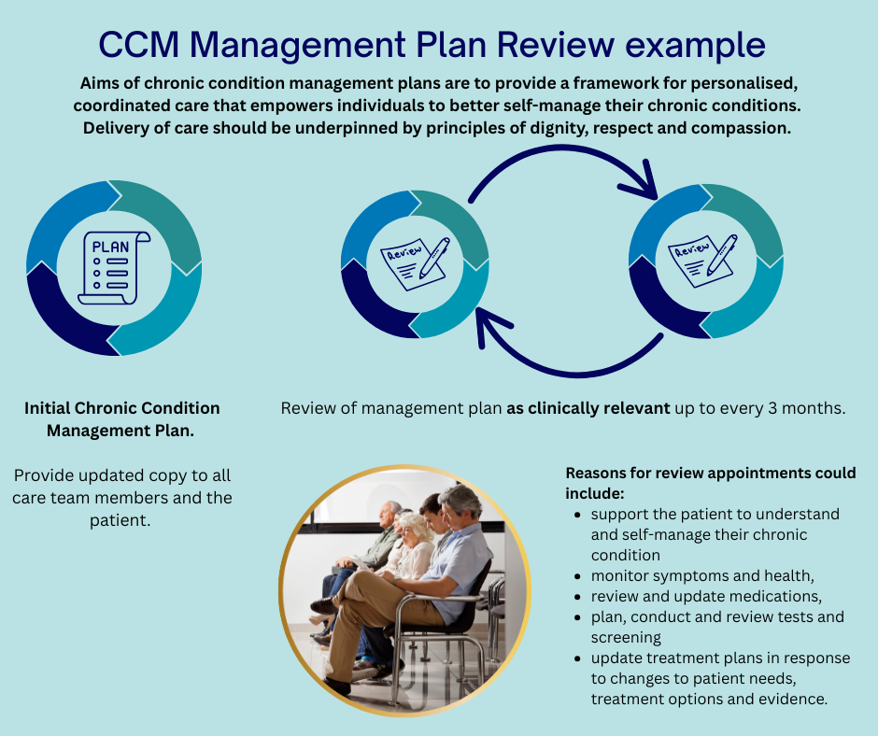
For patients diagnosed with a chronic condition that is expected to impact their health for longer than 6 months (or is terminal), Chronic Conditions MBS items support general practices to develop plans and continue to actively manage, monitor, and coordinate ongoing care. CCM items also support access and referral to allied health and other services for patients, including those that would benefit from multidisciplinary team care to manage their chronic condition. Patients can track their care plan items via their Medicare Online Account – Chronic Condition Management Tracker.

1.4 Relevant resources – See Section 5


Section 2 – Preparing your practice for CCM Quality Improvement action


Section 2 – Preparing your practice for CCM QI Action

A systematic approach to defining team roles, engaging patients, and quality improvement is necessary for successful Chronic Condition Management (CCM).

The activities outlined in the “Call to Action” below (and included in Section 4) can help to prepare your practice for incorporating CCM into workflows, enhancing scheduling, communication, and developing skills and cohesion for your entire practice team.

Activity 4.1 Pre-activity: CCM Practice Readiness Checklist is a good place to start planning and consider the sequence of actions to build your CCM readiness and engage your practice team.



Activities to Prepare your Practice Team for CCM Quality Improvement:
4.1 Pre-activity: CCM Practice Readiness Checklist
4.1.1 Preparing for Chronic Conditions Management and MyMedicare patient registration
4.2 Planning with your practice team
4.2.1 Engage your Practice
4.2.1 Activity – Swim Lane - Roles and Responsibility
4.2.2 Explore the benefits of MyMedicare with your practice team
4.2.3 Explore Chronic Conditions Management changes with your practice team

Every successful Quality Improvement starts with setting clear goals, underpinned by data and requires ongoing measurement and cycles of new activity in response to your findings. This process engages your primary health care team in assessing progress and tracking if change(s) are leading to an improvement.

Demonstrating the impact of your team’s QI actions is essential to maintaining engagement, momentum and building a culture of celebrating success!

It is best to measure at the beginning of the activity (baseline) and then at regular intervals. Use the Model for Improvement (MFI) framework to methodically work through identifying a clear problem, and to explore solutions and take action.

The QI Activity Goal below is an example of a clear goal for Chronic Conditions Management and MyMedicare you could adapt to your practice.

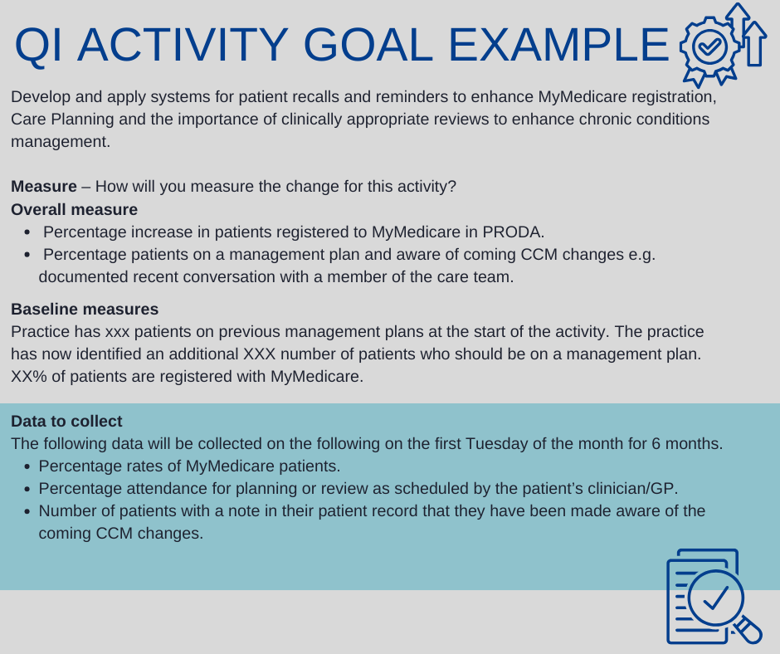


Section 3 - Delivering care to meet CCM MBS requirements


Section 3 - Delivering care to meet CCM MBS requirements
Section Navigation
3.1 Chronic Conditions Management (CCM) MBS changes and information
3.2 Referral Pathways for Allied Health Services
3.3 CCM MBS User Guide
3.4 Patient Drivers for Attending Chronic Condition Review Appointments



Chronic Conditions Management MBS Items include initial Chronic Condition Management plans and reviews of a chronic conditions management plan. Patients registered with MyMedicare can only access Chronic Condition Management (CCM) plans and reviews through their MyMedicare general practice. Patients not enrolled in MyMedicare can access CCM services from their usual GP.

For the full details see MBS Online.

3.1 Chronic Conditions Management (CCM) MBS changes and information
Changes to Chronic Disease Management and MBS items
Chronic Conditions Management (CCM) MBS item changes recommended by the MBS Review Taskforce simplify, streamline, and modernise the arrangements for health care professionals and patients.
Transition arrangements will be in place for 2 years to ensure current patients do not lose access to services.
From 1 July 2025:
Items for GP management plans (229, 721, 92024, 92055), team care arrangements (230, 723, 92025, 92056) and reviews (233, 732, 92028, 92059) will cease and be replaced with new streamlined GP chronic condition management items (see table below for item numbers).
To support continuity of care, patients registered through MyMedicare will be required to access the GP chronic condition management plan and review items through the practice where they are registered. Other patients will be able to access the items through their usual GP.
Where multidisciplinary care is required, patients will be able to access the same range of services currently available through GP management plans and team care arrangements.
GPs and prescribed medical practitioners will refer patients with a GP chronic condition management plan to allied health services directly. The requirement to consult with at least two collaborating providers, as described under the current team care arrangements will not apply.
Practice nurses, Aboriginal and Torres Strait Islander health practitioners and Aboriginal health workers will be able to assist the GP or prescribed medical practitioner to prepare or review a GP chronic condition management plan.
To support reviews and ongoing care as clinically appropriate, the MBS fees for planning and review items have been equalised. The fee for the preparation or review of a plan in $156.55 for GPs and $125.30 for prescribed medical practitioners (current as of 1 July 2025). Patients will also need to have their GP chronic condition management plan prepared or reviewed in the previous 18 months to continue to access allied health services.
Consistent with current arrangements, unless exceptional circumstances apply, a GP chronic condition management plan can be prepared once every 12 months (if necessary), and reviews can be conducted as clinically appropriate but not more frequently than once every 3 months. It is not required that a new plan be prepared each year; existing plans can continue to be reviewed.
Patients that had a GP management plan and/or team care arrangement in place prior to 1 July 2025 will be able to continue to access services consistent with those plans for two years. From 1 July 2027, a GP chronic condition management plan will be required for ongoing access to allied health services.
These changes do not affect MBS items (231, 232, 729, 731, 92026, 92027, 92057, 92058).
Table 1: Chronic Condition Management Items commencing 1 July 2025
Name of Item | GP item number | Prescribed medical practitioner item number
Prepare a GP chronic condition management plan – face to face | 965 | 392
Prepare a GP chronic condition management plan - video | 92029 | 92060
Review a GP chronic condition management plan – face to face | 967 | 393
Review a GP chronic condition management plan – video | 92030 | 92061

The figure below demonstrates how planned care and appropriate periodic reviews for patients with one or more chronic conditions contribute to the delivery of more person-centred care.

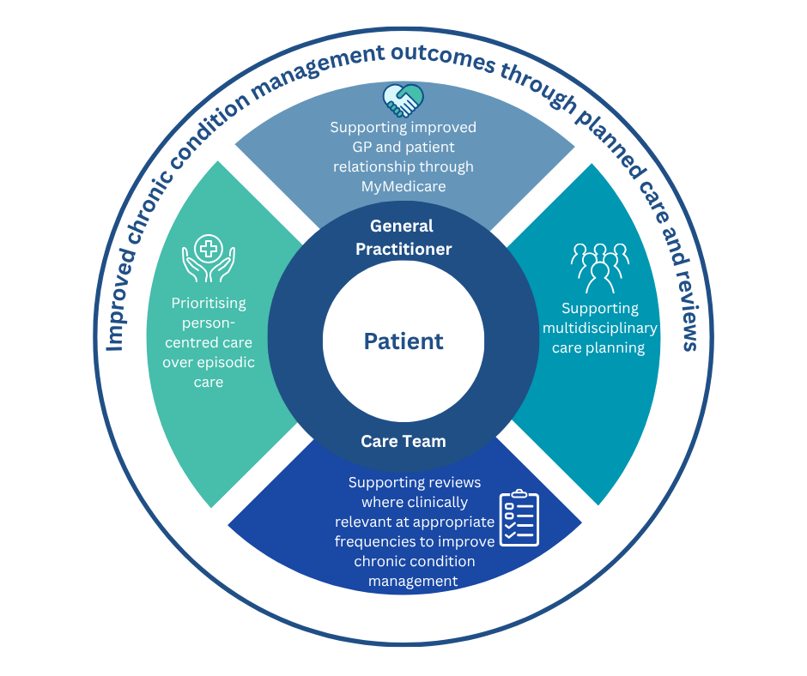

3.2 Referral Arrangements for Allied Health Services (For Chronic Condition Management)
As per MBS Online from 22 May 2025, referral requirements for most MBS-supported allied health services related to CCM on or after 1 July 2025, have been simplified to be more consistent with the arrangements for referrals to medical specialists.
- Any referrals for allied health services written prior to 1 July 2025 will remain valid until all services under the referral have been provided (see separate factsheet on transition arrangements).
- From 1 July 2025, Team Care Arrangement referral forms will no longer be used for referrals to allied health services
- There is no requirement for allied health providers to confirm acceptance of the referral or otherwise provide input into the preparation of the GP chronic condition management plan (GPCCMP).
- Requirements for allied health providers to provide a written report back to the GP after the provision of certain services (e.g. the first service under a referral) are unchanged.
- Unless otherwise specified by the referring medical practitioner, referrals to allied health services for patients with a chronic condition will be valid for 18 months.
- The new referral requirements apply to all allied health referrals under the chronic conditions management framework, as well as some other MBS-supported allied health services.
What are the changes?
From 1 July 2025, these requirements for referrals also apply to the following allied health services (and their video and phone equivalent) items:
- Group M3 (subgroup 1) – individual allied health services for patients with a chronic condition (referred under the chronic conditions management arrangements)
- Group M8 – pregnancy support counselling allied health services
- Group M9 – allied health group services for patients with type 2 diabetes (referred under the chronic conditions management arrangements)
- Group M10 (subgroup 1) – complex neurodevelopmental disorders and eligible disabilities allied health services
- Group M11 – allied health services for Aboriginal and Torres Strait Islander people (referred under the chronic conditions management arrangements or following a health assessment).
More information: MBS Online - Upcoming changes to the MBS Chronic Disease Management Framework

3.3 CCM MBS User Guide
Refer to the Chronic Conditions Management MBS User Guide for examples of how CCM management planning items can be used and claimed by general practices.
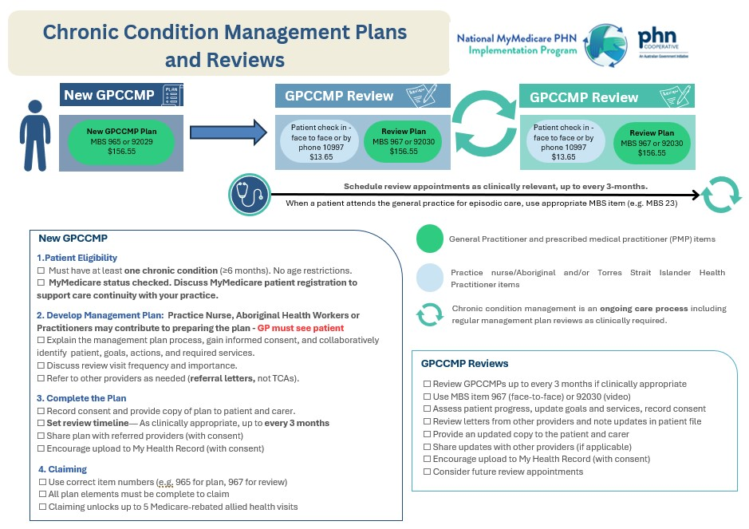

3.4 Patient Drivers for Attending Chronic Condition Review Appointments
Applying patient-centred care approaches contributes to better engagement in ongoing care with your practice team. Many Chronic Conditions require periodic review appointments for planned care, and patients need to feel a strong sense of engagement and see the value in attending appointments when they may otherwise feel quite well! The following patient review appointment engagement tips can help to increase attendance and engagement with patients at planned review appointments.

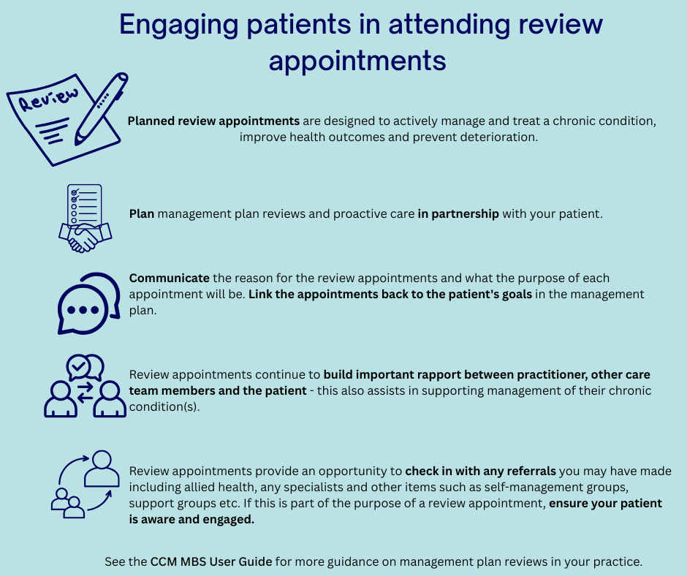


Section 4 – Activities: Implement in your practice



Section 4 – Activities: Implement in your practice
Section Navigation

4.1 Pre-activity: CCM Practice Readiness Checklist
Other suggested activities

Section Navigation – Activities List
4.1 Pre-activity: CCM Practice Readiness Checklist
4.1.1 Preparing for Chronic Conditions Management and MyMedicare patient registration
4.2 Planning with your practice team
4.2.1 Engage your Practice
4.2.1 Activity – Swim Lane - Roles and Responsibility
4.2.2 Explore the benefits of MyMedicare with your practice team
4.2.3 Explore Chronic Conditions Management changes with your practice team
4.3 Raise Patient Awareness
4.3.1 Registration and Planning management plan reviews
4.3.1 Activity - Communication Action Plan
4.3.2 Review and Strengthen the Process
4.3.3 Review and Strengthen Communication
4.3.3 Activity – Scripts: phone, SMS, email and website
4.4 Recall existing CCM patients
4.5 Check in, review and celebrate
Tips and Tools for Maintaining QI Momentum


Click on the activity of interest or scroll through in the activities chapter in order

4.1 Pre activity : CCM Practice Readiness Checklist
The CCM Practice Readiness Checklist is a great place to start with planning for Chronic Conditions Management changes and includes links you can work on with your practice.
PLANNING AREA | TASKS TO DO
Step 1  Plan the transition | ☐Getting ready QI Checklist  ☐Designate a CCM change lead and change team  ☐Document the change plan  ☐Preparing for Chronic Conditions Management and MyMedicare patient registration  ☐Plan team roles in the transition according to staff skills, interest and position – Refer to Team roles and responsibilities  ☐Have a change team meeting and communicate upcoming changes to the team  ☐As a team, plan key activities and timelines  ☐Set up a shared file/folder for the change team to share documents etc
Step 2  Prepare your team | ☐Discuss with your wider team what is changing and why  ☐Get staff ideas and feedback on proposed change plans  ☐Ensure team members have dedicated time to do their required tasks  ☐Plan regular meetings of the change team to track progress  ☐Communicate progress regularly with whole of practice via noticeboard, email, group chat, staff meetings  ☐Discuss the upcoming changes with your allied health providers etc
Step 3  Review your resources | ☐Do a stocktake of existing CDM resources  ☐Locate resources in central location for ease of access  ☐Allocate staff members and timelines for updating resources
Step 4  Raise patient awareness | ☐Consider patient messaging (What’s in it for them?)  ☐Talking scripts  ☐Poster, information sheets brochures for patients  ☐Calls to action/communications to patients (email, SMS, direct communication)  ☐Train reception staff in MyMedicare and CCM messaging  ☐Ensure reception is opportunistically registering patients for MyMedicare  ☐Monitor the list of your patients who have deregistered from your practice in HPOS and follow up
Step 5  Engage existing CDM patients | ☐Communicate changes from CDM to CCM to patients  ☐Recall existing CDM patients: for new GPCCMP when their review is due  ☐Determine/review the process for booking review appointments  ☐Document and communicate any changes to booking processes  ☐Confirm how the practice will check MyMedicare registration status
Step 6  Identify new CCM patients | ☐Use clinical software and other data tools identify eligible patients by condition, medication, etc  ☐Identify patients who have been previously identified for CCM but have not taken up the offer and follow up with them (e.g. Primary Sense Health Assessment or Patient with High Complexity reports)  ☐Opportunistically identify new CCM patients during consultations, HA’s, immunisations etc
Step 7  Check in, review and celebrate | ☐What is needed to embed the current changes?  ☐How will your track CCM reviews?  ☐Update workflow documents, position descriptions and policy and procedures manuals  ☐Plan your next steps  ☐How will you celebrate your successes?

4.1.1 Preparing for Chronic Conditions Management and MyMedicare patient registration:
The below steps assist your practice to prepare for the Chronic Conditions Management changes, follow the steps below as a practice team – these steps may prompt your team to plan for other activities.

your patients with a chronic condition or existing management plan to register with MyMedicare.

your practice for MyMedicare if you have not done so already.
information about MyMedicare on your practice social media page using Social Media Tiles.
MyMedicare posters and brochures in your practice waiting room/reception and display MyMedicare Patient videos in your waiting room screens.
your practice website to include links to MyMedicare patient registration information.
the MyMedicare Registration form and brochure with your patient consent form.
your practice team to speak with patients about MyMedicare.
MyMedicare at a practice meeting and print copies of MyMedicare brochures and MyMedicare patient registration frequently asked questions to use in conversations with patients.
what these changes mean with your practice team. Identify any processes you need to review or update (e.g. incorporate MyMedicare registration in your chronic disease management workflows).
Encourage
Post
Place
Update
Include
Discuss
Prepare
Register
Discuss

Plan Do Study Act
The following example MFI and PDSAs demonstrate how to use your practice data, to plan and action Quality Improvement related to CCM.
These are also located in the Appendix section of this document – Appendices.
3.1 MFI and PDSA - Identifying Active Patients & Linking to MyMedicare Program
3.2 MFI and PDSA - Correcting Missing Demographic Information
3.3 MFI and PDSA – Accurate Recording of Demographic Data and Lifestyle Risk Factor
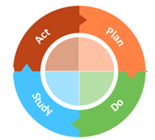
3.4 MFI and PDSA – Data Coding Accuracy for Chronic Conditions

4.2 Planning with your practice team
This activity aims to raise awareness among your practice team of MyMedicare, Chronic Conditions Management changes, and support your team to explore their roles in both MyMedicare and Chronic Conditions Management.
By exploring and defining these roles, your practice team can work collaboratively to prepare for change and develop processes, systems and skills needed to succeed.
There are a range of ideas outlined below for you to use to tailor and modify to develop your own plan for change at your practice. We recommend you document your plan using a Plan-Do-Study-Act Template.
Activity outcomes
- Your practice team has a better understanding of MyMedicare (Voluntary Patient Registration)
- Your practice team has a better understanding of Chronic Conditions Management
- Your practice team roles in MyMedicare and Chronic Conditions Management are well defined, and each team member has a clear role and responsibilities

4.2.1 Engage your Practice

Inform your practice team about MyMedicare and the changes to Chronic conditions management:
- Team meeting or quick lunch catch up to communicate the changes
- Post an update in the practice staff room
- Send an email to the practice team with the critical information
To explore and document team roles and responsibilities related to MyMedicare and Chronic Conditions Management resources proposing some team roles ideas and a blank template are provided below to help you get started:
- Explore roles and responsibilities with the practice team in a meeting or quick lunchtime discussions (see Swim Lane - Roles and Responsibilities to assist with this activity and thinking)
- Document agreed roles and responsibilities and communicate this with your team
- Discuss and document how each team member will incorporate their responsibilities into their workday and work week
- Schedule a time to review your documented roles and responsibilities
  - Check in with your practice team 4 weeks after publishing these for a quick reflection and to maintain momentum as people adapt to their new responsibilities
  - Review team roles and responsibilities at 3 months and make any changes or improvements based on lessons learned

4.2.1 Activity – Swim Lane - Roles and Responsibility
Use this swim lane process map to visually clarify which team members roles and responsibilities performed each task in a care process, identify inefficiencies, and collaboratively redesign workflows to ensure everyone works at the top of their scope.
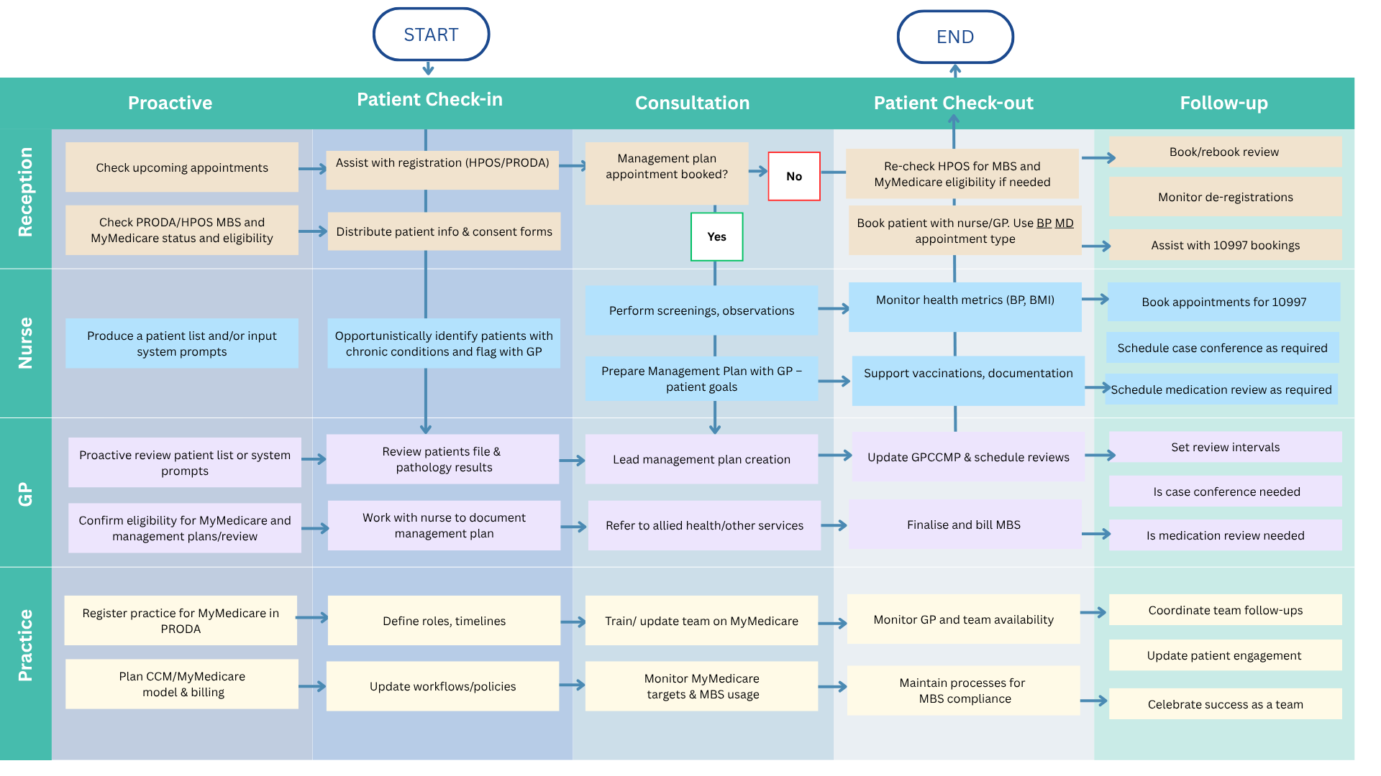

4.2.2 Explore the benefits of MyMedicare with your practice team
Consider the adoption of consistent talking points for your practice about MyMedicare.
Talking points for your practice for MyMedicare are included below for you to consider, adapt and share. If you plan to discuss these in an open forum with your team, you may want to share these in advance, and pose some general questions such as:
i. What could be some of the benefits of increasing MyMedicare participation for our practice?
ii. What does/could MyMedicare mean for our practice and patients?
iii. How does a MyMedicare practice-patient relationship fit with our practice ethos and strategy?
The MyMedicare GP Toolkit provides a good summary of the current benefits of MyMedicare for General Practices. The toolkit also includes a range of helpful resources your practice can use to communicate with patients.

MyMedicare Conversation Starters
- We are a MyMedicare practice, you can now choose a general practice for ongoing care for your health and wellbeing needs.

- MyMedicare helps our practice build a strengthened relationship with you to provide well-coordinated health care for you. This relationship helps other providers to identify your general practice when they view your My Health Record.

- MyMedicare is voluntary and you can change your registered general practice if you need to.

- If you haven’t already registered, you can register today using the myGov App or a paper form (insert where forms are available in your practice)

Have a printout available of the below QR code for consulting rooms and reception to assist patients to register using the myGov App. (Printable page available on next page)

MyMedicare

- We are a MyMedicare practice, you can now choose a general practice for ongoing care for your health and wellbeing needs.

- MyMedicare helps our practice build a strengthened relationship with you to provide well-coordinated health care for you. This relationship helps other providers to identify your general practice when they view your My Health Record.

- MyMedicare is voluntary and you can change your registered general practice if you need to.

If you haven’t already registered, you can go to https://my.gov.au/
Login to your MyGov account, go to Medicare then to MyMedicare tile to register.


Scan the QR Code to go to the MyGov website

4.2.3 Explore Chronic Conditions Management changes with your practice team
A summary of CCM changes can be found in Section 3 of this workbook.

Have a team discussion and pose some open questions such as:

- How are these changes similar or different to current CDM care?

- Are our practice nurses or Aboriginal and Torres Strait Islander health practitioners confident in management planning or is there more training or development to enhance their skills and roles?

- What is our ratio of management plans to management plan reviews at the moment? What changes would we need to make to enable reviews to be scheduled as clinically appropriate?

- More considerations for planning are included in the CCM Checklist.

More information is available at these links

- MBS Online

Plan Do Study Act
The following example MFI and PDSA is relevant to this section and these activities.

These are also located in the Appendix section of this document – Appendices.
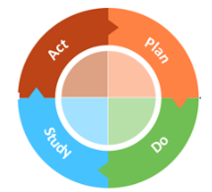
3.5 MFI and PDSA – Team awareness, desire and readiness

4.3 Raise patient awareness
This activity supports your practice team to engage your patients to increase their understanding and participation in MyMedicare and CCM review appointments required for ongoing care.
The following activities focus on:
- Strengthening patient-practice relationships by registering Chronic Condition Patients for MyMedicare
- Planning care for patients that includes management plan review appointments as appropriate and communicating the purpose of each appointment to the patient.
We suggest you document your plan for each Activity Idea below using a Plan-Do-Study-Act Template. Ensure responsibility for each activity is allocated to a member of your practice team with a timeline for completion.
Activity Outcomes
- Register all returning Chronic Disease Management Patients for MyMedicare with your practice prior to, or at their next Chronic Disease Management appointment.
- Develop a process for booking future review appointments for any patient you put onto a Chronic Disease Management Plan.
- Develop a clear communication for why review appointments are important to attend for your practice team and patients (including if there are out of pocket costs for the patient).
- Develop a process to manage missed or cancelled patient review appointments.

4.3.1 Registration and planning management plan reviews

Register all returning Chronic Disease Management Patients for MyMedicare with your practice prior to, or at their next Chronic Condition Management appointment.
- Prompt your patients to register in advance of their appointments.
  - Send an SMS to all patients with a scheduled Chronic Disease Management Plan encouraging them to register with your General Practice before their appointment using Medicare Online or print and complete a MyMedicare Registration form to bring to their appointment, or
  - Invite patients to attend their appointment early to complete a MyMedicare Registration Form in the practice waiting room.
- Encourage your patients to register at their next appointment
  - Check each patient’s MyMedicare Registration status with your practice when they present for their appointment or the day before their appointment
  - Provide a MyMedicare Registration QR code or utilise other team members to assist patients to register while in the clinic such as practice nurses or Aboriginal and/or Torres Strait Islander Health Practitioner.

Use the communication action plan on the next page to consider all quality improvement needs related to increasing MyMedicare registration of chronic conditions patients within your practice.

4.3.1 Activity - Communication Action Plan

QI focus area
Why improve
this focus areas?
QI ideas
“What” of the action plan
Resources
MyMedicare Patient Registration
To increase patient registration for MyMedicare for our General Practice

What are the benefits of undertaking activities in this area?
- Opportunity to formalise, establish or enhance our relationship for ongoing coordinated care with patients
- To prepare for Chronic Conditions Management (CCM) MBS item changes
- To prepare for changes to Better Access Mental Health Treatment Plans

What ideas can we explore?
Ideas for targeting patients:
- Engage patients to encourage registration as they present to the practice or attend appointments
- Engage patients that qualify for MyMedicare (e.g. have attended the practice twice in 24 months)
- Engage patients that attend the practice for ongoing care management (e.g. Chronic Condition Management Plans, Mental Health Treatment Plans, Health Assessments and Health Checks

Communication approaches/ideas
- Patient waiting room and reception posters or flyers (use existing or design your own)
- Promotion through our website or social media
- Search and tag patient records for action when they present or contact the practice
- Encourage patients to register through Medicare Online Account or myGov Mobile app
- Nurse or doctor conversations at appointments. Monitor reminder cards, display information in clinic rooms.
- SMS or email campaign
- MyMedicare patient forms offered to patients (note- paper forms submitted through PRODA require additional staff time required to process) or send a MyMedicare registration link
- Practice staff room poster documenting your practices unique MyMedicare value or key messages

Practice resources
- MyMedicare GP Toolkit (includes posters, social tiles, flyers, etc)
- MyMedicare Videos
- Introducing MyMedicare – Fact sheet
- Registering in MyMedicare – Fact sheet
- MyMedicare practice registration – Frequently asked questions
- Registering patients with MyMedicare – Systems overview for practices and providers
- MyMedicare Program Guidelines
- About MyMedicare for health professionals

4.3.2 Review and Strengthen the Process
Review and strengthen the process for booking review appointments for patients you put onto a Chronic Condition Management Plan.
    - Consider and develop a method for how your practice will approach scheduling review appointments. Understand your practice’s review processes and ensure that workflows reflect these.
    - Develop workflows for reception – to ensure that as the patient is handed over from the GP to reception, and before they leave your practice, reception has an action to schedule their next appointment, understands the clinically appropriate timeframe for review to inform scheduling, and communicates the appointment time and date clearly to the patient (SMS, or reminder card, or other).
    - Develop a process for appointment reminders in leadup to review appointments – frequency (e.g. 1 week and 24 hours) and modality (phone call or SMS) to ensure your attendance rates for review appointments remain high. You may wish to include a message for each patient to check Medicare Online to ensure they are registered for MyMedicare with your practice, and document any questions they have to bring to the appointment.

Review and strengthen the process to manage missed or cancelled patient review appointments.
Document the process for how to manage cancellations or missed review appointments. As part of this process consider:
    - How is the cancellation or non-attendance of review CCM appointments documented? For example, will your practice flag the patient’s file so the GP is notified next time the patient attends, or will you retain a list of patients that need to be contacted and re-scheduled?
    - Who needs to be notified? (e.g. Nurse or Aboriginal Health Practitioner with responsibility for Chronic Disease coordination, and the patients usual GP).
    - What are the standing arrangements for re-scheduling chronic condition review appointments? For example, does your practice aim to re-schedule within 2 weeks of the cancellation or follow up non-attendance with a phone call to reschedule as a standard operating procedure?
    - Are there any data searches that need to be completed at regular intervals to identify any patients that may have missed their appointment but not been re-scheduled? For example, you could run a report from your clinical practice software for patients that have not had a review in more than 6 months and provide this list to a Nurse or Aboriginal Health Practitioner or Health Worker with responsibility for Chronic Condition coordination for them to follow up and re-schedule any patients that have missed their scheduled review.


4.3.3 Review and strengthen communication

Review and strengthen communication for why review appointments are important to attend for your practice team and patients (including if there are out of pocket costs for the patient).
    - Review your process and strengthen how you document priorities and actions due for the next review appointment in the patients’ medical record (in your practice software) as part of all Chronic Condition Management Plans and Reviews. For example, document any:
  - Outcomes, goals or targets the patient has for their review appointment
  - Education or points of discussion planned for the review appointment
  - Tests or pathology due that need to be scheduled
  - Referrals that need to be completed

b) Communicate the importance of the review appointment with your patient and their carers (if appropriate) including:
- Emphasise the importance of clinically determined reviews focusing on actions for the patient and why the review is needed with your patient at the conclusion of the appointment
- Provide patient with a printed copy of the management plan and review appointment plan
- Outline expectations and processes to re-schedule review appointments ahead of time
- Activity 4.3.3 on the next page supports practices to carry out these suggestions on a daily basis.

c) Develop messaging for patients about the benefits of proactive care, care when you are not acutely unwell, or keeping you well. Develop communications to support this in your practice, for example:
- Waiting room posters targeting patients with chronic conditions
- Talking points for the practice team to reinforce the importance of reviews and attending for care when patients are not acutely unwell. On the next page are some suggested Scripts: phone, SMS, email and website for your practice to consider and modify to your needs.

4.3.3 Activity – Scripts: phone, SMS, email and website
Please tailor scripts for phone, SMS, email, and website for practice staff to use when communicating with patients about Chronic Condition Management Plans and MyMedicare.

📞 Phone Script (Reception or Nurse Call)
Hi, this is [Your Name] from [Practice Name]. I’m just checking in about your ongoing care.
If you have a health condition that lasts six months or more, you may be eligible for a Management plan. This supports your health needs with a clear plan, plus may enabled up to 5 subsidised visits per year to allied health providers, as suggested by your GP.
We also recommend registering for MyMedicare, which helps us provide more coordinated care.
Would you like to book a longer appointment to get started or get more info?

📱 SMS Script
Hi [First Name], you may be eligible for a Management plan and MyMedicare registration with your GP at [Practice Name].
This can support your ongoing care and support access to subsidised allied health visits.
Call [Phone] or book online: [Website]

📧 Email Script
Subject: Management plan & MyMedicare – Supporting Your Health
Hi [First Name],
If you have a long-term health condition, you may benefit from a management plan at [Practice Name]. It helps you and your GP plan and manage your care, and may include referrals by your GP for up to 5 subsidised allied health visits per year.
We also recommend registering with MyMedicare to make sure your care is continuous and well-coordinated.
🕑 A longer appointment is needed to set up your plan.
📅 You’ll check in with your GP every 3–6 months.
Reply to this email, call us on [Phone], or book online at [Website]
🌐 Website Text (Info Page or Pop-up)
Do you have a long-term health condition?
We can help you with a management plan at [Practice Name]. This includes:
- Your health goals
- How we’ll support you
- Who might help you as part of your care team
We also recommend registering for MyMedicare, a voluntary enrolment program that links you to us as your regular practice — for more coordinated care.
🕑 Longer appointments are needed to set up your plan
📅 You’ll check in with your GP every 3–6 months
👉 Ask us today, or [Book Online Now]

Plan Do Study Act
The following example MFI and PDSAs are relevant to this section and these activities.
These are also located in the Appendix section of this document – Appendices.
3.6 MFI and PDSA - Patients eligible for chronic disease management planning or review
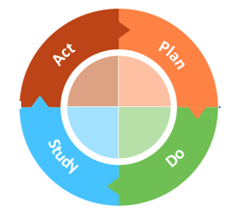
3.7 MFI and PDSA – Patients with chronic conditions – Diabetes
3.8 MFI and PDSA – Patients with a management plan billed in the past 12 months

4.4 Recall existing CCM patients
Vaccine reminders
RACGP standards require preventive care and tailored reminders, including for patients with limited English.
Use your software to identify and remind patients due for vaccines.
Software | Adding reminders | Create mail merges | Create bulk SMS | Adding notes
Best Practice | Add a Clinical Reminder to a patient | Send Health Awareness Communications | Send clinical reminders | Add and review contact notes
Medical Director | Recall, Reminders, Actions and Outstanding Requests | Mail merge | Sending SMS reminders | Editing a patient’s details from within their record

Plan Do Study Act
The following example MFI and PDSAs are relevant to this section and these activities.
These are also located in the Appendix section of this document – Appendices.
3.9 MFI and PDSA – Patient Engagement and Reminders
3.10 MFI and PDSA - Reducing Missed Appointments

4.5 Check in, review and celebrate
Group reflection after completing activities:
As a team, analyse and review baseline data results and discuss change ideas and actions.
Use PDSA cycles to test and measure change ideas

The degree to which the activity learning outcomes were met:  Not met  Partially met  Entirely met | To what degree this activity was relevant to your practice:  Not met  Partially met  Entirely met
What did you learn? What changes would you make to your practice as a result?
For example,
- Has patient engagement increased through education efforts?
- Which educational strategies were most effective?
- Have MyMedicare registrations improved following engagement efforts?
- Do relevant team members know how to send out GoShare patient resources, videos and apps?
- What barriers were encountered in patient engagement?

RACGP CPD: utilise the self-reporting feature on Quick Log mycpd.racgp.org.au to document reflection.
https://www.servicesaustralia.gov.au/how-to-record-encounter-using-air-site-through-hpos?context=23401

Tips and Tools for maintainng QI momentum
Use the following checklist of good change management tips to maintain your QI momentum.
Sustainability checklist to maintain change
Activities
Cyclical nature of PDSAs- Adopt, adapt, abandon​ | ☐Adopt: excellent work, embed that change.  ☐Adapt: determine if a change is needed to the plan and start a new PDSA.  ☐Abandon: Rethink the next PDSA  ☐Lessons can be learned from PDSAs that are abandoned.  ☐ Keep a record of learnings.
Document your improvement activity: Record your completed QI activities to meet PIP QI guidelines and CPD requirements | ☐Record your completion.  ☐Documentation must be kept for 6 years for evidence of PIP QI if your practice is audited by the Department of Health, Disability and Ageing.  ☐Clinical Audit QI activities can be recorded and contribute to RACGP Measuring Outcomes CPD Activities.
Sustaining project outcomes. Consider which practice documentation may need to be updated to include the change: | ☐Updates to Policy and Procedure manual.​  ☐Specific task procedures​.  ☐Local signs or instructions.  ☐Staff work practices.  ​☐Position descriptions​.  ☐Staff induction.  ☐Staff skills development or education.
Communication is key to finishing a successful project. Consider: | - QI project outcome feedback to staff.  - Discuss project strengths and challenges.  - Feedback to patients, where appropriate.
Celebrate success | - Celebrate your outcomes and achievements by sharing morning tea with your team.  - Consider sharing your practice improvement activity efforts with your patients through practice newsletters, website or RACH’s you work with. E.g. displaying 'run charts' to demonstrate change over time.
Review and reflect | ☐ Discuss project strengths and challenges.  ☐ Annually review the PDSA outcomes to ensure activities are still being adhered to and completed  ☐ Annually review and audit your data related to this activity. Identify gaps, areas for improvement and set new targets if needed.  ☐ Where to next on your continuous QI journey?  ☐ Consider potential topics for a new QI activity, and how your experience with this activity can help you to be more efficient and effective

Section 5 – Resources - Best Practice Care for CCM




Section 5 – Resources - Best Practice Care for CCM

Section Navigation – Resources List
5.1 MyMedicare
5.2 CCM Relevant Resources
5.3 PHN Resources and Tools
5.4 RACGP Red Book
5.5 Health Pathways

Click on a resource of interest or scroll through in the resources chapter in order

5.1 MyMedicare
5.1.1 MyMedicare Resources
- MyMedicare GP Communication Toolkit
- MyMedicare Fact Sheet
- MyMedicare information for practices and providers
- MyMedicare Resources for patients; general practices, providers; and translated resources

5.1.2 MyMedicare registration

MyMedicare
Practice Registration
MyMedicare Patient Registration

MyMedicare practice registration checklist here.
Adding GPs as providers to the Organisation Register in PRODA here.
Providing practice staff with relevant delegations to view and manage patient registration here.
Educating non-clinical staff on the steps involved in patient registration with your practice and preferred GP here
Patient facing resources to formalise the relationship between patient, general practice, and preferred GP here.
Patient eligibility and methods of registration here.
MyMedicare Patient Registration Form here.
Patient registration benefits here.
MyMedicare GP toolkit

5.2 CCM relevant resources
Other CCM-relevant resources
Website – CCM requirements- Services Australia Website
5.2.1 CCM Practice Resources:
- Upcoming changes to MBS Chronic Disease Management Arrangements | Australian Government Department of Health, Disability and Ageing
- MyMedicare Resources (available in 10 Languages)
- Social Media Tiles
- MyMedicare - Poster 1
- MyMedicare Poster 2

5.2.2 CCM Patient resources

Patient resources to explain MyMedicare
To inform patients and their carers about MyMedicare the resources below can help explain the benefits and what it means for them.
Patient Brochures
mymedicare-dl-brochure.pdf (health.gov.au)
Easy Read MyMedicare Patient brochure

5.3 Healthy North Coast Resources and Tools
Healthy North Coast have also produced other resources and information for general practices to support the delivery of best practice care for CCM. These resources are listed below
MyMedicare Patient Engagement and Registration Communications

Planning with your practice team – awareness and practice team roles

Engage returning Chronic Disease Management Patients

5.4 RACGP Red Book
The RACGP Red BOOK (insert link) provides a comprehensive guide. RACGP - About the Red Book
RACGP – Guidelines for preventive activities in gerenal practice RACGP - Guidelines for preventive activities in general practice
RACGP – Chronic Disease RACGP - Chronic disease

5.5 HealthPathways
HealthPathways are available to support best practice care in your local area, including hospital and specialist service referrals. The following HealthPathways are particularly relevant for chronic condition management.
- PHN to insert list of relevant health pathways for Chronic Condition Management here


Appendices


Appendices

Click on the appendix of interest or scroll through in the appendices in order
Section Navigation – Appendices List
Appendix 1 - Team roles template for general practices
Appendix 2 - Model For Improvement and PDSA Template
2.1 Model for Improvement Template
2.2 PDSA (Plan-Do-Study-Act) Template
Appendix 3 Example MFI and PDSAs
3.1 MFI and PDSA - Identifying Active Patients & Linking to MyMedicare Program
3.2 MFI and PDSA - Correcting Missing Demographic Information
3.3 MFI and PDSA – Accurate Recording of Demographic Data and Lifestyle Risk Factor
3.4 MFI and PDSA – Data Coding Accuracy for Chronic Conditions
3.5 MFI and PDSA – Team awareness, desire and readiness
3.6 MFI and PDSA - Patients eligible for chronic disease management planning or review
3.7 MFI and PDSA – Patients with chronic conditions – Diabetes
3.8 MFI and PDSA – Patients with a management plan billed in the past 12 months
3.9 MFI and PDSA – Patient Engagement and Reminders
3.10 MFI and PDSA - Reducing Missed Appointments
Appendix 4 - Claiming workflow - Management Plan (GPCMMP 965 or 92029)
Appendix 5 - Claiming workflow Management Plan Review (GPCCMP Review Appointments)

Appendix 1 - Team roles template for general practices

Practice Team Member | Chronic Conditions Management (CCM) Role and Responsibilities | MyMedicare Role and Responsibilities
Practice Manager
Practice Principal

Practice Nurse, Aboriginal and Torres Strait Islander Health Practitioner
Responsible/Preferred MyMedicare General Practitioner
Reception Team

Appendix 1: Completed Example Team roles template: Roles and Responsibilities for MyMedicare and Chronic Conditions Management
An example of potential roles and responsibilities for team members is included below. You can use this as a starting point for discussion or use the blank template below to openly seek contributions from your practice team.
Practice Team Member | Chronic Conditions Management (CCM) Role and Responsibilities | MyMedicare Role and Responsibilities
Practice Manager | - Business planning with the practice principal to establish preferred CCM model of care and billing practices  - Work with the practice team and practice principal to determine roles and responsibilities for the practice team to support comprehensive CCM for patients  - Engage and communicate with the practice team to coordinate teamwork for CCM  - Document policy and procedures to describe how the practice supports proactive care for CCM  - Maintain up-to-date patient registers of patients with a Chronic Condition  - Undertake audits of practice records to identify eligible patients due for CCM plans or reviews, investigations, immunisations or screening  - Establish and oversee recall/reminder systems  - Support GPs with the flow of information in relation to CCM  - Support/manage reception staff responsibilities  - Manage succession planning  - Monitor progress against CCM QI improvement measures | - Business planning with the practice principal to establish preferred model of care and billing practices for MyMedicare registered patients  - Work with the practice team and practice principal to determine roles and responsibilities for the practice team for MyMedicare registered patients  - Document policy and procedures to describe how the practice engages MyMedicare registered patients including:  - MyMedicare practice, provider and patient registration processes  - Organisation Register, site record and program registration is complete, including up to date RACGP Accreditation/Exemption details/certificate number and renewal period added.  - Access to timely care and appointment availability,  - Bulk billing incentives and telehealth access,  - Communication to maintain engagement and about changes or practice news,  - Regular attendance to support ongoing comprehensive and proactive care,  - Allocations of patients to GP’s aligned to GP capacity, work schedule, interests and preferences  - Develop communication material for patients about the benefits of MyMedicare Registration with the General Practice  - Engage the practice team to communicate and plan for changes related to MyMedicare requirements (e.g. new practice incentives or MBS items associated with MyMedicare)  - Manage succession planning and staff changes that impact MyMedicare patients
Practice Principal | - Work with the practice team and practice manager to determine clear roles and responsibilities or the practice team to support comprehensive chronic conditions management for patients  - Business planning with the practice manager to establish preferred CCM model of care and billing practices | - Determine participation in MyMedicare and associated measures in PROD/HPOS  - Engage with General Practitioners at the practice to explore target numbers of MyMedicare patients for each GP based on their interest areas, work schedule and preferences  - Determine if practice will automatically accept MyMedicare patient registrations
Practice Nurse, Aboriginal and Torres Strait Islander Health Practitioner | - Work with reception staff to promote Chronic Conditions Management  - Respond to recall/reminder systems and engage in opportunistic discussions to encourage participation with eligible patients  - Workup, document and contribute to Chronic Conditions Management Plans and Review documentation and discussion with patients  - Clearly document timelines, actions, investigations, goals and areas of focus for care in preparation for the next CCM review and confirm and communicate these with the patient and care team  - Perform immunisations (as clinically required/requested by the GP)  - Perform data measures on patients including height, weight, BMI, blood pressure, smoking or alcohol status | - Develop and implement quality Improvement activities for MyMedicare Registered patients including:  - Routine Health Care Checks/screening for population cohorts, prevention, disease risk  - Immunisation planning for MyMedicare Registered patients
Responsible/Preferred MyMedicare General Practitioner | - Respond to recall/reminder systems and engage in opportunistic discussions to encourage CCM participation with eligible patients  - Perform a clinical review on each patient  - Arrange any relevant tests or investigations  - Determine approach for CCM Review appointments for patients based on clinical need  - Clearly document timelines, actions, investigations, goals and areas of focus for care in preparation for the next CCM review and confirm and communicate these with the patient and care team  - Support eligible patients to participate in screening or vaccinations, including addressing potential barriers (e.g. fear, embarrassment, lack of knowledge, access etc)  - Perform measurements, screening, immunisations and/or work with Practice Nurses to do so  - Maintain RACGP Standards for General Practice - Criterion GP2.2 - Follow up systems | - Appointment/diary planning with practice manager to improve access for MyMedicare registered patients.  - Developing enduring care relationship with MyMedicare patients. Discussing and documenting shared expectations for ongoing care, patient life goals and health outcomes.  - Identifying and participating in Quality Improvement clinical audit for MyMedicare registered patients
Reception Team | - Order and maintain supplies of resources  - Display brochures, flyers and posters  - Schedule review appointments for CCM patients based on practice procedures and clinical recommendations of GP and Nurses  - Respond to recall/reminders opportunistically when a patient phones for an appointment and/or by handing relevant resources to patients in the waiting area  - Send GP signed recall/reminder letters (and/or text messages and phone calls) to eligible (or soon to be eligible) patients to encourage participation  - Provide resources and support information in alternative languages as needed.  - Manage review appointment cancellations, notifying care team to seek guidance and rescheduling appointments to ensure regular care delivery | - Engage patients to encourage registration for MyMedicare and describe benefits  - Enter completed MyMedicare paper registration forms into HPOS/PRODA  - Check Patient Registration status for MyMedicare in advance of CCM appointments to ensure eligibility for CCM MBS items  - Monitor PRODA/HPOS for MyMedicare system notifications for patients de-registering for MyMedicare from your practice, and take any actions to inform the team or contact the patient to check in  - Monitor Practice email correspondence to ensure and notifications of expiring RACGP accreditation/exemption is updated to continue MyMedicare program eligibility.

Appendix 2 – Model For Improvement and PDSA Template

1.0 Model for Improvement and Plan-Do-Study-Act Cycle
Start by documenting your practice QI team and define your problem and specified a robust Problem Statement using the Quality Improvement Template. Next, consider Model for Improvement.
In the Model for Improvement, the 'Thinking Part' focuses on the overall improvement strategy, while the 'Doing Part' implements changes through the Plan-Do-Study-Act (PDSA) cycle. This model uses PDSA cycles to test changes, ensuring measurable and sustainable improvements.
Click here for a short video explaining the Model for Improvement and PDSA’s.
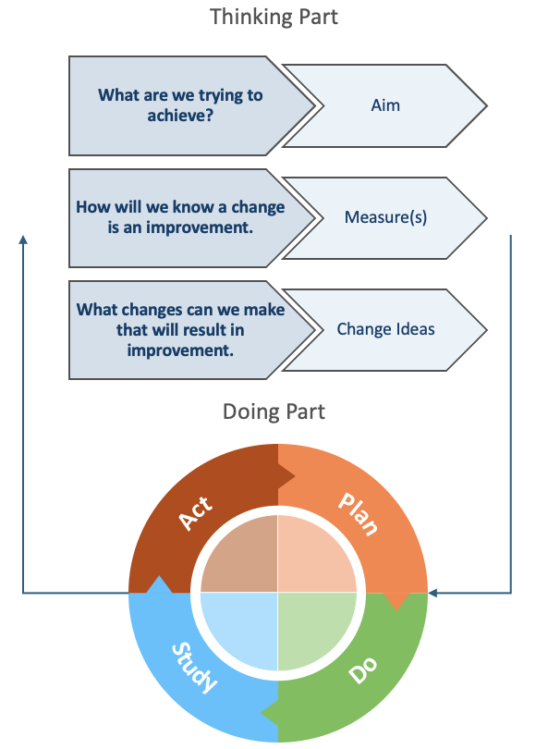
Step 1: Thinking Part - Model for Improvement
- AIM: What are we trying to accomplish? Develop a S.M.A.R.T. (Specific, Measurable, Attainable, Realistic, Time-bound) and people-crafted Aim Statement.
- MEASURE: How will we know that a change is an improvement? Identify what good looks like and develop a measure(s) of success.
- CHANGE IDEAS: What changes can we make that will result in an improvement? Engage the whole team in formulating change ideas using tools such as brainstorming, driver diagrams or process mapping. Each change idea may involve multiple small rapid PDSA cycles.
Step 2: Doing Part - Plan-Do-Study-Act (PDSA)
- PLAN: Describe the change idea (what, who, when, where). Predict outcomes and define the data to collect.
- DO: Carry out the plan. Collect data. Consider what worked well and why? Document any unexpected observations, events or problems.
- STUDY: Analyse results, compare them to predictions, and reflect on what you learned.
- ACT: Based on what you learned from the test, consider what you will do next (e.g., adopt, adapt or abandon)? How does this inform the plan for your next PDSA?
Source: Langley, G., Nolan, K., Nolan, T., Norman, C. & Provost, L. 1996, The Improvement Guide, Jossey-Bass, San Francisco, USA

1.1 Quality Improvement Template

Practice name: | Add your primary healthcare service name here | Date: | Add date of commencement here
QI team: | List the team members involved
Problem: | Describe why this work is strategically important. What problem is the team addressing? What does our data indicate about it, and what are the causes?
Problem Statement: | Document your succinct problem statement here
Once you have completed the QI template, move onto the Model for Improvement (the Thinking Part)
For guidance and support on conducting quality improvement in your primary healthcare services, please contact your Regional Manager, Healthy North Coast.

Appendix 2.1 - Model for Improvement Template

Step 1: Thinking Part - Three Fundamental Questions
Complete the Model for Improvement (MFI) as a whole team.

AIM | - What are we trying to accomplish?
By answering this question, you will develop your GOAL for improvement. It important to establish a S.M.A.R.T (Specific, Measurable, Achievable, Relevant, Time bound) and people-crafted aim that clearly states what you are trying to achieve.
MEASURE(S) | - How will we know that a change is an improvement?
By answering this question, you will develop the MEASURE(S) you will use to track your overarching goal. Record and track your baseline measurement to allow for later comparison.
Tip: Use a Run Chart to plot trends.
Baseline: |  | Baseline date:
CHANGE IDEAS | - What changes can we make that will result in improvement?
By answering this question, you will develop IDEAS for change.
Tip: Engage the whole team in formulating change ideas using Institute for Healthcare Improvement QI tools such as brainstorming, driver diagrams or process mapping. Include any predictions and measure their effect quickly.
Idea 1
Idea 2
Idea 3
Idea 4
Idea 5 | Add other rows if needed.
Next steps: | Each idea may involve multiple short and small PDSA cycles.
Once you have completed the Model for Improvement, shortlist your ideas and start to put them into action using the Plan-Do-Study-Act (PDSA) cycle to plan, test, and review changes.

Appendix 2.2 - PDSA (Plan-Do-Study-Act) Template

Step 2: Doing Part - Plan-Do-Study-Act
Once you have completed the Model for Improvement (MFI), use the template below to document and track your PDSA cycles (i.e. small rapid tests of change).

Idea | Plan |  | Do | Study | Act
# | Plan the test | Prediction | Do the test on small scale | Analyse the results | Make a plan for next step
 | How will we run this test? Who will do it and when? What will we measure? | Prediction or hypothesis on what will happen. | Was the plan completed? Yes or No. Collect data. Consider what worked well and why? Document any unexpected observations, events or problems. | Analyse results, compare them to predictions, and reflect on what you learned. | Based on your learnings from the test, what will you do next (e.g., adopt, adapt or abandon)? How does this inform the plan for your next PDSA?
Change idea 1.1 | Specify
 | Keep adding rows and cycles as needed.
Change idea 1.2 | Introduce a new change idea is required.
 | Keep adding rows and cycles as needed.
Summary of Results

Appendix 3: Example MFI and PDSAs

3.1. MFI and PDSA - Identifying Active Patients & Linking to MyMedicare Program

  - Model for Improvement
15
Step 1: Thinking Part - Three Fundamental Questions
Complete the Model for Improvement (MFI) as a whole team.

AIM | - What are we trying to accomplish?
By answering this question, you will develop your GOAL for improvement. It important to establish a S.M.A.R.T (Specific, Measurable, Achievable, Relevant, Time bound) and people-crafted aim that clearly states what you are trying to achieve.
Improve the accuracy of active patient identification and ensure 10% of eligible active patients are registered for the MyMedicare program within the next six months.
MEASURE(S) | - How will we know that a change is an improvement?
By answering this question, you will develop the MEASURE(S) you will use to track your overarching goal. Record and track your baseline measurement to allow for later comparison.
Tip: Use a Run Chart to plot trends.
Percentage of active patients identified who are successfully registered with MyMedicare.
Baseline: | 4000 active patients and 50 registered with MyMedicare | Baseline date: | 10/11/2023
CHANGE IDEAS | - What changes can we make that will result in improvement?
By answering this question, you will develop IDEAS for change.
Tip: Engage the whole team in formulating change ideas using tools such as brainstorming, driver diagrams or process mapping. Include any predictions and measure their effect quickly.
Idea 1 | Extract a list of patients flagged as active patients who are not registered for MyMedicare.
Idea 2 | Engage with staff to verify patient records (e.g., contact patients to confirm activity status and preferred GP).
Idea 3 | Ensure patients are properly registered with MyMedicare and that their records are accurate.
Idea 4 | Incorporate MyMedicare enrolment discussions during patient contact and pre-plan for upcoming appointments
Next steps: | Each idea may involve multiple short and small PDSA cycles.
  - PDSA (Plan-Do-Study-Act)
Step 2: Doing Part - Plan-Do-Study-Act
Once you have completed the Model for Improvement (MFI), use the template below to document and track your PDSA cycles (i.e. small rapid tests of change).

Idea | Plan |  | Do | Study | Act
# | Plan the test | Prediction | Do the test on small scale | Analyse the results | Make a plan for next step
Change idea 1.1 | Practice Manager to extract a list of patients flagged as active patients who are not registered for MyMedicare by 1/07/25. Prediction: there will be patients that are inactive. | Completed on 1/1/23 | Conduct the first round of active patient verification for 50 patients and 10 were inactive as predicted. 15 were enrolled but MyMedicare status was missing. Update records to correct status and register them for MyMedicare. | Conduct a bulk archive of inactive patients. Bulk import MyMedicare enrolments to PMS instead of manual/ per patient.  Incorporate MyMedicare enrolment discussions during patient contact and pre-plan for upcoming appointments | Practice Manager to extract a list of patients flagged as active patients who are not registered for MyMedicare by 1/09/25. Prediction: there will be patient that are inactive.
1.2 | Conduct a bulk archive of inactive patients Prediction: need to do this regularly.
Change idea 1.2 | Incorporate MyMedicare enrolment discussions during patient contact Prediction: some staff will not be comfortable with inviting patients to register
 | Keep adding rows and cycles as needed.
Summary of Results

3.2 MFI and PDSA - Correcting Missing Demographic Information
  - Model for Improvement
Step 1: Thinking Part - Three Fundamental Questions
Complete the Model for Improvement (MFI) as a whole team.
AIM | - What are we trying to accomplish?
By answering this question, you will develop your GOAL for improvement. It important to establish a S.M.A.R.T (Specific, Measurable, Achievable, Relevant, Time bound) and people-crafted aim that clearly states what you are trying to achieve.
Reduce the number of patient records with missing or incorrect demographic information (age, sex, and duplicate records) by 250% within three months, while promoting MyMedicare enrolment.

MEASURE(S) | - How will we know that a change is an improvement?
By answering this question, you will develop the MEASURE(S) you will use to track your overarching goal. Record and track your baseline measurement to allow for later comparison.
Tip: Use a Run Chart to plot trends.
Percentage of corrected records regarding age, sex, and elimination of duplicates, including enrolment status for MyMedicare.

Baseline: | 6 duplicate records, 4 missing age and 1 missing gender.  50 MyMedicare enrolled | Baseline date:
CHANGE IDEAS | - What changes can we make that will result in improvement?
By answering this question, you will develop IDEAS for change.
Tip: Engage the whole team in formulating change ideas using tools such as brainstorming, driver diagrams or process mapping. Include any predictions and measure their effect quickly.
Idea 1 | Audit 200 patient records to identify missing or incorrect age, sex, and duplicates or use a data extraction tool (e.g. Primary Sense or CAT4 data cleansing report)
Idea 2 | Engage front desk and clinical staff to fill in or update missing details.
Idea 3 | Remove duplicate records by merging data.
Idea 4 | During this process, ensure eligible patients are informed about and enrolled in the MyMedicare program.
Next steps: | Each idea may involve multiple short and small PDSA cycles.
  - PDSA (Plan-Do-Study-Act)
Step 2: Doing Part - Plan-Do-Study-Act
Once you have completed the Model for Improvement (MFI), use the template below to document and track your PDSA cycles (i.e. small rapid tests of change).

Idea | Plan |  | Do | Study | Act
# | Plan the test | Prediction | Do the test on small scale | Analyse the results | Make a plan for next step
Change idea 1.1 | Audit 200 patient records to identify missing or incorrect age, sex, and duplicates or use a data extraction tool (e.g. Primary Sense or CAT4 data cleansing report). Prediction: there will be patient that are incomplete record due to booking system. | Completed on 1/7/25 | Perform audits and update records for the initial 200 patients, including enrolling those who are eligible for MyMedicare. 11 were incomplete records as predicted. 15 were enrolled but MyMedicare status was missing. Update records to correct status and register them for MyMedicare. | Engage front desk and clinical staff to fill in or update missing details.  Incorporate MyMedicare enrolment discussions during patient contact and pre-plan for upcoming appointments | Audit 200 patient records to identify missing or incorrect age, sex, and duplicates or use a data extraction tool (e.g. Primary Sense or CAT4 data cleansing report). Prediction: there will be patient that are incomplete record due to booking system.
Change idea 1.2 | Engage front desk and clinical staff to fill in or update missing details.  Prediction: staff at get busy and forgot to capture missing info.
 | Introduce a new change idea is required.
 | Keep adding rows and cycles as needed.
Summary of Results

3.3 MFI and PDSA – Accurate Recording of Demographic Data and Lifestyle Risk Factor
  - Model for Improvement
Step 1: Thinking Part - Three Fundamental Questions
Complete the Model for Improvement (MFI) as a whole team.

AIM | - What are we trying to accomplish?
By answering this question, you will develop your GOAL for improvement. It important to establish a S.M.A.R.T (Specific, Measurable, Achievable, Relevant, Time bound) and people-crafted aim that clearly states what you are trying to achieve.
Ensure 80% of active patients have their life risk factors <e.g. smoking, alcohol, height, weight, waist measurement and BP> recorded accurately within six months, and that these factors are integrated into MyMedicare enrolment processes.
MEASURE(S) | - How will we know that a change is an improvement?
By answering this question, you will develop the MEASURE(S) you will use to track your overarching goal. Record and track your baseline measurement to allow for later comparison.
Tip: Use a Run Chart to plot trends.
Percentage of active patient records containing complete life risk factors in the past 6 month, with cross-checks against MyMedicare registration.
Baseline: | - Active patients = 4000  - BP (recorded <6month) = 500  - MyMedicare enrolled = 50 | Baseline date: | 1/7/2025
CHANGE IDEAS | - What changes can we make that will result in improvement?
By answering this question, you will develop IDEAS for change.
Tip: Engage the whole team in formulating change ideas using tools such as brainstorming, driver diagrams or process mapping. Include any predictions and measure their effect quickly.
Idea 1 | Review 500 patient records to identify gaps in life risk factors.
Idea 2 | Update any missing information during the patient's next appointment.
Idea 3 | Discuss MyMedicare enrolment with eligible patients during consultations.
Idea 4 | Review 500 patient records to identify gaps in life risk factors.
Next steps: | Each idea may involve multiple short and small PDSA cycles.

  - PDSA (Plan-Do-Study-Act)
Step 2: Doing Part - Plan-Do-Study-Act
Once you have completed the Model for Improvement (MFI), use the template below to document and track your PDSA cycles (i.e. small rapid tests of change).

Idea | Plan |  | Do | Study | Act
# | Plan the test | Prediction | Do the test on small scale | Analyse the results | Make a plan for next step
Change idea 1.1 | Practice Nurse to review 500 patient records using a selected data extraction tool to identify gaps in life risk factors. Prediction: low rates are due to no proactive reminder system | Completed on 1/7/25 | Practice Nurse to review 500 patient records only 100 patients had BP recording done in the past 6month. 15 were found to be inactive patients. | Create prompts/action for clinicians to record life risk factors during consultations.  Put a bright label on BP machine as a visual prompt for staff to record BP. | Practice Nurse to review 500 patient records using a selected data extraction tool to identify gaps in life risk factors. Prediction: low rates are due to no proactive reminder system
Change idea 1.2 | Put a bright label on BP machine as a visual prompt for staff to record BP.  Prediction: effective visual prompt
 | Keep adding rows and cycles as needed.
Summary of Results

3.4 MFI and PDSA – Data Coding Accuracy for Chronic Conditions
  - Model for Improvement
Step 1: Thinking Part - Three Fundamental Questions
Complete the Model for Improvement (MFI) as a whole team.

AIM | - What are we trying to accomplish?
By answering this question, you will develop your GOAL for improvement. It important to establish a S.M.A.R.T (Specific, Measurable, Achievable, Relevant, Time bound) and people-crafted aim that clearly states what you are trying to achieve.
Ensure that 95% of patients with chronic conditions (e.g. diabetes, hypertension, COPD) have correctly coded conditions in their medical records within the next six months, with a focus on MyMedicare enrolment.

MEASURE(S) | - How will we know that a change is an improvement?
By answering this question, you will develop the MEASURE(S) you will use to track your overarching goal. Record and track your baseline measurement to allow for later comparison.
Tip: Use a Run Chart to plot trends.
Percentage of patient records with correctly coded chronic conditions (e.g. diabetes, hypertension, COPD), and the proportion of these patients enrolled in MyMedicare.

Baseline: | - Active patients = 4000  - Coded Diabetes = 200  - Indicated diabetes and not diagnosed = 150  - MyMedicare enrolled = 50 | Baseline date:
CHANGE IDEAS | - What changes can we make that will result in improvement?
By answering this question, you will develop IDEAS for change.
Tip: Engage the whole team in formulating change ideas using tools such as brainstorming, driver diagrams or process mapping. Include any predictions and measure their effect quickly.
Idea 1 | Identify a cohort of patients with diabetes, and review for coding accuracy
Idea 2 | Train clinical staff on best practices for chronic condition coding
Idea 3 | Include MyMedicare enrolment as part of the coding review process.
Idea 4 | Add other rows if needed.
Next steps: | Each idea may involve multiple short and small PDSA cycles.
PDSA (Plan-Do-Study-Act)
Step 2: Doing Part - Plan-Do-Study-Act
Once you have completed the Model for Improvement (MFI), use the template below to document and track your PDSA cycles (i.e. small rapid tests of change).

Idea | Plan |  |  | Do | Study | Act
# | Plan the test |  | Prediction | Do the test on small scale | Analyse the results | Make a plan for next step
Change idea 1.1 |  | Identify a cohort of patients with diabetes, and review for coding accuracy Prediction: inconsistent coding and free-text of conditions | Completed on 1/7/25 | Principal GP to review 150 patients with indicated and not diagnosed patients. The majority 80 patients have pre-diabetes and 45 were overdue for a HBA1C test. 5 were inactive patients. 10 were on metformin relating to polycystic ovary syndrome, 20 were incorrectly coded and the remaining 35 patient were provided to other GPs for investigation. | Schedule a clinician meeting to create a uniform coding for diabetes and update clinical coding policy. Invite PHN to present to your team on the importance of clinical coding | Identify a cohort of patients with diabetes, and revie for coding accuracy Prediction: inconsistent coding and free-text of conditions
Change idea 1.2 |  | Schedule a clinician meeting to create a uniform coding for diabetes and update clinical coding policy. | Clinical meeting held 14/7/25 | 5 out of 7 GPs attend this meeting. 3 of the GPs were not aware of comment and provisional diagnosis fields and therefore have been free-texting diagnosis. Reason for visit was also defaulting to add to patient history due to BP preference settings. This was fixed for all GPs. | PMs preference settings to be fixed for all GPs to not enforce reason for visit to be added automatically to patient history. | Schedule a clinician meeting to create a uniform coding for diabetes and update clinical coding policy.
Summary of Results

3.5 MFI and PDSA – Team awareness, desire and readiness
  - Model for Improvement
Step 1: Thinking Part - Three Fundamental Questions
Complete the Model for Improvement (MFI) as a whole team.

AIM | - What are we trying to accomplish?
By answering this question, you will develop your GOAL for improvement. It important to establish a S.M.A.R.T (Specific, Measurable, Achievable, Relevant, Time bound) and people-crafted aim that clearly states what you are trying to achieve.
To increase awareness and understanding among the practice team about MyMedicare and Chronic Conditions Management (CCM) changes, while defining and documenting each team member’s roles and responsibilities. This will help build readiness for change and support sustainable implementation.
MEASURE(S) | - How will we know that a change is an improvement?
By answering this question, you will develop the MEASURE(S) you will use to track your overarching goal. Record and track your baseline measurement to allow for later comparison.
Tip: Use a Run Chart to plot trends.
- Team members can describe the purpose and benefits of MyMedicare and CCM changes.
- Documented and agreed team roles and responsibilities.
- Feedback from the team shows increased confidence and clarity.
- Team reflects on the process and adapts based on shared learnings.
Baseline: |  | Baseline date:
CHANGE IDEAS | - What changes can we make that will result in improvement?
By answering this question, you will develop IDEAS for change.
Tip: Engage the whole team in formulating change ideas using tools such as brainstorming, driver diagrams or process mapping. Include any predictions and measure their effect quickly.
Idea 1 | Hold a team meeting or lunch catch-up to communicate MyMedicare and CCM changes
Idea 2 | Share updates via email or in the staff room.
Idea 3 | Use talking points to explore MyMedicare benefits.
Idea 4 | Facilitate discussion around CCM changes and training needs.
Idea 5 | Define, document, and review team roles and responsibilities regularly.
Next steps: | Each idea may involve multiple short and small PDSA cycles.

PDSA (Plan-Do-Study-Act)
Step 2: Doing Part - Plan-Do-Study-Act
Once you have completed the Model for Improvement (MFI), use the template below to document and track your PDSA cycles (i.e. small rapid tests of change).

Idea | Plan |  | Do | Study | Act
Change idea # | Plan the test | Prediction | Do the test on small scale | Analyse the results | Make a plan for next step
1.1 Introducing MyMedicare to the Team | raise awareness about MyMedicare across the practice team.  - Organise a 15–30 min team meeting or informal lunch session.  - Share talking points and benefits of MyMedicare beforehand.  - Pose open questions for discussion.  Who: Practice manager and GP lead  When: Week 1  Where: Staff meeting room | Was the plan completed? Yes or No. Document any unexpected events or problems | Held the meeting, provided handouts, and facilitated discussion on MyMedicare benefits and how it may impact the practice. | - Team showed interest but had questions about patient eligibility and enrolment.  - Some team members unaware of how it aligns with the practice’s current strategy.  - Quick post-meeting feedback collected showed 80% of attendees found the session useful. | - Plan a follow-up FAQ session.  - Add a MyMedicare summary to the practice resource folder.  - Ensure key updates are emailed post-session.
Change idea 1.2  Defining and Documenting Team Roles | Clearly define and document each team member’s role in CCM and MyMedicare.  Plan:  - Use provided role template.  - Hold short 1:1 discussion with each staff member or in a small team huddle.  - Document and share consolidated roles with the team.  Who: Practice manager  When: Week 2–3  Where: In-practice meetings |  | Met with all team members. Used the role template to draft roles and responsibilities. Shared draft with staff via email for feedback. | - Most team members appreciated the clarity.  - A few roles needed adjusting after real-world testing.  - Team identified gaps in CCM training during reflection. | - Schedule 4-week check-in to reflect on roles.  - Organise a short training session on CCM planning.  - Update and re-share finalised roles document.
Summary of Results


3.6 MFI and PDSA - Patients eligible for chronic disease management planning or review
Activity goal | Identify MyMedicare eligible patients with diabetes, chronic vascular disease or chronic kidney disease who are eligible for GPMP/TCA.
QI lead & team | Who will need to be involved?
Start date | Start date | End date | end date

3.7 MFI and PDSA – Patients with chronic conditions – Diabetes
Activity goal | As there are a range of conditions that could fall under this group, here are examples to help identify MyMedicare eligible patients within the diabetes cohort.
QI lead & team | Who will need to be involved?
Start date | Start date | End date | end date

3.8 MFI and PDSA – Patients with a management plan billed in the past 12 months
Activity goal | Identify MyMedicare eligible patients with diabetes have had a GPMP/TCA / Review
QI lead & team | Who will need to be involved?
Start date | Start date | End date | end date


3.9 MFI and PDSA – Patient Engagement and Reminders
Activity aim | Develop and apply systems for patient recalls and reminders to enhance in MyMedicare registration , Management planning and the importance of frequent reviews to enhance chronic conditions management..
QI lead & team members | Who will need to be involved?
Start date | Start date | End date | end date

For the above example MFI and PDSA topic ideas, use the templates in Appendix 2.

3.10 MFI and PDSA - Reducing Missed Appointments

Step 2: Doing Part - Plan-Do-Study-Act (Once you have completed the Model for Improvement (MFI), use this template to document and track your PDSA cycles)
Idea | Plan |  | Do | Study | Act
# | Plan the test | Prediction | Do the test  on small scale | Analyse the results | Make a plan  for next step
1.1 | Establish a structured follow-up process for missed appointments, including phone calls and letters. |  | - BP  - Pracsoft  - Cubiko
1.2 | Assign a nurse or admin staff to track and rebook missed chronic condition management reviews
2.1 | Identify patients at risk of disengagement and develop targeted strategies (e.g., GoShare). |  | - GoShare Diabetes Management plan
2.2 | Create patient-centred goals with more frequent reviews i.e. weight management, lifestyle, mental health, chronic pain, blood glucose levels, smoking cessation |  | - 2KG Challenge  - CAT4 Physical activity  - CAT4 Mental Health  - CAT4 Chronic Conditions  - CAT4 Smoking cessation
Summary of results

Appendix 4 - Claiming workflow - Management plan (GPCMMP 965 or 92029)

CCM services may be provided more frequently in exceptional circumstances. Exceptional circumstances exist for a patient if there has been a significant change in the patient’s clinical condition or care requirements that necessitates the performance of the service for the patient.

Appendix 5- Claiming workflow Management plan Review (GPCCMP Review Appointments)


This resource has been created as part of the National MyMedicare PHN Implementation Program in partnership with National Improvement Network Collaborative (NINCo) Stream 3.


Level 1, 14 Edgewater Court Robina QLD 4226 | PO Box 3576, Robina Town Centre QLD 4230
P 07 5635 2455 | E ninco@gcphn.com.au | W www.ninco.com.au
Copyright 2025. Primary Care Gold Coast Limited (ABN 47 152 953 092), trading as National Improvement Network Collaborative.
All rights reserved. Content is correct at time of publication.
National Improvement Network Collaborative (NINCo) gratefully acknowledges the financial and other support from the Australian Government Department of Health. While the Australian Government Department of Health has contributed to the funding of this material, the information contained in it does not necessarily reflect the views of the Australian Government and is not advice that is provided, or information that is endorsed by the Australian Government. The Australian Government is not responsible in negligence or otherwise for any injury, loss or damage however arising from the use or reliance on the information provided herein.
23042024/23042025

