National Guidelines for doctors
managing workers exposed to
respirable crystalline silica
with specific reference to the occupational
respiratory diseases associated with engineered stone

Disclaimer
These Guidelines are a general guide to appropriate practice, to be followed subject to the clinician’s judgements and the patient’s preference in each individual care. The Working Group acknowledges that there is continuing debate in the literature on definitions. The primary role of the Working Group was to develop Guidelines that provide information to assist decision-making, where necessary to clarify create definitions based on current knowledge and consensus as experts in the field, and to guide regulators concern potential reforms to the laws. The recommendations included within these Guidelines are based on the expert consensus using the best evidence available at the time of development.
Citation
Dust Disease Taskforce Working Group. National Guidelines for doctors managing workers exposed to respirable crystalline silica – with specific reference to the occupational respiratory diseases associated with engineered stone. Available on the Dust Taskforce Website (https://www1.health.gov.au/internet/main/publishing.nsf/Content/ohp-nat-dust-disease-taskforce.htm)
Source of funding
Development of these Guidelines was supported by the Australian Government Department of Health. The development of the final recommendations has not been influenced by the views of interest of the funding body.

Table of Contents
Glossary vi
Acknowledgments viii
National Guidelines for doctors managing workers exposed to respirable crystalline silica: Guideline Summary 10
Introduction 12
Scope of the Guidelines 13
Target audience 14
Occupational respiratory diseases 15
Occupational respiratory diseases 16
Epidemiology of silicosis 18
Pathophysiology of silicosis 19
Classification of silicosis 20
Acute silicosis 23
Accelerated silicosis 23
Chronic silicosis 24
Complicated variants 24
Artificial stone silicosis 24
Exposure to RCS and silicosis 25
Enhanced progression with continued exposure to RCS 25
Progression in the absence of further exposure to RCS 25
Prevention of occupational respiratory disease 27
Primary prevention 28
Secondary and tertiary prevention 28
Statutory obligations of the PCBU – Is the workplace safe? 29
The supervising medical practitioner and health monitoring 30
Guidelines 31
(i) Case identification practices 32
(ii) Ongoing health surveillance 33
Case identification 34
1. How to identify a person of interest and refer them to the appropriate medical practitioner? 35
2. How to carry out an initial assessment? 36
A. What baseline data should be collected? 37
B. Exposure stratification 38
C. Lung function stratification 38
D. Diagnostic imaging 42
E. Other investigations 44
3. When should psychosocial support and education to prevent disease or disease progression be provided? 45
Ongoing health surveillance 47
4. When should routine health surveillance be carried out? 47
5. Who carries out ongoing surveillance for the person? 52
6. What are the notification requirements? 54
Future Research 55
Appendices 56
Appendix A: Exposure dose questionnaire 57
Appendix B: Shared decision making tool 58
Appendix C: Form report example 60
References 62

Tables
Table 1: The different categories of silicosis 21
Table 2: Prevention of silicosis 27
Table 3: Recommended action thresholds 40
Table 4: Criteria used in clinical practice to assess disease progression in fibrotic interstitial lung disease 49
Table 5: Surveillance schedule following first diagnosis based on risk of progression 50
Table 6: Surveillance schedule based on the Exposure Index of a person who has normal baseline results and has left the industry (no predictable continuing exposure to RCS) 51

Figures
Figure 1: Different types of rock and rock products and their typical percentage of silica 19
Figure 2: Steps to identify the appropriate referral pathway 34
Figure 3: Steps for initial assessment of a worker or person exposed to RCS 36
Figure 4: Baseline data to collect 37

Abbreviations

ACE | Angiotensin converting enzyme
AFOEM | Australasian Faculty of Occupational and Environmental Medicine
BTS | British Thoracic Society
CI | Confidence interval
CT | Computerised tomography
CXR | Chest X-ray
DLCO | Diffusion capacity of the lung for carbon monoxide
FGF | Fibroblast growth factor
FVC1 | Forced vital capacity in one second
FVC | Forced vital capacity
GLI | Global Lung Function Initiative
GP | General Practitioners
HRCT | High-resolution computed tomography
ICORED | International Classiﬁcation of HRCT for Occupational and Environmental Respiratory Diseases
ILD | Interstitial lung disease
ILO | International Labour Organization
LLN | Lower limit of the normal
MDT | Multidisciplinary teams
MRC | Medical Research Council
NHMRC | National Health and Medical Research Council
NIOSH | National Institute for Occupational Safety and Health
OEM | Occupational and environmental medicine
OR | Odds ratio
OSHA | Occupational Safety and Health Administration
PCBU | Person conducting a business or undertaking
PMF | Progressive massive fibrosis
PPE | Personal Protective Equipment
RACP | Royal Australasian College of Physicians
RANZCR | Royal Australian and New Zealand College of Radiologists
RCS | Respirable crystalline silica
SMP | Supervising medical practitioner
SPIROLA | Spirometry Longitudinal Data Analysis
SSN | Sub-solid nodules
TNF | Tumour necrosis factor
TSANZ | Thoracic Society of Australia and New Zealand
TWA | Time weighted average
UFP | Ultra fine particles
WES | Workplace exposure standard
WHS | Work Health and Safety

Glossary
Artificial stone | A historic term used to describe the composite stone-like material created by a variety of manufacturing processes that includes crystalline silica and/or silicates. Also known as Engineered (the preferred term), Manufactured or Composite Stone.
“At-risk role” | The specific occupations of concern.
Best practice | The best standards of practice based on what others are already doing.
Case identification (also known as case finding) | A strategy for targeting resources at individuals or groups who are suspected to be at-risk for a particular disease. It involves actively searching systematically for at-risk people, rather than waiting for them to present with symptoms or signs of active disease.
Contact tracing | The process of identifying, assessing and managing people who have been similarly exposed to those people with diagnosable disease.
Occupational respiratory disease | A generic term used in this context to mean a disease associated with hazardous exposure via the respiratory system. While traditionally associated with the visible dusts, in this context it is used to describe any inhalable substance.
Engineered stone | The preferred term used to describe artificial stone.
Health-risk behaviour | Any behaviour or action with potentially negative effects on health.
Health monitoring | The monitoring of a worker to identify changes in their health status because of exposure to specific hazardous substances in the workplace. It is a statutory requirement where, in the Australian setting, the level of clinical and biological monitoring may be limited by law. It is separate from, but often overlaps with “health surveillance”.
Health (or medical) screening | A systematic method of detecting risk factors or suspicious abnormalities among people who are symptom-free, so that health problems can be either prevented or followed up, diagnosed and treated as early as possible.
Health surveillance | A broad concept which describes the ongoing surveillance in clinical practice after a case has been identified. When compared to health monitoring, it is more encompassing of a person’s health and wellbeing when compared to health monitoring. Health surveillance is not dependent on occupation related funding.
Informed consent | Informed consent is a person’s decision, given voluntarily, to agree to a health care treatment, procedure or other intervention that is proposed by their medical practitioner after receiving accurate and relevant information about the intervention, and understands the benefits and risks of the options available.
Lag | Time between first detectable disease and when the disease has progressed significantly to influence deployment and treatment options.
Latency | Diseases characterised by a long interval between first exposure and first detectable disease (clinically or by specific investigation).
Medical practitioner | Refers to any GP, respiratory specialists, occupational physician, thoracic surgeon or suitably qualified doctor.
Next best practice | The anticipated future next best practice; based on the trending of “best practice” and what is anticipated to be the next “best practice”. It requires a commitment to leadership, continued improvement based on the evolving body of evidence.
Respirable crystalline silica | A generic term to describe silica and silicate dust particles that can reach the alveoli region of gas exchange in the lung. They typically have an aerodynamic diameter less than 10micrometres. Their mean particle size is less than 5.0 um and significant toxicity is associated with particles less than 1-2 um.
Respiratory (health) surveillance | The process whereby a group of exposed workers are regularly tested to ensure that they are not developing respiratory diseases that are known to be associated with specific work exposures.
Silicosis | A parenchymal fibrotic lung condition caused by the inhalation of respirable crystalline silica dust.
WES Excursions | Periods when there is a transient exceedance of the WES for a short duration, cumulatively usually less than 30 minutes, that would not otherwise be detected by time weighted averaging.

Acknowledgments
National Dust Disease Taskforce Working Group members:
Member name | Organisational affiliations | Position | Role in the Working Group
Professor Fraser Brims | Sir Charles Gairdner Hospital, Western Australia | Consultant Physician Respiratory Medicine | Independent clinical expert
 | Curtin University Medical School | Director of Early Years Clinical Skills
 | Institute for Respiratory Health | Deputy Director
 | Western Australian Mesothelioma Registry | Chair
 | National Dust Disease Taskforce | Member
Professor Dan Chambers | Prince Charles Hospital, Queensland | Consultant Physician Thoracic & Transplant Medicine | Independent clinical expert
 | St Vincent's Private Hospital, Queensland
 | International Lung and Heart-lung Transplant Registry | Associate Director
Dr David Deller | Gold Coast Respiratory and Sleep Clinic, Queensland | Consultant Physician Respiratory and Sleep Medicine | Independent clinical expert
Dr Graeme Edwards | Work and Health Risk Management, Queensland | Consultant Physician, Occupational and Environmental Medicine | Working Party Chair  Independent clinical expert
 | National Dust Disease Taskforce | Member
 | Royal Australasian College of Physicians – Australasian Faculty of Occupational and Environmental Medicine | Clinical Lead - Silicosis
Dr Ryan Hoy | Cabrini Malvern Medical Centre, Victoria | Consultant Physician Respiratory and Sleep Medicine | Independent clinical expert
 | Monash University | Principal Investigator
 | National Dust Disease Taskforce | Member
Dr Catherine Jones | I-Med Radiology Network | Specialist Chest Radiologist, Cardiac and Thoracic Imaging | Independent clinical expert
 | Royal Australian and New Zealand College of Radiologists - Thoracic Radiology Special Interest Group, | Executive Member of their
Dr Rosemarie Knight | The Work Doctor, Queensland | Consultant Physician, Occupational and Environmental Physician | Independent clinical expert
Associate Professor Deborah Yates | St Vincent’s Hospital, New South Wales  University of New South Wales | Consultant Physician Respiratory Medicine | Independent clinical expert
Dr Catherine Kelaher | Office of Health Protection, Australian Government Department of Health | Principal Medical Adviser | Representative of the Medical Scientific and Advisory Unit, of the Office of Heath Protection and Response, Department of Health
Ms Jackii Shepherd | Safe Work Australia | Director, Occupational and Hygiene Policy | National policy perspective
Ms Katherine Stone | icare New South Wales | Head of Specialist Care Delivery | State-based policy perspective
Ms Nicola Wojcik | WorkSafe Victoria | Manager, Strategic Health Programs, Innovation & Insights | State-based policy perspective

Organisations or participants who were involved in consultations:

National Guidelines for doctors managing workers exposed to respirable crystalline silica: Guideline Summary
This Guideline has been developed to provide Australian medical practitioners with the best available evidence to guide their practice when identifying people at-risk from respirable crystalline silica (RCS) exposure and carrying out health surveillance. While these Guidelines are focused on RCS, it is structured as a framework for the assessment of any worker with occupational dust exposure.
Case identification and health surveillance of dust disease

1. How to identify a person of interest and refer them to the appropriate medical practitioner?
- Use the referral steps to identify an appropriate medical practitioner.  - Contact the supervising medical practitioner (SMP) (if they have one) with consent.  - Refer to a respiratory physician if someone has significant respiratory or a change in symptoms. | - Use the exposure assessment tool for patients with unclear or minor symptoms and no SMP.  - For workers exposed for less than one year, educate and reinforce safe work practices.
Supervising medical practitioner
- The SMP can coordinate the health monitoring activity and facilitate the exposure assessment for the worker.

2A. What baseline data should be collected for case identification?
- Collect demographic, exposure and medical history, respiratory symptoms and physical examination findings. | - With the person’s consent, upload the information on their My Health Record.

2B. How to determine a person’s exposure risk?
- If you are confident and experienced, carry out the exposure assessment.
Respiratory physician and occupational physicians
- Use the exposure assessment tool for patients exposed to RCS.

2C. Who should receive lung function testing and how?
Respiratory physician and occupational physicians
- All workers exposed to RCS should have spirometry testing performed to TSANZ standards.  - Review the patient if any of the forced expiratory volume in one second (FEV1) thresholds are met.  - Spirometry testing should be carried out every 6 to 12 months if results are below 80% of the Global Lung Function Initiative (GLI) predictive values. | - Consider a diffusion capacity of the lung for carbon monoxide (DLCO) test for all high-risk workers.  - DLCO must be performed at an accredited lab.  - Workers with a change in DLCO of more than 15% between screenings should be referred for HRCT.  - Refer to a respiratory physician if there is a 10% reduction in DLCO in less than one year.

2D. What diagnostic imaging should be performed and when?
Respiratory physician and occupational physicians
- The International Labour Organization (ILO) classification of chest X-ray (CXR) itself should not be used to diagnose silicosis or access to statutory entitlements if an HRCT is consistent with the diagnosis. |  |  | - Request a high-resolution computerised tomography (HRCT) if the person has:  - had high or very high exposure; or an ILO CXR >0/1; or  - abnormal lung test findings; or  - significant respiratory or other symptoms.
Specialist radiologist
- The HRCT should be performed using as low a radiation dose as is practicable. |  | - Recommend the multidisciplinary team review the HRCT if there is any diagnostic uncertainty.

2E. Are there any other tests that need to be carried out?
Respiratory physician and occupational physicians
- All people should have a blood test to assist in diagnosing RCS related diseases or exclude other diagnoses.

3. When should psychosocial support be provided?
- Provide ongoing psychosocial support.  - Use the shared decision-making tool to discuss options to avoid further RCS exposure. | - Do not describe the person’s workplace as at-risk without a formal workplace assessment.  - All workers who choose to continue working in a high-risk occupation, should be supported and be monitored.

4. When should education be provided?
Targeted advice should be provided at each visit.  Consider the following important topics:  - Complying with safe work practices  - Importance of hygiene and cleanliness  - The possible adverse health effects related to significant exposure | - Correctly using personal predictive equipment (PPE)  - Fit checking and testing  - Being clean-shave if negative-pressure respirators are used  - Using powered air purified respirators when tight fitting respirators are unsuitable  - Stopping smoking.
Case identification and health surveillance of dust disease

5. When should routine health surveillance be carried out?
- Use the specific routine surveillance schedule for persons at low, medium and high-risk of disease progression.
- Use the specific routine surveillance schedule for persons with normal baseline test results and have left the industry or no longer exposed to RCS.
- For all people with low-risk of exposure to RCS, they should be surveyed for no less than 20 years. If they were or are a smoker they should have lifelong health surveillance.

6. Who should carry out ongoing surveillance for the person?
- The same specialist who conducted the baseline assessment should carry out surveillance.
- For a patient who is no longer employed in an “at-risk role”, the person’s GP should oversee any health surveillance activity.
Supervising medical practitioner
- The SMP must oversee any surveillance activity, for as long as the person is employed in an “at-risk role”.
- All SMPs responsible for the statutory health monitoring of a workplace should be publicly identifiable.

7. What are the notification requirements?
- With the person’s consent, findings and surveillance schedules should be provided to the GP and SMP as well as uploaded to the persons My Health Record.
Government
- Continue progressing the development of a National Occupational Respiratory Disease Registry.

Introduction

The past 15 years have seen the unexpected re-emergence of occupational respiratory diseases across Australia. Of particular concern is the recent resurgence of silicosis, a fibrotic lung condition caused by the inhalation of respirable crystalline silica (RCS) dust.
Silicosis is an incurable, potentially fatal disease but is entirely preventable.
An epidemic of accelerated silicosis has been linked to the cutting, grinding and polishing of engineered stone used commonly in modern kitchen and bathroom benchtops. This product contains a significantly higher percentage (>90%) of crystalline silica compared to natural stone (5-50%).
State and territory governments have implemented a range of activities aimed at addressing the respiratory health issues in this industry sector, including provision of guidance for assessing those at-risk. Most state governments have introduced clearer regulations to prohibit the uncontrolled dry cutting of engineered stone to protect workers from exposure to RCS dust.
In July 2019, the Australian Government Department of Health established the National Dust Disease Taskforce to inform a national approach to the prevention, early identification, control and management of occupational respiratory diseases in Australia (1).
The Taskforce will inform a national approach by undertaking an independent review of the systems in place to protect Australians who are at-risk from occupational respiratory disease.

This will include providing advice on:
- Actions that have been taken to date to address occupational respiratory disease across all Australian jurisdictions.
- Existing policy and regulatory arrangements in Australia to protect those at-risk from occupational respiratory disease, more specifically reviewing what controls are in place and how these are applied and monitored.
- Opportunities for improvement across the system to ensure protection of those at-risk populations.
- Options for sustainable approaches for the future prevention, detection and management of occupational respiratory diseases, including the consideration of the establishment of a National Occupational Respiratory Disease register, including its scope and anticipated outcomes.
- Options for potential new research required to support understanding, prevention and treatment of preventable occupational respiratory disease.
The objectives of the Taskforce are to identify ways to:
- Reduce incidence and severity of occupational respiratory diseases.
- Ensure availability of effective treatment.
- Reduce exposure through improved prevention, awareness and capacity building.
- Eliminate or minimise risks through better machinery and workplace design.
- Ensure appropriate control of potentially hazardous materials.
- Achieve better work health and safety (WHS) outcomes through improved regulation and compliance.
- Review the latest research on respiratory diseases and identify knowledge gaps.

Through consultations held across Australia, the Taskforce heard differing views on what the most appropriate health screening methods are, with many critical of the minimum health monitoring processes required under WHS Regulations. Common themes raised were the need for a more comprehensive understanding of the workplace, clearer exposure risk characterisation, clinical guidance and enhanced enforcement of safe work practices for those who remain in the industry sector.
In the engineered stonework sector, the Taskforce found that historically, health monitoring had not been undertaken. The lack of monitoring resulted in several workers being diagnosed with symptomatic, late-stage disease. The Taskforce also found inadequate or inappropriate health monitoring was being conducted in other industry sectors such as building and construction, mining, quarrying and tunnelling.
The Royal Australasian College of Physicians (RACP), the Thoracic Society of Australia and New Zealand (TSANZ), the Australasian Faculty of Occupational and Environmental Medicine (AFOEM), and the Royal Australian and New Zealand College of Radiologists (RANZCR) have all called for the development of National Guidelines for case identification and surveillance of at-risk populations for silicosis.
In its interim advice to the Minister for Health, the Taskforce recommended (early Recommendation 4) the development of national guidance on an active case finding approach to identify people at-risk from RCS dust exposure at the workplace (1).
Purpose of the Guidelines
The National Guidelines for doctors managing workers exposed to RCS (the Guidelines) are for medical practitioners managing workers exposed to RCS. They have been developed to enhance the medical practitioners understanding of the nature and complexity of the disease and provide key practice points with reference to:
- identifying people at-risk form RCS dust exposure; and
- carry out health surveillance within their specific training and experience.
The Guidelines should not be seen as an inflexible recipe; rather, they provide a guide to appropriate practice to be followed subject to clinical judgement and patient preferences.

Scope of the Guidelines
The Guidelines cover the most critical components and strategies to effectively identify people at-risk of disease from RCS dust exposure as well assess and manage people exposed to RCS in the workplace.
The following is out of scope for the Clinical Guidelines:
- Physician involvement in contact tracing of colleagues of an affected worker.
- Specific treatment of workers diagnosed with occupational respiratory diseases.
- Activity involving the medical practitioner in the process of identifying people who have been similarly exposures to an index case.

Target audience
The Guidelines are intended for use by registered medical practitioners collaboratively with their patients: GPs, Consultant Physicians in Occupational and Environmental Medicine and Respiratory Medicine, Researchers and Radiologists. This also includes any medical practitioner who has had a patient referred to them from a supervising medical practitioner (SMP).

Development
The Guidelines have been developed according to processes outlined by the National Health and Medical Research Council (NHMRC) under the direction of an interdisciplinary Working Group. Refer to the administration report that details the Interdisciplinary Working Group membership, process, consultations and terms of reference.
The literature referenced in this document is not intended to be a comprehensive evidence-based literature review but rather a selective reference to the relevant literature to inform the reader about the salient issues, what evidence is more readily available, the gaps in our knowledge, and the rationale for the recommendations. Consequently, these Guidelines and subsequent practice points were developed based on the evidence available and a consensus of clinicians actively managing workers afflicted by their exposure to RCS and other dusts.
Use
The primary goal of the Guidelines is to help medical practitioners work with their patients and actively identify people at-risk due to RCS dust exposure and carry out surveillance activities.
Guidelines differ from the clinical care or clinical pathway. Guidelines provide an overview of the current best evidence translated into clinically relevant statements or practice points. Care or clinical pathways, also known as critical pathways, care paths or case management plans, are based on best practice guidelines but provide a local link between the Guidelines and their application.
The Guidelines recommends shared decision-making processes for assessing the respiratory health of a worker with exposure to RCS dust. In addition, the Guideline identifies triggers for the appropriate referral for additional testing or investigations to reflect the person’s circumstances, subject to the clinician’s judgement and patient’s preferences.
In considering implementation..

Occupational respiratory diseases

Occupational respiratory diseases
Occupational respiratory diseases, both respiratory and non-respiratory, are in the vast majority, secondary to occupational exposures. Occupational dust exposure is known to be a significant yet underestimated cause of respiratory illness and long-term disablement in Australia (2).
People exposed to dust while at work may develop several diseases, many of which may lead to symptoms and abnormal clinical findings long after the original exposure has ceased. Once they occur, most have long lasting effects and can shorten a person’s life expectancy. The most common occupational respiratory diseases include:
- Silicosis due to RCS dust exposure
- Chronic obstructive pulmonary disease (COPD)
- Chronic bronchitis
- Emphysema
- Asbestos-related diseases
- Mining related dust pneumoconiosis such as coal mine dust (black lung), mixed dust pneumonoconiosis and diffuse dust related pulmonary fibrosis
- Other types of pneumoconioses caused by breathing in specific types of dust particles such as berylliosis (beryllium metal) and byssinosis (cotton bracts)
- Work-related asthma / occupational asthma
- Hypersensitivity pneumonitis – in which the lungs develop specific sensitivity to inhaled particles containing fungus, moulds or chemicals.
In addition to the lung parenchymal and airway spectrum of occupational respiratory diseases, other diseases associated with RCS include:
- Lung cancer
- Scleroderma and other autoimmune sequelae such as rheumatoid arthritis
- Chronic kidney disease.
To identify and support people with a potential occupational respiratory disease, requires an understanding of the pathophysiology of the disease as well as the social and organisational constructs within which the worker exists. The social and organisational factors that influence disease progression should be actively managed – both before and after disease detection.
The pathophysiology of occupational respiratory diseases in their established forms have been the subject of extensive research and many aspects are well understood. The most widely studied is silicosis. However, recently there has been an emergence of artificial stone related silicosis. This has created an urgent need and opportunity to learn more about the disease, learn from workers who have been exposed and minimise the risk of a life-threatening preventable disease from occurring in the future.
Identifying and monitoring the wellbeing and progression of the cohort of exposed workers creates strategic opportunities to learn from their experience for the benefit of others. Consequently, this Guideline is to be linked with the National Occupational Respiratory Disease Registry. This will enable future editions of this Guideline to benefit from evolving knowledge.
These diseases are characterised by a long interval between first exposure to the hazardous dust and first detectable disease (discovered clinically or by specific tests). This is interval is known as “latency”. While some factors such as intensity of exposure, cumulative dose and nature of the hazard are known to affect the length of latency, the specificity and sensitivity of tests used to detect the presence of the disease is also important. Overall, the longer the latency, the more difficult it becomes to identify the link between a hazardous exposure and the harm. This influences the frequency of health surveillance activity.
Lag also critically influences health surveillance protocols. Lag is the time between first detectable disease and when the disease affects occupational capacity, deployment and treatment options. During this period, the person may appear well but must manage any potential for further exposure that may influence disease progression, and their adjustment to a disease that will shorten their life.
For people with slowly progressing or inactive disease, preventing exposure to future hazardous exposures is important. This can be influenced by but is not dependent on the actions of medical practitioners. Provided the tests selected for health surveillance have sufficient sensitivity to detect the earliest clinically significant disease, combining WHS, health-risk prevention strategies with health surveillance activities conducted by medical practitioners, serves three functions:
- Identifying people who are the most vulnerable to disease due to their historic exposure while working within what are now-known as “unsafe work practices”.
- Reinforce the importance of compliance with safe systems of work. If the system is working, medical practitioners should not be detecting disease from recent exposure.
- Identify new outbreaks of disease associated with novel exposures, often involving changed or new industrial processes.
For an intervention to have the best chance of favourably influencing the outcome, early diagnosis is essential.
Recent experience has revealed that the traditional indices used (time since first exposure, spirometry, ILO chest radiographs or the presence of symptoms) has meant for some people, silicosis is already well established. At this stage, the opportunity for intervention to materially alter the person’s clinical course is under investigation.
Early detection of at-risk individual indices enables implementation of measures necessary to prevent, arrest and if possible reverse the progression of the disease.

Epidemiology of silicosis
Accurate assessment of the prevalence of occupational respiratory disease is difficult for many reasons. Silica and silicates are widely used in the large number of industrial applications. It is estimated that millions of workers are exposed to this mineral worldwide (3). However, the number of people who are at-risk of or affected by silicosis is currently unknown. This is primarily because of an inability to accurately record and pool relevant data collected by the various stakeholders involved – employers, doctors and regulators; time delays between exposure and diagnosis; and limited understanding of the relationship between exposure and disease (4).
The available data in Australia is from Queensland and Victoria. In Queensland, as at 30 November 2020, 1053 people working or have worked with engineered stone have been screened since the program was announced on 18 September 2018 (5). The program has identified 32 cases with progressive massive fibrosis (PMF) and 191 cases meeting the criteria for any other forms of silicosis. This creates a 20% crude prevalence for all forms of silicosis in this industry sector. Unfortunately, analysis of the cohort by exposure history, type of disease or the nature of any progression was not available. Additional data is anticipated from the “Respiratory Health Screening of Stonemasons in Victoria” established by WorkSafe Victoria in conjunction with Monash University.
Silica-related diseases are associated with significant premature mortality among workers of all ages (6, 7).
In the United States, between 1996 and 2005, 1746 deaths due to silica exposure resulted in 20 234 years of life lost, with an average of 11.6 years of life lost (8). For the same period, among 307 people who died before age 65, there were 3045 years of life lost, with an average of 9.9 years of life lost from a working life (9, 10).
The absence of a centralised registry to pool individual case-based data perpetuates the lack of knowledge and underpinned the National Dust Disease Taskforce’s recommendation to establish a National Occupational Respiratory Disease Registry in its interim report. In response, the Australian government has accepted the need for a National Occupational Respiratory Disease Registry in Australia.

Pathophysiology of silicosis
Silicosis is an irreversible pneumoconiosis typically (but not always) caused by high exposure to RCS dust. Silica, also known as silicon dioxide is a naturally occurring and widely abundant mineral that forms the major component of most rocks and soils. There are non-crystalline and crystalline forms of silicon dioxide.
The non-crystalline or amorphous forms of silica are not often associated with parenchymal lung damage (11), although pneumoconiosis has also been observed secondary to these exposures.
"Free" crystalline silica – also known as quartz, cristobalite, tridymite and tripoli – is unbound to other minerals. "Combined" forms of silica, called silicates, are compounds in which silica is bound to other minerals. Examples of silicates used in industry include asbestos (hydrated magnesium silicate), talc (Mg3Si4O10(OH)2), and kaolinite (Al2Si2O5(OH)4), a major component of kaolin (china clay) (8). Engineered stone has the highest percentage of silica (Figure 1). Aggregates mortar and concrete have various levels of silica present. All have been described as causing pneumoconiosis.
Figure 1: Different types of rock and rock products and their typical percentage of silica
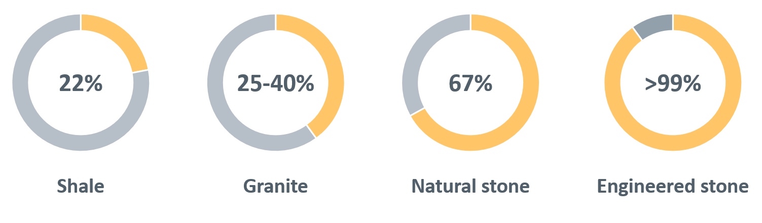
Silica dust is generated in the workplace by mechanical processes such as crushing, cutting, drilling, grinding, sawing or polishing of natural or man-made products containing silica.
Following aerosolisation, inhaled RCS dust particles (<10 μm aerodynamic diameter) can be carried to the distal airways and alveoli. Larger particles deposit on the muco-ciliary epithelium of the nose, throat and larger upper airways and therefore fewer reach the gas exchange regions of the lung to create the potential for harm.
Studies of dust composition (12) and explanted lungs have identified a consistent presence of sub-2 μm sized silica particles. Ophir, Shai (13) showed a possible association between ultrafine particles (UFP) (<1 µm) and poorer pulmonary function test results, worsening findings on computerised tomography (CT) and elevated inflammatory biomarkers. Freshly generated RCS dust is more toxic than aged dust particles (14, 15) and a growing body of evidence suggests surface area rather than RCS mass are important factors contributing to toxicity. Currently, the evidence is not at the level necessary to trigger revision of WES (16), but this is an area under continuing review. If these findings are substantiated by further research it will have a profound impact on our understanding, measuring and controlling the hazard. For example, we know that higher speed mechanical cutting devices create much smaller particles when fracturing crystalline quartz in the substrate. The composition of engineered stone appears to enhance the hazard. Therefore, in addition to using wet processes and local exhaust ventilation to limit respirable dust, equipment may need to be speed limited.
Once in the respirable zone of the lung, the silica particles are engulfed by alveolar macrophages (14) and several pro-inflammatory and profibrotic pathways are activated (4, 13, 17).
Interleukin (IL)-1 is secreted directly by macrophages and indirectly after activation of toll-like receptors. This enhances the production of IL-1, tumour necrosis factor (TNF), caspase-1, and fibroblast growth factor (FGF).
Modulation of the nucleotide-binding domain (NOD)-like receptor protein 3 (NALP3) protein inflammasomes induces regulatory T cells to express cytotoxic T-lymphocyte antigen 4, IL-10, and transforming growth factor-beta (TGF-β). This process occurs independently of lymphocyte interaction (18). Inflammasome activation also occurs in alveolar macrophages.
The affected macrophages undergo cell necrosis, autophagy and the release of non-degraded intracellular silica and/or silicates. If the cumulative silica load is sufficient to overcome the host’s clearance mechanisms, early alveolar air space, parenchymal and lymphatic changes will result. It is these changes which cause the centrilobular ground glass opacification which characterises early silicosis on CT scans. Eventually, further macrophages recruitment occurs, further release of oxidants, proteases, inflammatory cytokines and arachidonic acid metabolites. This cycle self-perpetuates, causing progressive alveolar inflammation and fibrosis. The factors slowing or stopping the process in those individuals who develop relatively inactive disease is largely unknown.
Understanding the central role of the alveolar macrophage has recently been enhanced by improvements in laboratory technologies and better understanding of macrophage lineage and function (19). Preliminary studies have also shown significant promise to identify reliable biomarkers of disease, especially when findings are interpreted in the presence of other less specific markers; however, further research is needed for this to be validated.

Classification of silicosis
The diagnosis of silicosis is a clinical conclusion based on:
- a clinical history of sufficient exposure to silica/silicates consistent with a cumulative lung burden capable of triggering the disease process, and
- lung parenchymal radiographic appearances more likely to be consistent with silicosis, and
- an absence of another more likely diagnoses that can simulate the radiographic abnormalities of silicosis.
Clinical manifestations, if present and physical examination findings provide evidence to support the diagnosis. However, these factors are not necessary for a formal diagnosis. Over the last 70 years, diagnostic criteria has evolved with improvements and standardisation of chest radiographs and health surveillance programs that identify pre-symptomatic disease.
There are three categories (acute, chronic and accelerated) of silicosis that has been described based on time since first exposure and radiological appearance (see Table 1). The existing classification framework by Álvarez, González (9) has been built on to incorporate the prognostic value of the rate of change in lung function that influences that nature of the interventions available for the subclass.
Table 1: The different categories of silicosis
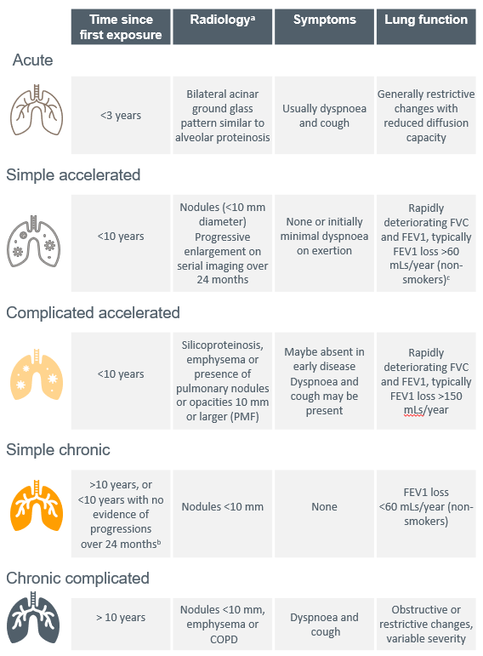
Source: Modified from Álvarez, González (9)
Abbreviations: FEV1, forced expiratory volume in one second; FVC, forced vital capacity; PMF, progressive massive fibrosis
a. The radiology and radiological progression is defined as a change in ILO (20) subclass or equivalent International Classiﬁcation of HRCT for Occupational and Environmental Respiratory Diseases (ICOERD) (21) classifications.
b. With screening that includes HRCT, we can detect parenchymal changes consistent with chronic silicosis before the elapsed 10 years since first exposure and at ILO profusion grades other than >0/1. This criterion is based on the absence of documented rapid progression. It is derived from and to be concordant with criteria defining the rapidly progressive pneumoconiosis seen with the spectrum of coal mine occupational respiratory diseases (22). It has potential prognostic significance and defines a group of affected people with a <10-year exposure history and who appear less likely to progress to complicated manifestations of the disease. This characterisation can only be applied retrospectively, after there has been a demonstrated absence of rapid progression. The evidence suggests this cohort could be as high as two-thirds of those workers who would otherwise be labelled as suffering from accelerated silicosis.
c. A criterion for rapidly progressive pneumoconiosis seen in the spectrum of coal mine occupational respiratory diseases (23).
As the purpose of diagnostic sub-classification is to assist targeted intervention and research, an alternative classification system is also gaining momentum:
- Acute: silicoproteinosis (ground glass appearance, and soft nodularity) is the dominant feature on HRCT and clinically there is evidence of rapid radiological or functional progression.
- Simple: parenchymal disease without evidence of rapid progression.
- Complicated: parenchymal disease with radiological or functional evidence of rapid progression.
While the rate of disease progression is clearly important to clinical decision-making and a FEV1 loss >60 mL/year appears to be the threshold, insufficient data was considered available to warrant formally changing the established sub-classification criteria.
In the Australian setting, case identification activities in workers who have been exposed to engineered stone have revealed increased prevalence of accelerated and complicated silicosis. It has also highlighted that some workers do not meet the established diagnostic criteria for silicosis but are clearly at-risk given their significant exposure histories and detectable changes.
Furthermore, the epidemic of artificial stone silicosis has raised the possibility that toxicity in this cohort may relate to a combination of factors in addition to the magnitude of exposure including:
- the nature of the resin used to bind the quartz in engineered stone, and/or
- the other elements used to create the range of composite materials supplied to the market.
This is an area that will require careful investigation. Complicating the toxicology further, for acute silicosis (diagnosed within 3 years of first exposure) and to a lesser extent accelerated silicosis (diagnosable within 10 years of first exposure), case-based experience suggests that cumulative lung burden should not be considered linear. High intensity exposures have potential to not just shorten the time required to cumulate a sufficient lung load but could also trigger alternative mechanisms of toxicity. This could explain differences in the incidence of acute and accelerated silicosis with engineered stone.
In all forms of silicosis there appear two distinct subsets – those who rapidly progress and those who do not.
Rate of progression in workers exposed to silica is known to show individual variation and is likely to be influenced by factors that are currently unknown, and therefore requires further research.

Silico-lymphadenopathy (no parenchymal disease)
The presence of silica-related hilar and mediastinal lymphadenopathy but without radiological evidence of parenchymal change has long been recognised. These cases do not meet the diagnostic criteria for silicosis and have become been easier to detect due to CT scans. The frequency with which these cases have been seen in the engineered stone exposed cohort reinforces the need to identify these workers as an at-risk category of workers who must be identified and closely followed in a disease registry.
For GPs who would like to follow a learning course on diagnosis and management of silicosis: see the Royal Australian College of General Practitioners learning resource

Acute silicosis
A diagnosis of acute silicosis is often identified in exposed individuals who experience rapid onset and/or worsening of symptoms including dyspnoea, cough, fever and sometimes pleuritic pain. Early accelerated silicosis can present with similar features. Fortunately, both forms of silicosis can be managed in the same way while they are investigated and the diagnosis established.
Acute silicosis is similar to alveolar proteinosis. Bilateral perihilar consolidations as seen with alveolar proteinosis can be seen on CXR, and high-resolution computed tomography (HRCT) reveals ground glass opacities or air space consolidations. There is usually progressive breathlessness, pleuritic chest pain, fever, cough, fatigue, weight loss and rapid progression to death from respiratory failure.
Acute silicosis is generally caused by massive exposure. Example of at-risk exposures include sandblasting with sand (but not usually sand substitutes), silica flour manufacture and abrasive fabrication and uncontrolled manufacturing processes involving high silica content substrates.
When acute silicosis is suspected in a patient with recent high dose exposure to silica (up to 3 years prior), the initial assessment is aimed at understanding the exposure history and excluding other possibilities contributing to the differential diagnosis, such as pneumonia, acute respiratory distress syndrome, heart failure, diffuse alveolar haemorrhage, eosinophilic pneumonia, lipoid pneumonia, and pulmonary alveolar proteinosis (8). Silica particles are identifiable within the pulmonary macrophages and provide good sensitivity and specificity for this diagnosis. However, there are difficulties in accessing testing in Australia. Consequently there are no readily available diagnostic tests for acute silicosis and further testing is nearly always required to formally exclude alternative diagnoses (4).
Urgent referral to a respiratory physician and/or hospital is recommended. Tests such as such as full blood count and differential, brain natriuretic peptide and cultures of blood and sputum are helpful in excluding possibilities from the differential diagnosis. While extended testing may be necessary to exclude other pathologies, these are best considered by the respiratory physician and should not delay referral.
Identifying people with acute silicosis early is important to lessen any parenchymal changes from any treatable cause becoming established. Potentially favourable interventional trials are in planning or already under way.

Accelerated silicosis
Accelerated silicosis is an intermediate entity between the acute and chronic forms that generally appears after a period of exposure of 3 to 10 years. It progresses more rapidly to the complicated forms of silicosis such as PMF than chronic silicosis. However, even some individuals with radiological evidence of PMF do not appear to progress. Symptoms of breathlessness occur earlier than in chronic silicosis, and complications such as emphysema and respiratory failure are more likely to develop in this cohort (4).
Examples of at-risk exposure include sandblasting, stone masonry using powered tools without dust controls and respiratory protection as well as any work with engineered stone. There have also been several cases reported in association with tunnelling and quarrying.
Again, identifying people with accelerated silicosis early is important. the need to identify cases before any significant parenchymal disruption or distortion due to fibrosis becomes established. Potentially favourable interventional trails are also in planning or already under way.

Chronic silicosis
Chronic silicosis can be challenging to diagnose. It is often asymptomatic or presents with only very mild exertional dyspnoea. Simple and complicated chronic forms are the most common types of silicosis, appearing generally after 10 or 15 years of exposure. Symptoms range from the asymptomatic simple chronic silicosis detected by radiological examination to complicated silicosis that most frequently presents with dyspnoea and cough. Examples of classic at-risk exposures for the development of chronic silicosis include foundry work and mining.
The primary clinical focus is to optimise respiratory health, support the psychosocial needs of the affected person and aggressively treat any reversible complications, in particular intercurrent infection.

Complicated variants
The classic radiological sign of simple silicosis is a bilateral diffuse nodular pattern (opacities <10 mm), with greater upper lobe and posterior involvement. The simple form may progress to complicated silicosis in which nodular conglomeration occurs (nodules >10 mm in cross-section or PMF), associated with parenchymal retraction with or without para-cicatricial emphysema.
As the disease progresses, the typical complications of emphysema may be seen, as well as various patterns of calcification. Necrosis and cavitation are uncommon and may be a sign of complicating infection including tuberculosis. In more advanced cases, there is extensive structural breakdown with formation of fibrotic masses, respiratory failure, pulmonary arterial hypertension, cor pulmonale and right heart failure. However, there is no data to suggest that lung transplantation has worse outcomes compare to other patients.
This progression from simple to complicated silicosis is a consequence of a complex interaction between intensity and duration of exposure and while it may be relevant, there is insufficient data to conclude that genetic susceptibility is a major contributing factor.

Artificial stone silicosis
Artificial stone silicosis is a spectrum of disease presentations, similar to the historical forms of silicosis but with shorter latency and more rapid progression. The diagnostic label is applied due to the source silica exposure and has been added to the classification scheme to highlight the possibility of secondary factors influencing disease progression. These may be associated with the binding resins and the composite substances that create the range of stone finishes. The typical presentation early in the disease course is of soft centrilobular ground glass infiltrates which are predominantly upper zone.
Screening programs have identified several important subgroups. For example cases with:
- hilar or mediastinal lymphadenopathy (with or without calcification) without parenchymal disease
- PMF but normal lung function
- chronic simple silicosis with numerous nodule below the resolution of conventional ILO-CXRs some complicated by PMF.

Exposure to RCS and silicosis
Epidemiological studies (24, 25) based primarily on standardised chest X-ray (CXR) findings using ILO criteria, have demonstrated a strong relationship between cumulative exposure to RCS dust, disease severity and the risk of progression. This risk of progression continues even after the worker is no longer exposed to RCS dust. Many studies have examined the effect of silica exposure on longitudinal lung function, these have not shown similar results.
Hertzberg, Rosenman (26) attempted to assess the effect of silica exposure assuming 40 years of maximal exposure at 0.1 mg/m³, eight-hour time weighted average (TWA). The results suggest continued exposure at this level would result in a longitudinal declined of forced vital capacity (FVC) and forced expiratory volume in 1 second (FEV1) of 1.6 mL/year and 1.1 mL/year respectively, per mg/m³ of mean silica exposure. The normal rate of FEV1 decline due to ageing in non-smokers is approximately 30 mL/year (27).
In Australia, the current workplace exposure standard (WES) for RCS is a TWA of 0.05 mg/m³ in all jurisdictions except for Tasmania. WHS Ministers and Safe Work Australia have advised that more research will be undertaken to explore lowering the WES further.

Enhanced progression with continued exposure to RCS
Once a worker has been diagnosed with silicosis, continued exposure to RCS causes faster disease progression. For example, Gold miners with ongoing exposure had greater functional impairment and radiological severity of disease compared to those who ceased exposure (28). Hessel, Sluis-Cremer (29) showed that continued exposure, increased the number of workers who progressed (94.6% vs 88.3% for workers with continued exposure and those without, respectively). Carneiro, Barreto (28) also showed continuing hazardous silica exposure was associated with risk of developing significant radiological changes (International Labour Organization [ILO] nodule perfusion category 3, odds ratio [OR] = 6.42, 95% confidence interval [CI]: 1.20–34.27), presence of PMF and/or large opacities (OR = 3.85, CI: 1.07–13.93) compared to those who left the high exposure setting studied.
In a prospective cohort study of 141 granite workers with silicosis, Lee, Phoon (30) found that 37% showed radiographic evidence of disease progression over a 2 to 17-year follow up period. Progression was strongly associated with duration of exposure and severity of disease status at the time of initial CXR. Workers were at increased risk of progression if they had evidence of large opacities on their initial CXR. These findings have also been reported in coal mine workers (31).

Progression in the absence of further exposure to RCS
Silicosis generally progresses in the absence of further exposure. This has been demonstrated in many studies including a retrospective cohort study of Japanese tunnel workers (32). In Dumavibhat, Matsui (32), despite leaving the workforce and removing themselves from further silica exposure, more than half of continued to progress in disease severity, some in under two years. A series of silicosis cases in Turkish denim sandblasters who had been subject to very high exposures, also showed rapid disease progression in the absence of further silica exposure in as little as four years (33).
There are some studies which have not shown inevitable progression in their cohort, at least in terms of their CXR imaging and lung function tests. This could relate to insensitive tests (CXR vs HRCT), a pattern of episodic progression not previously described, and/or a relatively short duration of follow up. Unfortunately, available literature failed to reveal descriptors that might identify this group, and their longer term clinical course. However, in many studies there appears to be a small but consistent group of workers who do not manifest rapidly progressive disease even if they have PMF at diagnosis or describe less than 10 years since first exposure (accelerated silicosis).
A recent example, León-Jiménez, Hidalgo-Molina (25) report was focused on the rapid progression observed in their cohort with 56% of their patients progressing to two or more ILO subcategories. Even so, they documented that 55% of patients with ILO category 1; 47% with ILO Category 2; and 29% with ILO Category 3. During the mean follow up period of 4 years, patients did not change their ILO category.
While Ress and Murray (34), suggested this group might be between one- to two-thirds of affected workers, the impression is that it could be less than one-third. Mohebbi and Zubeyri (35) reported that 34.8% of their case series including 23 silica flour packers with acute and accelerated silicosis did not progress over a mean follow up period of 30 months (range 12–54 months).
Continued exposure to RCS does not preclude the potential for developing chronic silicosis in the survivor cohort or triggering an accelerated response. In theory, inadvertent high short-term exposure to RCS could potentially convert an inactive process into active progressive disease. Until an appropriate registry is established these outcomes remain theoretical.
Developing silicosis in the previously exposed worker, but without evidence of disease when first seen, can occur even in the absence of further exposure (31). Combined with the potential for transient lapses in safe work practices, once silicosis is recognised or even strongly suspected it is recommended the risk of further RCS exposure be avoided. This recommendation is enhanced by short-term excursions from the regulatory exposure standard.
However, what the evidence does show is that until there is clear evidence of disease progression, the decision to stop work should be a patient-centred shared decision.

Prevention of occupational respiratory disease
Prevention of silicosis and occupational respiratory disease generally is broadly divided into three categories: primary, secondary and tertiary prevention, as summarised in Table 2.
Currently, there is no treatment for silicosis. Prevention of cumulative exposure that might trigger silicosis is therefore the highest priority.

Table 2: Prevention of silicosis
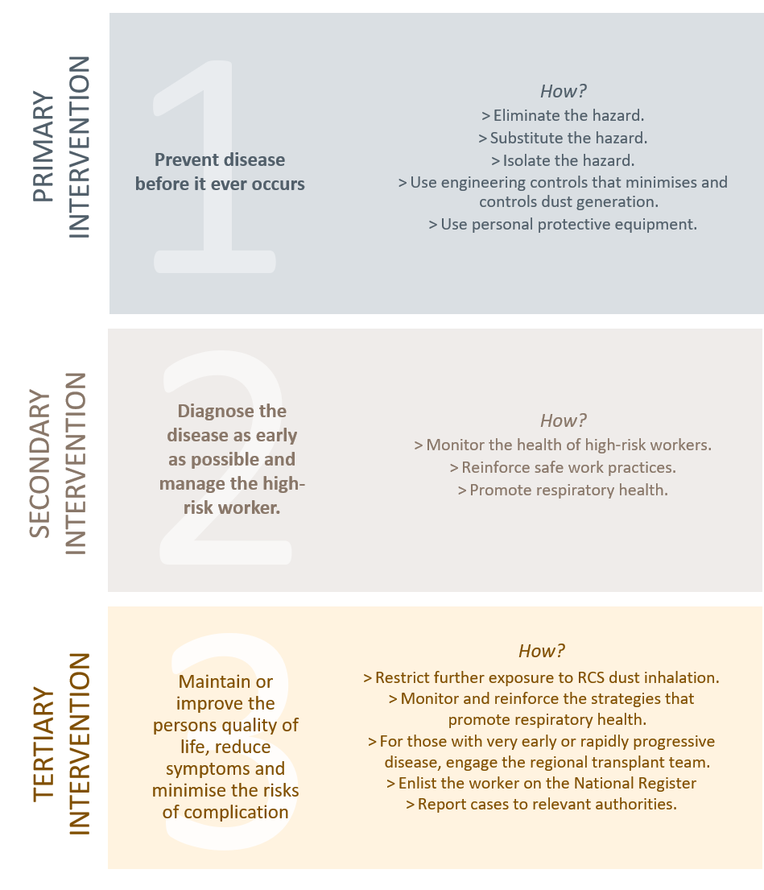
Abbreviations: RCS, respirable crystalline silica

Primary prevention
This is primarily the responsibility of the individual and their workplace. However, medical practitioners contribute by promoting awareness of the health consequences and actively reinforcing and encouraging compliance with safe work practices. Primary prevention adopts, as far as reasonably practicable, the Hierarchy of Risk Controls (36):
- Eliminate the hazard.
- Substitute the hazard with a safer product. For example, sourcing a stone benchtop with a lower percentage of silica.
- Isolate the hazard. For example, designate areas for tasks that generate dust and appropriate worker positioning during these tasks.
- Use additional engineering controls to control dust generation.
- Use administrative controls to limit exposure duration.
- Use Personal Protective Equipment (PPE). PPE should be a non-discretionary complementary strategy not a sole strategy to manage the risk.

Secondary and tertiary prevention
For secondary prevention, diagnosing a person with disease as early as possible can be challenging. Exposure assessment at this stage has unfortunately not achieved the level of sophistication to enable robust stratification of an individual’s risk. Currently it is also not possible to describe what increment of additional cumulative exposure is needed for a person with potential sub-clinically detectable, dormant or slowly progressing chronic disease to develop into more rapidly progressive disease. Given the ethical research considerations, such insights are unlikely to be discoverable by prospective case-controlled research design. Consequently, it is not possible to know what the risk of silicosis is for an individual from continued exposure at or below the Australian WES. The clinical trajectory of any individual will also be unknown until sufficient time has elapsed to observe the disease behaviour in that person.
When encountering an individual with established disease, the default recommendations, regardless of their clinical state, are:
- prudent avoidance of further exposure to RCS (24) and
- consider alternate roles.
This advice, however, should be balanced against the significant impact of ceasing work – psychologically, socially and financially. Upon diagnosis, it can be difficult for a person to process that it may be their own workplace that is causing them harm. This can compound their sense of hurt and psychological distress. The person’s workplace should therefore be independently assessed before providing such an opinion, particularly if the person has normal complex lung function (FEV₁, FVC and diffusion capacity) and who is clinically asymptomatic.
Unless there is a clinical indication to do so, there is no urgency to leave the workplace until the nature of their disease and circumstances are better understood. In addition, unless there is a real risk of a short-term intense additional incremental RCS exposure, deployment in a statutory compliant workplace is very unlikely to materially contribute to the natural progression of their disease. This is because the disease is already established and progressing. During the worker’s phase of adjustment to the diagnosis, the worker warrants optimal support to make informed decisions.
Consequently, a shared decision-making process is highly recommended (37, 38). The person should be provided with the options they have available as well as the benefits and potential harms of each (See 3. psychosocial support and education). In a patient-centred model of health care delivery, providing the opportunity for people to question and understand the advice provided by a trusted clinician as well as take the time needed to make an informed decision is central to facilitating desired behavioural change. The same principle applies for health surveillance.

Statutory obligations of the PCBU – Is the workplace safe?
As a medical practitioner your patient, or sometimes your patient’s workplace insurer, may ask your advice concerning the risk of harm should your patient return to their place of work. This can be difficult when only limited information is available and is best undertaken by a consulting specialist physician in occupational and environmental medicine. The tendency is to apply a precautionary principle and recommend absence while investigations take place. Referral to an occupational or respiratory physician is highly recommended. A patient-centred shared decision tool is included in Appendix B to assist in the process.
Under existing WHS laws (36), across all jurisdictions a “person conducting a business or undertaking” (PCBU) has specific duties to identify hazards and manage the risks to health and safety when using, handling, generating and storing hazardous chemicals, including silica.
Consequently, PCBUs have a statutory duty to apply the primary prevention strategies (see Primary prevention) and to fund and support the secondary prevention strategies for their at-risk workers. Currently, unless a compliance code has been enacted for your jurisdiction, if a PCBU is performing work that uses or handles silica containing products and/or undertakes tasks that could generate RCS dust, they must undertake a formal risk assessment and self-assess whether the workplace ‘poses a significant risk’ to their worker’s health. For some industry sectors, the risk assessment has been carried out by the regulator and a compliance code of practice developed to inform the industry sector.
However, If the PCBU does not perform the risk assessment, fails to identify the hazard, or more commonly the PCBU does not understand the limitations of WES, then workers may remain at-risk until the jurisdictional inspectorate issues an infringement notice.
The current WES (published by Safe Work Australia and revised in December 2019) for RCS mandates that an eight-hour TWA of 0.05 mg/m³ must not be exceeded and limits apply to accommodate permissible excursions. When working with engineered stone these excursion limits are easily breeched but may not be appreciated when exposure is averaged.
Operationally, PCBU’s implement “action levels” at 50% of the relevant WES. This means that if measurements are greater than 50%, it triggers an investigation and corrective actions. Depending on the jurisdiction and the airborne hazardous substance in question, a prescribed frequency and type of personal air monitoring is recommended and enforceable. Unfortunately, at this stage, qualitative evidence of compliance with requirements outlined in current compliance codes is less than desirable.
As there are different shift profiles for different occupations, TWAs can be adjusted to provide the equivalent protection while accounting for greater exposure duration and reduced recovery hours between shifts. Short-term exposure standards (STELs) and peak limitations are derived to protect people from acute critical effects and should not be adjusted.
As a medical practitioner asked to assess the safety of a workplace, it is important to realise that generally, a dust generating process is not considered to be under reasonable control if short-term exposures exceed three times the TWA exposure standard for more than a total of 30 minutes per eight-hour working day, or if a single short-term value exceeds five times the TWA exposure standard. As these measurements are not normally reported, you need to look beyond the reported levels and qualitatively assess the pattern and intensity of dust generation that can be masked by ‘averaging’.
Another factor to consider when counselling your patient is your assessment of when the exposure “most likely” occurred. Given the nature of the disease process this will most likely be “years ago” (especially for chronic silicosis). To date, there has not been any cases reported in Australia where the exposure to engineered stone dust was less than three years (3). As the workforce can be migratory the significant exposure may have occurred with a former employer. Work practices can also change so with heightened awareness, current work practices may have substantially reduced the risk of further exposure.

The supervising medical practitioner and health monitoring
Following the PCBU’s risk assessment, if the person’s health is considered at significant risk from exposure or there is an applicable compliance code of practice, a health monitoring program is required. The PCBU acquires a duty to engage a suitably qualified medical practitioner to carry out and supervise their health monitoring program. The medical practitioner has no statutory authority to direct which workers must undergo health monitoring.
The current legislation varies across jurisdictions relating to how or when a medical practitioner, should be involved in the health-risk management of the PCBU’s workforce. Only after a risk assessment indicates, are GPs or consultant physicians with a specific interest in occupational medicine required to supervise health monitoring programs.
In some settings, guidance has been developed and embedded in compliance codes of practice relating to engineered stone. These are statutory empowered guidance documents to assist duty holders to translate into action their minimum statutory obligations. Safe Work Australia is currently developing a model code of practice for optional implementation by the states and territories who have adopted the model WHS laws.
Consequently, if a person presents that you suspect has been exposed to RCS dust, it is highly recommended that you obtain consent to liaise with the SMP responsible for health monitoring at their workplace. The SMP should have valuable intelligence about the worker’s health monitoring program, the workplace’s compliance with safe systems of work and an established relationship with your patient’s employer that can provide ongoing support for you and your patient. If your patient doesn’t undergo health monitoring, you can refer your patient to:
- if your patient is asymptomatic – a consultant physician in Occupational and Environmental Medicine (OEM), or if you are a respiratory physician and seeking the support of an Consultant Physician in OEM, or
- if your patient is symptomatic – a Respiratory Physician with expertise in occupational lung diseases.
For further information on the role and responsibilities of a medical practitioner conducting health monitoring for exposure to hazardous chemicals which overlaps with health surveillance, Safe Work Australia has published a “Crystalline silica health monitoring guide” for medical practitioners (39).

Guidelines
The identification, investigation and ongoing management of individuals at-risk of RCS related disease can be divided into (i) case identification and (ii) ongoing health surveillance. While focused on RCS, the Guidelines are structured as a framework for the assessment of any worker with occupational dust exposure. The following practice points (unless otherwise stated) are provided to describe a set of minimum standards to inform health practitioners undertaking case identification and health surveillance. These standards are also recommended for any statutory or government activity.

(i) Case identification practices
GP clinics and local community focused health centres are important resources to both idenitfy and respond to the needs of the worker. For those who no longer work in an at-risk industry, GPs and other health centres play an even more important role in indentifying cases early, referring them to the appropriate specialists and providing support to the person, their family and friends.
Case identification is a strategy for targeting resources at individuals or groups who are suspected to be at high-risk for a particular disease. In the occupational setting, case identification has similarities to screening and contact tracing seen in the public health setting. These activities seek to risk stratify the target population for further investigation and ongoing management.
To change health-risk behaviours or reinforce safe practices, awareness and understanding of behaviours that can negatively impact a person’s health are critical. Historically (prior to April 2018) this had been lacking across the engineered stonework sector in particular (40). More recently, in all jurisdictions, broad promotion of the issues of hazardous dusts and silicosis, and various jurisdictional specific case identification programs has enhanced health awareness with variable effectiveness (41).
While broad health promotion messages at the population-level have been successful in some settings, cultural and language barriers have posed challenges reaching a wider population. Consequently, case identification requires a high level of suspicion by the clinician to identify people who have been exposed to RCS or have a history of hazardous cumulative exposure that might require health surveillance.
The purpose of case identification is to:
- Identify, educate and support workers with no early markers of disease but who remain at-risk of hazardous cumulative exposure, particularly those with a history of hazardous cumulative exposure that require more frequent health surveillance.
- Identify people who have markers of possible early disease, but do not yet reach the threshold for diagnosis that require active health surveillance.
- Provide counsel and support for people with early disease and apply interventions to minimise the risk of rapid progression.
- Identify people with established disease and refer them for specialist shared care.
The process of case identification will vary and reflect jurisdictional assessment of the target population within that region. Examples of case identification include:
- A limited “one off” event, publicly marketed via multiple media channels with limited ongoing access for those individuals who may have missed ‘the event’.
- An embedded ongoing activity targeting specific industry sector/subsectors.
- A combination of both processes.
Regardless of the process adopted, for a national case identification program to be effective it requires:
- Robust and consistently applied diagnostic criteria for case and potential case recognition.
- Consistent diagnostic and follow up investigative services that reflects the sensitivity and specificity of the metrics employed.
- Targeted contact tracing by the relevant health authorities.
- Data collection in a format that enables serial and cross-sectional pooled data analysis – aligned to the information requirements of the National Occupational Respiratory Disease Registry.
- A model of aftercare supported by clinical governance.
The outcomes of case identification are:
- Baseline data collection
- Finding people with disease
- Risk stratification of those with exposure without disease.
Risk Stratification will depend on:
- Exposure history
- Calculated exposure dose
- Symptoms and comorbidities
- Results of investigations
- Current and planned vocational deployment.

(ii) Ongoing health surveillance
Health surveillance is the purposeful and ongoing acquisition, interpretation and synthesis of patient data in a manner that informs clinical decision-making. Health surveillance is more than statutory defined health monitoring. It encompasses the multidimensional nature of a person’s health and is informed by the body of medical evidence at the individual and public health levels as well as the societal need.
Activities are undertaken within a schedule that reflects what is known of the pathophysiology of the diseases and surveying for the earliest reliable indices of clinical significance. Consequently, health surveillance is informed by the evolving body of knowledge concerning the:
- Appropriate intervals to detect a change of significance sensitivity to the natural intra-individual and inter-individual variation.
- Detecting the more rapidly progressive forms of the disease as soon as practical.
- Next best practice principles (what is anticipated to be best practice in the future) endorsed by the medical profession for assessing and diagnosing occupational lung diseases (42).
In addition, forongoing surveillance to be effective it must:
- engage with and enhance existing jurisdictional resources including GP clinics, hospitals, specialist clinics, imaging services, pathology services and allied health care services; and
- be conducted within a quality-controlled continuity of care framework.

Case identification
Additional resources required:
- General medical questionnaire
- MRC respiratory questionnaire
- Descriptors of high-risk roles – Similar exposure groups (SEGs)
- Contact database for occupational physicians and suitably qualified medical practitioners.

Figure 2: Steps to identify the appropriate referral pathway
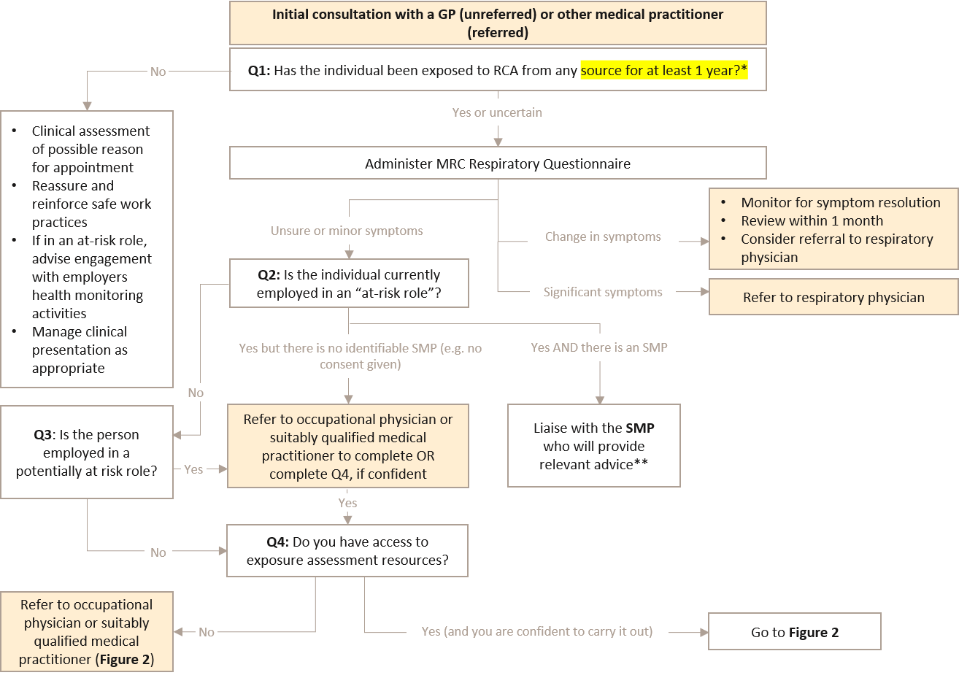
Abbreviations: GP, general practitioner; MRC, medical research council; RCS, respirable crystalline silica; SMP, supervising medical practitioner; Q, question
*To date if a person has worked less than 3 years in an “at-risk role” in Australia, there has not been a reported confirmed case. The National Occupational Respiratory Disease Registry will continue to monitor case experience and modify this threshold if necessary.
**The SMP and the PCBU has a statutory responsibility to provide advice relevant to the person’s exposure risk setting.

1. How to identify a person of interest and refer them to the appropriate medical practitioner?
Key practice points
  - If your patient is employed in an “at-risk role”, contact the worker’s SMP (with their consent).
- Avoid duplication, obtain advice and support; health monitoring is funded by the PCBU.
[Statutory requirement]
  - If your patient has significant symptoms or a persistent change in symptoms, refer to a respiratory physician.
  - If your patient has unclear or minor symptoms, employed in a potentially “at-risk role” with no SMP, use the exposure assessment tool (see D. Diagnostic imaging)
- Refer to an experienced occupational physician or suitably qualified medical practitioner if you are not confident in exposure assessments.
  - For patients who have been exposed for less than one year or have no early markers of disease, strongly reassure, reinforce safe work practices and, address their clinical concerns, if necessary.
Supervising medical practitioner
  - The SMP can coordinate health monitoring activities and facilitate the exposure assessment.

For an initial assessment of a worker or person exposed to RCS, the person may:
- Present to a GP (unreferred)
- Present to an occupational physician, respiratory physician or a suitably qualified medical practitioner (referred – by a call centre, employer or GP).
If your patient appears to work in the building, construction, minerals, mines, quarrying or tunnelling industries, ask:
Have you worked with engineered stone or have any concerns about the nature of the dust in which you have worked?
If the answer is yes, Figure 2 (above) presents the steps a GP or other suitably qualified medical practitioner should follow to identify the appropriate physician to refer to and establish a baseline.
If the person is already employed in an “at-risk role” or is to be employed in an “at-risk role”, the assessment is expected to be coordinated by the SMP responsible for the workplace (see Statutory obligations of the PCBU). The assessment will be undertaken at the PCBUs expense. The relevant SMP should therefore be contacted, with informed consent, to avoid duplication of resource use and unnecessary radiation exposure. In some settings the SMP may engage the GP to undertake necessary activity.
If the person’s current employment does not include recognised at-risk activities (unless there is an accepted compensable injury) there is no funding beyond Medicare to pay for the medical practitioners professional time and investigations. Where cases are identified, remember that the person’s current workplace may not be the source of their significant exposure.

2. How to carry out an initial assessment?
Figure 3 presents the steps for a respiratory physician or occupational physician involved in case finding. Additional detail has also been provided on baseline data, exposure and lung function stratification, diagnostic imaging and additional investigations (2A to 2E). At the earliest stage possible, for those who are at-risk of mental illness, a Mental Health Questionnaire should be carried out. However, any person at high-risk or diagnosed with silicosis, should have ongoing psychological support and counselling (see When should psychosocial support and education to prevent disease or disease progression ).
Additional resources required:
- Exposure questionnaire (Appendix A)
- Modified MRC dyspnoea questionnaire
- Spirometry (TSANZ standard)
- Mental health questionnaire (at-risk persons)

Figure 3: Steps for initial assessment of a worker or person exposed to RCS
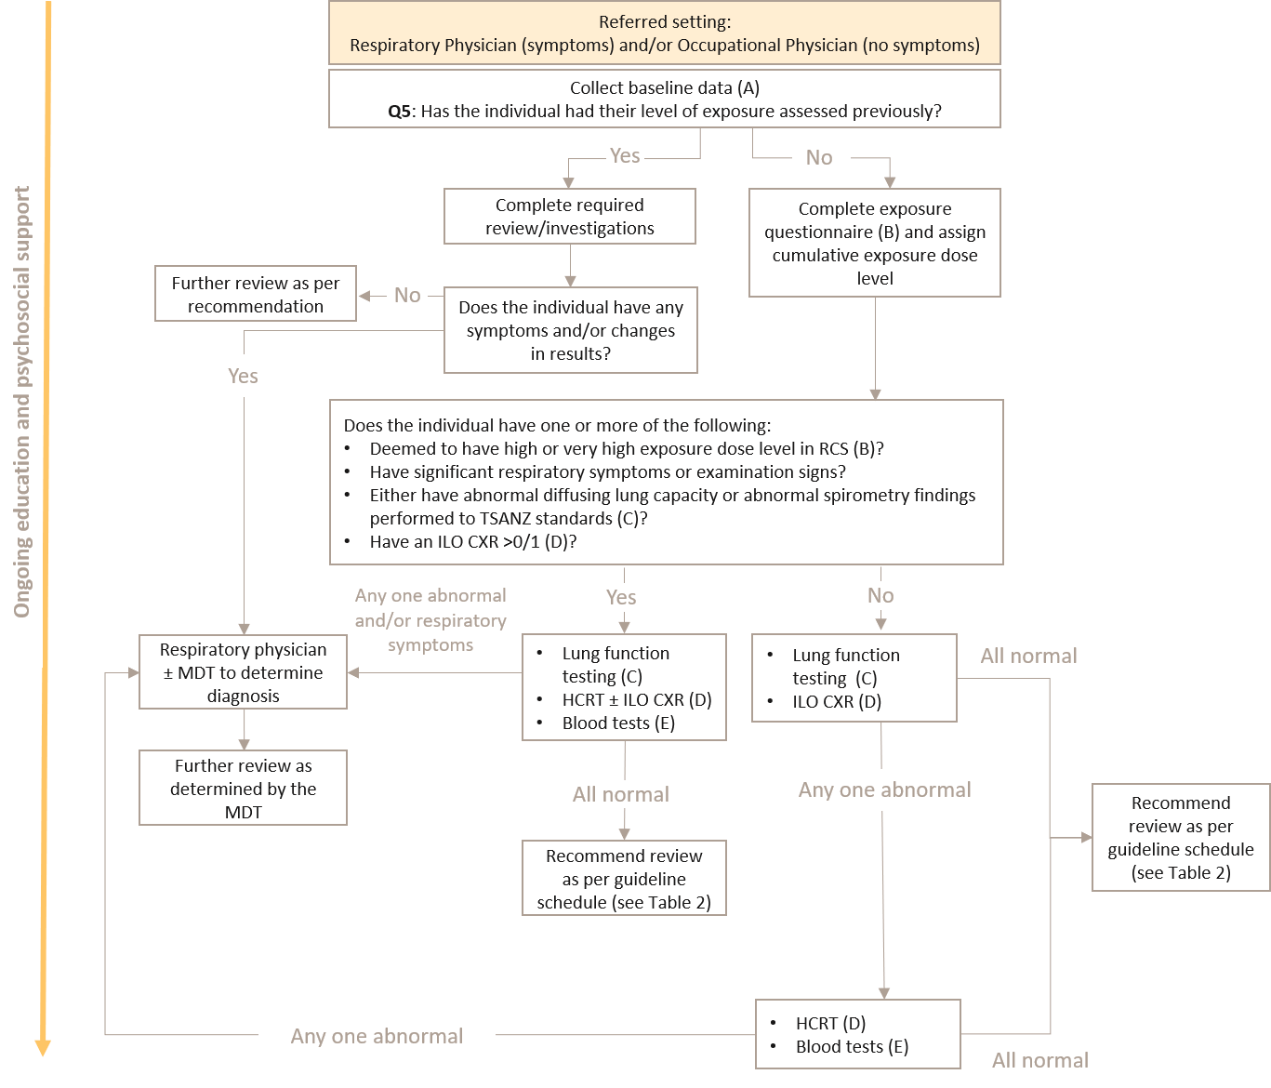
Notes: Please see notes below (2A to 2E) for additional detail
Abbreviations: CXR, chest X-ray; HCRT, high-resolution computed tomography; ILO, International Labour Organization; MDT, multidisciplinary team; RCS, respirable cystalline silica; TSANZ, The Thoracic Society of Australia and New Zealand

A. What baseline data should be collected?
Key practice points
- Collect baseline demographic, exposure and medical history, respiratory symptoms (if any) and physical examination findings.
- Upload, with the person’s consent, the information to their My Health Record.

Baseline data including demographic, exposure and medical history, respiratory symptoms (if any) and physical examination findings should be collected (Figure 3). With the person’s consent, all baseline information and ongoing follow up should be recorded on the individuals My Health Record. This will enable continuity of care and can improve the ability for a medical practitioner to make informed management decisions if there are clinically significant changes. The lung function data should be sufficient to facilitate SPIROLA trend analysis.

Figure 4: Baseline data to collect
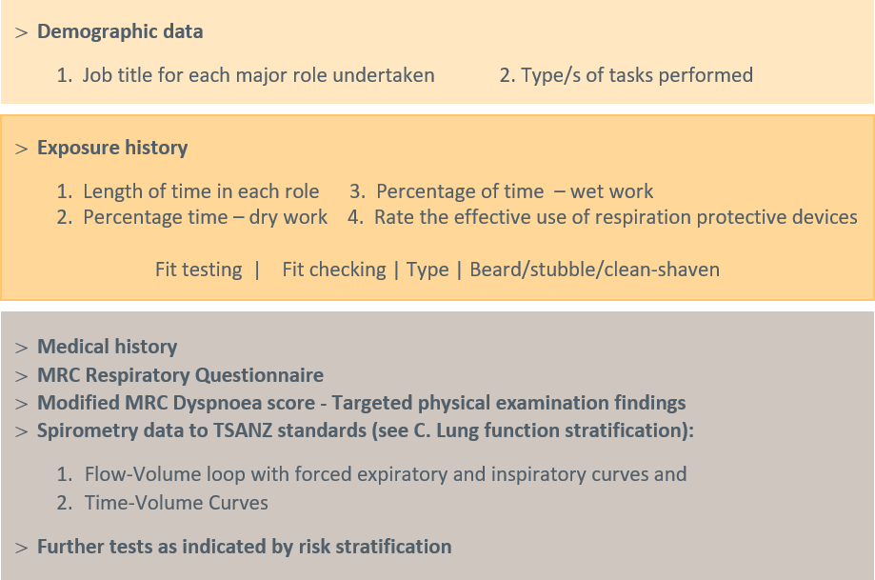
Abbreviations: MRC, medical research council; TSANZ, The Thoracic Society of Australia and New Zealand
Safe Work Australia’s publication “Hazardous Chemicals Requiring Health Monitoring” (43) includes guidance on respiratory health assessments for workers exposed to crystalline silica. It broadly sets out a process for baseline respiratory health assessments from a minimum regulatory perspective.
A person with respiratory symptoms is considered at high-risk until a satisfactory explanation is identified.

B. Exposure stratification
Key practice points
- If you are confident and have the appropriate experience, carry out the exposure questionnaire.
Respiratory physician and/or occupational physician
- Use the exposure questionnaire (see Appendix A) for people who have been exposed to RCS for at least one year.

Use the questionnaire for the stratification of a person’s exposure risk in Appendix A. The exposure risk is a product of intensity, nature and duration.
All patients who have been exposed to RCS for at least one year should have their exposure risk determined. Rarely, a worker may be exposed to very intense short-term exposure in a workplace. In such settings, the SMP would trigger a post-incident assessment independent of the standard health surveillance encounter.
The GP should refer the person to either a respiratory physician, occupational physician or experienced medical practitioner who can carry out an exposure assessment and provide the appropriate support. The medical professional or SMP has a professional obligation to advise the GP of the outcome.
Given the nature of occupational respiratory diseases, the exposure assessment should only be carried out by the GP if they are confident and have the appropriate education, experience and resources to do so.

C. Lung function stratification
Key practice points
Respiratory physician and/or occupational physician and/or suitably qualified medical practitioner
- Baseline spirometry testing to TSANZ standards should be performed for all workers exposed to RCS. In the specific setting or significant RCS exposure, the following thresholds require further review appropriate to the clinical findings:
- absolute FEV1 less than the LLN, or
- absolute FEV1 is less than 70% predicted from GLI reference values, or
- an absolute reduction of FEV1 by more than 30mL in one year, or
- longitudinal decline of FEV1 greater than 15% change reduction over any period of time.
- Repeat spirometry testing every 6 to 12 months if the results are below 80% of the GLI predicted threshold, testing should be carried out every 6 to 12 months.
- Consider a test for DLCO for all high-risk workers, including when there is an absence of respiratory symptoms, and:
- Refer for a HRCT if a person has a change in DLCO of more than 15% between screenings.
- Refer to a respiratory physician if a person has a 10% reduction in DLCO in less than one year.

Spirometry
Lung function testing is recommended for all workers exposed to RCS at baseline (ideally at the commencement of their first employed or contracted role). Testing should include the standardised measurement of FEV1, FVC, forced inspiratory vital capacity (FIVC) and the FEV1/FVC ratio together with printouts of the flow-volume loops and volume time curves.
Spirometry used in the diagnosis and surveillance of at-risk individuals must be performed by suitabley qualified technicians to TSANZ standards and in accordance with international guidelines.
Findings of spirometry testing in patients with silicosis may range between normal values and obstructive or restrictive patterns with marked decreases in FEV1 and FVC. Observational studies in large series of patients have shown that loss of lung function with reduced FEV1 and FVC is associated with the magnitude of exposure, extent of radiological lesions and history of tuberculosis. Spirometry should be performed not only at the time of initial assessment but also at periodic follow ups for the evaluation of possible functional deterioration.The ‘thresholds’ for FEV1 and impairment are defined by the comparison of absolute measurements to reference values (44), or longitudinal studies that show excessive declines in FEV1.
In the 2005 guidelines, the American Thoracic Society and European Respiratory Society recommended that the fifth percentile be used as the lower limit of the normal range (LLN). The LLN is a more robust threshold of what is considered “normal”. The historic 80% and 70% cut-offs were reasonable from a clinical management perspective for:
- FVC, FEV1, diffusion capacity of the lung for carbon monoxide (DLCO) and total lung capacity in middle-aged adults, but
- gave a high rate of false positive or false negatives for FEV1/FVC, forced expiratory flow (FEF) (25 to 75%) and maximal respiratory pressures. This has discriminated against people who have otherwise normal lung function.
A person will remain of interest and require frequent monitoring to establish the stability of lung function, if they are below 80% of the Global Lung Function Initiative (GLI) predictive value but score above the LLN. Statistically, 5% of people who “are normal” will be below the LLN.
Body weight is much less important than height when predicting most pulmonary function values and is not included in reference equations for spirometry. However, patients with a body mass index above 30 kg/m² may have mildly reduced lung volumes (45).
Unless there is an established explanation, further review by a respiratory physician is recommended if the spirometry findings at either the initial case identification assessment or during ongoing health surveillance if (46):
- absolute FEV1 is less than the LLN, or
- absolute FEV1 is less than 70% predicted from GLI reference values, or
- an absolute reduction of FEV1 by more than 30mL in one year, or
- longitudinal decline of FEV1 is greater than 15% change of predicted GLI over any period of time.

Diffusing lung capacity for carbon monoxide
DLCO, which must be performed using accredited equipment and personnel, has revealed disease in some workers even where their spirometry results have been above acceptable thresholds (47). Therefore, all high-risk workers should be considered for DLCO, including where there is an absence of respiratory symptoms.
Workers with a change in DLCO of more than 15% between screenings should be referred for HRCT. Diffusion capacity is affected in the complicated forms of silicosis and is sensitive to the presence of fibrosis. Static lung volumes can demonstrate a reduction in total lung volume and can provide valuable information when interpreting radiological findings. These examinations are performed in patients with complicated silicosis or if abnormalities are detected on standard spirometry. If there is confidence in the technical quality of the DLCO test, a 10% DLCO reduction in less than one year without adequate explanation, should trigger review by a respiratory physician.
Cardiopulmonary exercise studies do not appear to provide relevant data in asymptomatic patients, but they can be useful in selected cases for the objective measurement of breathlessness and exercise capacity (48).
The recommended action thresholds for spirometry and DLCO results is presented in Table 3.
Table 3: Recommended action thresholds
Measurement | Description | Result | Action to take
Absolute FEV1 | Screens for ILD such as silicosis, black lung disease; and if present, severity of COPD) | Normal: Greater than 80% predicted (GLI/GOLD) | Review every 12 months
 |  | Concerning “normal”: >70% and >LLN using GLI reference values | Repeat every 6 to 12 months
 |  | Abnormal: <70% or <LLN | Further assessment required
FEV1% (FEV1/FVC as a per cent) | Screens for COPD | Normal: Greater than 80% (absolute ratio) | Repeat every 12 months
 |  | Concerning “normal”: >70% and > LLN using GLI/GOLD predictive values | Review every 6 to 12 months
 |  | Abnormal: <70% or <LLN | Further assessment required
FVC | Screens for restrictive lung disease – ‘PAINT’ (pleural alveolar interstitial neuromuscular thoracic) | Normal: Greater than 80% using GLI reference values | Repeat within 12 months
 |  | Concerning “normal”: >70% and >LLN using GLI reference value | Review every 6 to 12 months
 |  | Abnormal: <70% or <LLN | Further assessment required
Post-bronchodilator spirometry | Screens for reversible obstruction | Normal: <12% improvement in both the FEV1 and the FVC | Diagnostic criteria for asthma – manage as per relevant guidelines
 |  | Absolute improvement in either FEV1 or FVC by 200 mL and > 12% improvement in either FEV1 or FVC | Review every 6 to 12 months
Diffusion Capacity (49) | ILD | Normal: Greater than 80% (absolute ratio) | Repeat as clinically indicated
 |  | Concerning “normal”: >70% and >LLN using GLI/GOLD predictive values | Review every 6 to 12 months
 |  | Abnormal: <70% or <LLN
Serial metrics | Progressive disease (50, 51) | Relative longitudinal decline FEV1 >5% 24 weeks | Repeat in 6 months
 |  | Absolute longitudinal decline FEV1 >10% 52 weeks | Refer
 |  | Absolute longitudinal decline FEV1 >15% | Refer
 |  | Annual decline FEV1 >30 mL/year (non-smoker) | Refer
 |  | Absolute longitudinal decline DLCO >15%, | Refer
Abbreviations: DLCO, diffusion capacity of the lung for carbon monoxide; FEV1, forced expiratory volume in one second; FEV, forced expiratory volume; FVC, forced vital capacity; GLI, Global Lung Initiative; GOLD, GLI for Obstructive Lung Disease; ILD, interstitial lung disease; LLN, lower limit of normal (fifth percentile)

D. Diagnostic imaging
Key practice points
Respiratory physician and/or occupational physician
- Request a HRCT for any of the following reasons:
- has had high or very high exposure dose level as calculated in the exposure dose matrix; or
- significant respiratory or other symptoms; or
- abnormal DLCO or spirometry findings; or
- an ILO CXR >0/1.
- If a HRCT is consistent with the diagnosis, ILO classification of a CXR should not be used to exclude a diagnosis of silicosis or access to statutory entitlements.
- Consider a HRCT when respiratory function testing, symptomology or exposure history is suggestive of need for further investigations, even if the ILO CXR <1/0.
Specialist radiologist
- The HRCT should be performed using as low a radiation dose as is practicable by a specialist radiologist with appropriate qualification and/or recognition and credentialling through RANZCR.
- The HRCT should be reported by the specialist radiologist. It is recommended that an HRCT interpretation should be reviewed by the MDT team when there is any diagnostic uncertainty.

When should a high-resolution CT scan be requested?
At any time during an individual’s engagement with the health care system, regardless of their duration in the engineered stone industry, if it is their baseline or subsequent periodic assessment, they are current or former workers in the artificial bench top industry, a non-contrast HRCT is clinically indicated for one or more of the following:
- The individual has been deemed to have had a high or very high exposure dose level as calculated in the exposure dose matrix (see B. Exposure stratification); or
- The individual has been identified to have significant respiratory, other symptoms or examination signs; or
- The individual has either abnormal DLCO or abnormal spirometry findings performed at a laboratory accredited by the TSANZ; or
- The individual has had an ILO CXR >0/1.
All chest CTs currently performed in Australia are effectively “high-resolution” compared with early versions of the technology. However, the abbreviation of HRCT often carries a residual belief that HR also means high dose and the acronym means different settings for different indications. The HRCT should be a non-contrast low dose HRCT scan including supine inspiratory and supine expiratory acquisitions. Thin slice images must be available for interpretation and it is recommended to reconstruct maximum intensity projection images and coronal images.
The HRCT study should be performed using as low a radiation dose as is practicable to produce the diagnostic quality imaging necessary for serial assessment. The administered radiation dose should be reported. The HRCT study should be reported by a specialist radiologist with appropriate qualification and/or recognition and credentialling through RANZCR.
It is recommended that any diagnostic uncertainty on HRCT interpretation, or other aspects of disease diagnosis, be discussed by a multidisciplinary team approach on a case-by-case basis.

When should a CXR be requested?
Historically CXR were the primary imaging modality used to detect lung disease due to silica exposure. However, HRCT has since been shown to have a higher sensitivity for detecting underlying disease, and greater accuracy in characterising the patterns of disease, particularly as it exists in the earliest detectable form.
A preliminary review of the data from Australian centres caring for workers with engineered stone-related disease has found that CXRs are failing to reliably detect disease. In one cohort of Queensland workers 43% with a normal CXR had disease visible on HRCT. In the same cohort bilateral PMF opacities were only visible on CXR in 64% of workers with this finding on HRCT. A range of interstitial lung abnormalities have also been identified on HRCT in engineered stone workers, including subtle findings such as small ground glass attenuation nodules (52) that must be distinguished from other possible causes.
Although only preliminary data is available, HRCT is the currently preferred modality in the diagnosis of silicosis as it lowers the risk associated with potentially false negative CXR in the setting of a high or very high level of silica exposure. However, because of the risk of false positives with the use of HRCT in a screening context, it is not currently recommended as a frontline screening modality in those who do not meet eligibility criteria that would otherwise warrant immediate investigation for diagnostic purposes. The need for a chest CT is based on the individual’s risk stratification.
Despite CXR lacking sensitivity and not being able to characterise disease as accurately as HRCT, a baseline CXR is recommended in some cases, and may still be needed to meet some jurisdictional requirements for the foreseeable future. In selected cases a CXR can be used as an alternative or in conjunction to HRCT for ongoing follow up in low-risk settings. The ILO has guidelines for the classification of radiographs of pneumoconiosis that were developed to standardise classification of lung opacities and reduce inter-reader variability.
Historically, all patients with a 0/0, 0/- or 0/1 CXR were classified as negative on initial radiological screening. However, because of the possibility for true positive cases to be occult on CXR, CXRs serve only as a preliminary assessment tool to be used in conjunction with results of respiratory function tests, symptomology, HRCT and exposure risk factors.
As outlined above, further radiology in the form of HRCT must be considered where respiratory function testing, symptomology or exposure history is suggestive of need for further investigations, even if the ILO classification is less than 1/0.

What imaging expertise is required?
Radiologists reporting silicosis should have experience in thoracic imaging including the imaging of interstitial lung disease (ILD) and the International Classiﬁcation of HRCT for Occupational and Environmental Respiratory Diseases (ICOERD) (21). While the ILO accreditation in CXR reading is acknowledged in its historical application to the reporting of occupational lung disease, “B-Reader status” is not recommended by the RANZCR as a mandatory requirement for radiologists reporting a CXR or HRCT in Australia. Radiologists reporting a CXR or HRCT for occupational lung disease should however, be regularly reporting for other ILDs.
Radiologists reporting HRCT for occupational ILD should ideally participate in interstitial lung disease multidisciplinary meetings at established ILD sites (or an equivalent review group).

E. Other investigations
Key practice points
- All people should have a blood to exclude other diagnoses and assist in diagnosing RCS related diseases.

TSANZ specifies that blood tests not too dissimilar to those indicated for other ILDs (including but not limited to serum angiotensin converting enzyme [ACE], rheumatoid factor and an autoimmune screen) (53) have a role in diagnosing silicosis after exposure to engineered stone. They also form part of the assessment to exclude other diagnoses.
Interferon-gamma release assays may also be indicated in diagnosing Mycobacterium tuberculosis infection for either at-risk individuals born overseas or with long-term exposure. This cohort has a higher than average population risk of developing emphysema, asthma, lung cancer, other pneumoconiosis, asbestos-related pleural and parenchymal lung disease and occupational bronchitis. They also have a higher risk of developing rheumatological, immunological and connective tissue disorders. Referral along an appropriate treatment pathway will depend on the spirometry results, imaging findings and symptomology.
Additionally, other diseases may present on chest imaging which are unrelated to the occupational respiratory exposure, and include, but are not limited to, cardiac pathology, lung infection and inflammatory processes, skeletal disorders and identification of foreign bodies. Identification of these other diseases should prompt appropriate further investigation, history taking and treatment outside this Guideline.
Consistent with standard professional practice, any Incidental medical finding that might be significant to the general wellbeing of the worker’s health and wellbeing should generate a ‘duty of care’ referral letter for the examinee’s treating practitioner.

3. When should psychosocial support and education to prevent disease or disease progression be provided?
Key practice points
- Offer psychosocial support and counselling to all workers at-risk or diagnosed with an occupational respiratory disease as well as their family and friends.
- Adopt a patient-centred approach and use the shared decision-making tool (Appendix B) that involves the person with the disease, their significant others and the medical practitioner to discuss options to minimise any further RCS exposure.
- Do not describe your patients workplace as at-risk without a formal assessment. All workers at-risk or affected with silicosis should have their current/most recent workplace formally assessed before it is declared a significant contributing factor to the individual’s disease or disease potential.
- All workers who are suffering and choose to continue work in an “at-risk role”, should be supported to do so if:
- the worker is able and willing to comply with optimal safe systems of work, and
- their clinical state is able to be monitored more frequently – four monthly instead of six monthly, and
- adequate control measures are operational and compliance with WES based excursions is evident, and
- return to work is supported by their employer and the worker’s compensation insurer.
- Educate and reinforce safe behaviours at each visit for all workers at-risk or diagnosed with silicosis. Examples of important topics to be covered include:
- Complying with safe work practices.
- The possible adverse health effects related to significant exposure.
- The importance of personal hygiene and cleanliness.
- Correctly using PPE.
- Fit checking and fit testing for effective respiratory protection.
- Being clean-shaven if negative-pressure respirators are used.
- Using powered air purified respirators when tight fitting respirators are unsuitable.

Upon diagnosis, it can be difficult for a person to process the fact that it may be their current workplace that is causing them harm. It is recommended the workplace be independently assessed before expressing an opinion that their current workplace is causing them harm. This is particularly important if the person has normal complex lung function (FEV1, FVC and diffusion capacity) and who is clinically asymptomatic or minimally symptomatic.
When encountering an individual who has been recently diagnosed, an individualised, patient-centred, shared decision-making approach is therefore highly recommended (see Secondary and tertiary prevention). Use the shared decision-making tool available in Appendix B to assist workers to make an informed decision on whether or not they should stop work.
The shared decision-making tool will assist workers to explore their options, facilitating consideration of the benefits and potential harms of stopping or continuing work. The tool also provides several questions for the person to consider and ask the medical practitioner to assist them in making a decision.
The goal of the shared decision-making tool is to enable the person and their primary supports to be involved in the decision-making process.
Given the nature of occupational respiratory diseases, the worker should be provided with the appropriate support to make an informed decision. If the GP does not have the appropriate experience or expertise, with the person’s consent, they should be referred to an occupational physician or respiratory physician. The SMP at the person’s workplace should also be engaged.
Supporting a worker’s return to work while their clinical state and rate of progression is closely monitored can be considered if:
- their clinical state is able to be more frequently – 4 monthly instead of six monthly, and
- adequate control measures are operational and compliance with WES is evident, and
- your patient is able and willing to complying with optimal safe systems of work, and
- return to work is supported by their employer and the workplace compensation insurer.
For all workers continuing in the workplace, individually targeted advice should be provided by a qualified clinician at the time of each health surveillance encounter. Such encounters should remind and reinforce safe work practices and optimal respiratory health. The consequences of non-compliance with safe systems of work should also be repeatedly highlighted.
Examples of important topics to be covered include (54):
- Stopping smoking if the worker is a regular smoker.
- Not smoking, including ‘social smoking’ or taking up smoking again.
- Fit checking and fit testing for effective respiratory protection.
- Being clean-shaven if negative-pressure respirators are used.
- Using powered air purified respirators when tight fitting respirators are unsuitable.
- Complying with safe work practices. For example, effective dust suppression/extraction, wet work, workstation housekeeping, using respirators with appropriate level of protection, protective clothing.
- The possible adverse health effects related to significant exposure.
- following protocols to correctly put on and off PPE as well as maintain and store PPE and clothing.
- highlighting personal hygiene and cleanliness, including:
- Washing face and hands before eating or drinking
- Not eating, drinking or smoking in the workshop
- Showering and changing into clean clothes and footwear before leaving the workplace
- Parking vehicles out of any dust plume
- Not taking the dust home.

Ongoing health surveillance

4. When should routine health surveillance be carried out?
Key practice points
- Carry out ongoing surveillance:
- for persons at low, medium and high-risk of disease progression, the recommended surveillance schedule (see Table 5) should be followed.
- for persons who have normal baseline test results and have normal ILO CXR or negative HRCT, the recommended surveillance schedule (see Table 6) should be followed.
- For all people with low-risk of exposure to RCS, they should be surveyed for no less than 20 years. However, if they were a smoker the multiplicative cancer risk means they should be subject to lifelong health surveillance.
The clinical utility of surveillance activity should ideally be associated with predictive modelling reflecting the case mix of the population in which it is to be used, the prevalence of outcomes of interest and the population from which it was derived. In the absence of robust modelling, these Guidelines are based on expert consensus informed by analogy and modelling in associated domains. Ge, Peters (55) has demonstrated the robust exposure-response relationship regardless of smoking, silicosis status and cancer subtype. It is anticipated the refinements to these recommendations will emerge from the disease registry once sufficient data has been collected and analysed.
Given the latency period of silicosis for people with low-risk of exposure and its clear carcinogenic potential it is recommended that individuals are monitored for no less than 20 years following their last known RCS exposure. If they are a smoker, with the multiplicative effect demonstrated by Ge, Peters (55), their potential increased cancer risk means their surveillance should continue indefinitely.
The Safe Work Australia guidance recommends annual health monitoring of individual at-risk individuals. Such activity is contingent on the person being deployed in a role that meets the relevant potential exposure criteria. if someone leaves that role, they may no longer be entitled to employer funded health monitoring activity.
Consequently, an effective professional relationship is highly desirable, as the SMP is ideally place This is particularly important during the time an individual is exposed to RCS irrespective of their level of risk. An annual respiratory review reminds the worker of the risks associated with their work and brings to consciousness the strategies necessary to keep them safe, for example fit checking and fit testing for those workers needing negative-pressure respiratory protection and assessing ongoing spirometry data.
The timeframe for periodic follow up should be adjusted based on the SMP’s exposure assessment, consideration of the person’s individual circumstances including their past and/or continued exposure to RCS and their level of risk determined at any one time.
Individuals, or a treating practitioner on their behalf, may request an earlier health surveillance review if there is concern about the development of respiratory symptoms including persistent cough, breathlessness or chest pains.

Principles applied
The following principles have been applied in developing the surveillance schedules:
- There is a critical need to understand the nature and rate of progression of silica-related diseases in its first detectable forms.
- Understanding the clinical course of the pathology at its earliest detectable state, provides the greatest opportunity for meaningful clinical intervention.
- Baldwin and Callister (56) British Thoracic Society (BTS) guidelines for the investigation and management of small pulmonary nodules provides robust evidence-based recommendations and includes:
- Reassessing all sub-solid nodules (SSN) with a repeat thin-section (maximum thickness of 1.25mm) CT at 3 months with maximum intensity projection or volume rendering to improve nodule detection and characterisation.
- For nodules <300 mm³ or <8 mm diameter, CT follow up is indicated and the presence of multiple nodules had a small negative effect on the likelihood of malignancy developing in any one nodule. Consequently, nodule management can be determined by the largest nodule when more than one nodule is present.
- Part-solid nodules that show enlargement of the solid component, or for pure ground glass nodules (pGGNs) that develop a solid component or enlarge ≥2 mm in maximum diameter require further assessment.
- Repeat low dose, thin-section CT at 1, 2 and 4 years from baseline is appropriate where the risk of malignancy is approximately <10%.
Further clinical insight has been derived from observations of the 223 workers with silicosis (21%, and 32 with PMF) identified to 28 February 2021 from Queensland Government’s screening of 1053 engineered stone workers (57). The screening program commenced in September 2018, and therefore increasing numbers are transitioning through a workers’ compensation two year statutory entitlement assessment of ‘permanent impairment’. At this time, peer reviewed pooled data analysis is not available, consequently the evidence is limited to personal observation and expert discussions associated with ILD-MDT case presentations.
This experience has been recently complemented by the Phase-1 report of the more rigorous pooled data analysis of workers participating in WorkSafe Victoria’s stone benchtop worker screening program undertaken by Monash University since May 2019 (58). This program has identified 133 cases of silicosis (29%, with 31 diagnosed with complicated silicosis) from 456 workers to July 2020. Phase 2 of this program continues. The more detailed analysis of first 12 months of observations from 239 workers which included 86 workers with silicosis, and 21 with complicated forms of the disease, was published online in March 2021 (59).
A consensus clinical impression not yet verified by the data, is that if an individual is more likely to rapidly progress, they will demonstrate that progression within in the first 12 months of surveillance from first diagnosis. Consequently, the schedule has been structured applying a precautionary approach to detect as early as possible those individuals that may progress in a non-linear pattern. There is a greater frequency of interaction that diminishes with evidence of stability.

Routine surveillance
Routine surveillance for disease progression in people who meet the diagnostic criteria of any ILD is presented in Table 4. The criteria has been modified from Cottin (60) to align with this Guideline and includes the assessment and progression of nodules.
Table 4: Criteria used in clinical practice to assess disease progression in fibrotic interstitial lung disease
Lung function | - Rate of decline in FVC (mL/year)  - Absolute or relative changes in FVC (mL or % predicted)  - Absolute or relative changes in DLCO % predicted
Symptoms and patient- reported outcomes | - Change in symptoms  - Change in everyday life exercise capacity  - MRC Respiratory Questionnaire monitoring shortness of breath, cough and quality of life
Acute worsening (defined) | - Acute exacerbation of fibrosis (idiopathic or triggered)  - Non-elective hospitalisation associated to a respiratory cause
HRCT | - Change in extent or texture of features on HRCT:  - Change in quantitative (ICOERD) scores  - Change in solid nodule size (largest cross-sectional measurement or volumetry)  - Change in SSN
Need for supportive care | - Availability of social and emotional supports  - Initiation of ambulatory oxygen therapy at exercise  - Initiation of supplemental oxygen therapy at rest or change in flow of oxygen
Exercise capacity | - Absolute change in six-minute walking test distance  - Change in oxygen saturation nadir during six-minute walking test  - Change in maximal exercise capacity
Serum biomarkers | - None validated  - Not yet applicable in clinical practice
Source: Modified from Cottin (60)
Abbreviations: DLCO, diffusion capacity of the lung for carbon monoxide; FVC, forced vital capacity; HRCT, high-resolution computerised tomography; ICOERD, International Classification of HRCT for Occupational and Environmental Respiratory Diseases; MRC, Medical Research Council; SSN, sub-solid nodules
Until the intelligence from the pooled data from the National Occupational Respiratory Disease Registry is known, a surveillance schedule was developed represents a considered balance of:
- the years and pattern of exposure,
- the anticipated prevalence of the respiratory diseases associated with RCS,
- the possible patterns and rate of progression, and
- the sensitivity and accessibility of the surveillance activity.
- patterns of future exposure to RCS.

When assessing potential RCS risk settings, the risk of further exposure is based on a 30 minute cumulative static air sampling of the tasks that could generate RCS. This will assess the operational risk of excursions independent of the TWA findings associated with personal air monitoring. If these exceed three times the TWA exposure standard for more than 30 minutes, or if a single short-term (5 or 15 minute grab sample) value exceeds five times the TWA exposure standard, the process is not considered adequately controlled. P3 PAPR (powered air purified respirator) respiratory protection is therefore required for persons performing the task.

Table 5 presents the recommended schedule of activity based on the person’s risk of progression (low, medium or high) when someone is first diagnosed with the disease. The risk of progression is stratified on the likelihood of a further increment of significant exposure, independent of employment status and who might fund the health surveillance activity (i.e. whether the affected worker chooses to exit or remain working in an at-risk role or industry sector).
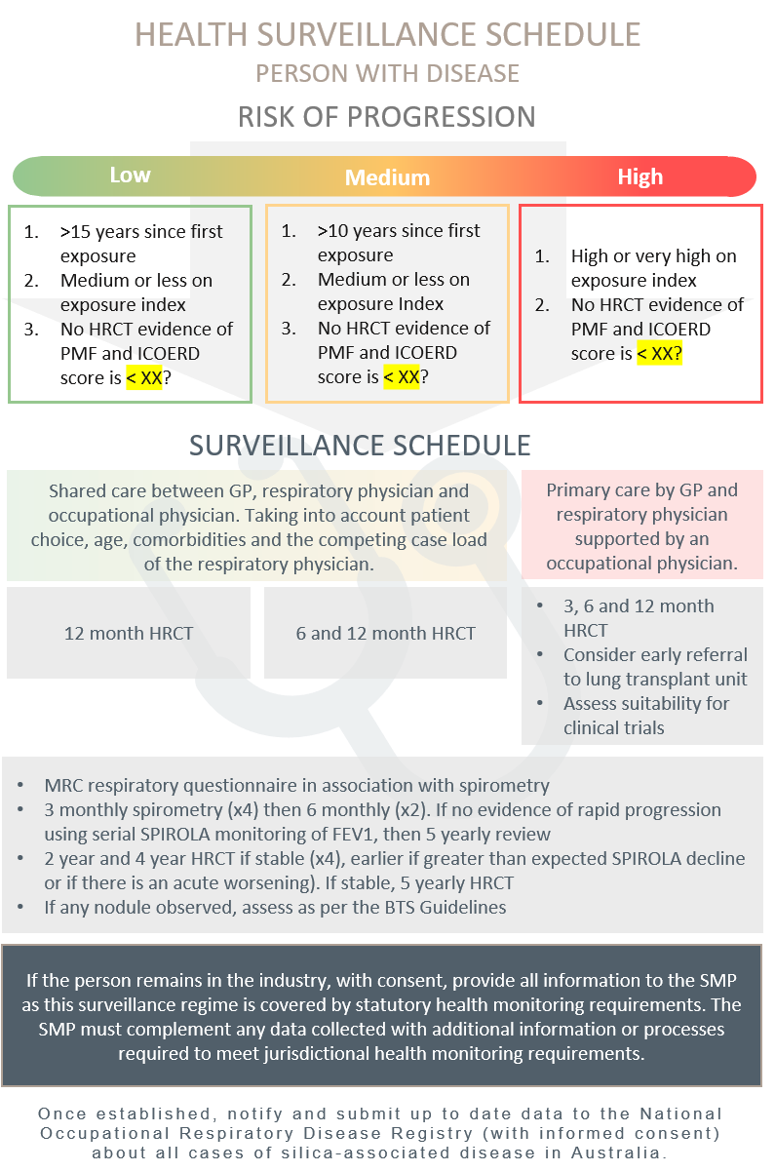
Table 5: Surveillance schedule following first diagnosis based on risk of progression
Abbreviations: BTS, British Thoracic Society; CT, computerised tomography; FEV1, forced expiratory volume in one second; HRCT, high-resolution computerised tomography; ICOERD, International Classification of High-resolution Computed Tomography for Occupational and Environmental Respiratory Diseases; MRC, Medical Research Council; PMF, progressive massive fibrosis; SMP, supervising medical practitioner; SPIROLA, Spirometry Longitudinal Data Analysis
Table 6 presents the recommended surveillance schedule based on the Exposure Index (see B. Exposure stratification) of a person who has normal baseline results and has left the industry (no predictable continuing exposure to RCS).

Table 6: Surveillance schedule based on the Exposure Index of a person who has normal baseline results and has left the industry (no predictable continuing exposure to RCS)
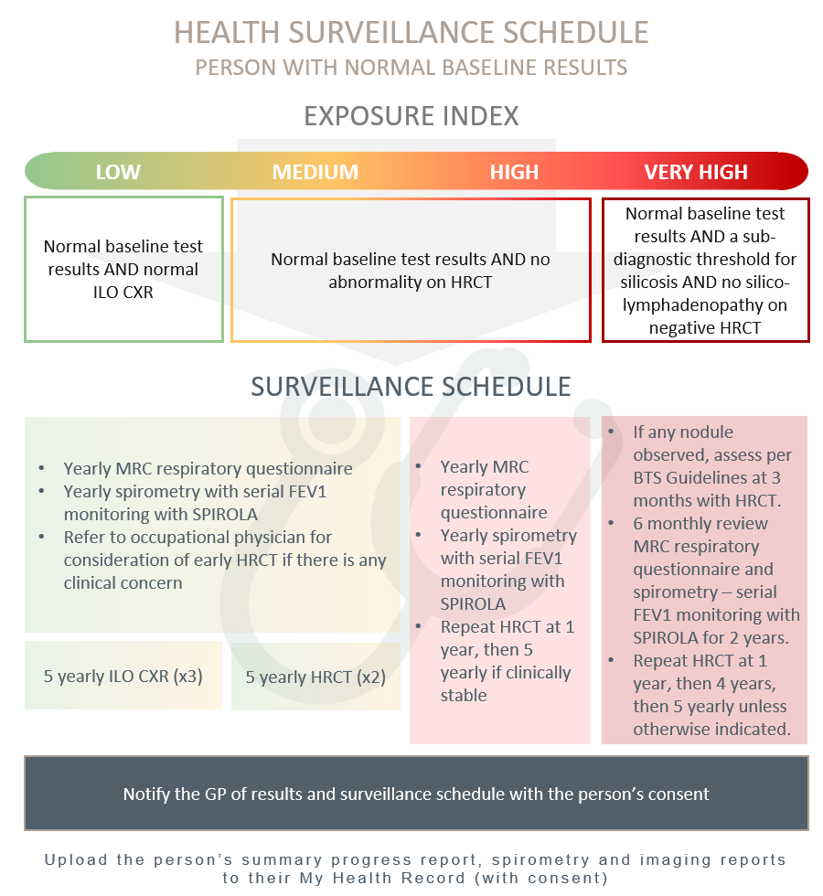
Note: HRCT must be capable of coronary angiography
Abbreviations: CXR, chest x-ray; FEV1, forced expiratory volume in one second; HRCT, high-resolution computed tomography; ILO, International Labour Organization; MRC, medical research council; SPIROLA, Spirometry Longitudinal Data Analysis Software

5. Who carries out ongoing surveillance for the person?
Key practice points
- Ongoing surveillance should ideally be carried out by the same specialist who conducted the baseline assessment.
- The GP, should with the support of any former SMP, and respiratory or occupational physician involved in their patient’s care, should oversee any ongoing surveillance for an individual who is no longer employed in a role where there are no “predictable excursions” to the WES TWA.
Supervising medical practitioner
- The SMP must oversee any health monitoring activity with consent with the worker’s treating medical practitioners (GP’s and relevant specialists), for as long as the person is employed in an “at-risk role”.
[Statutory requirement]
- With the person’s consent, the SMP should share care and communicate with any treating medical practitioner involved in the worker’s continued health and wellbeing.
- Information collected should be uploaded to the person’s My Health Record, with consent.
- All SMPs responsible for the statutory health monitoring of a worksite, should be publicly identifiable as supervising the health monitoring for that worksite. With the person’s consent, a GP can then contact the relevant SMP as and when needed.

For continuity of care, ongoing surveillance should occur under the guidance of the same specialist who conducted the baseline assessment. However, the nature of the follow-up will depend on the person’s:
- Disease status
- Individual’s personal circumstances, and
- Their work status.
Significantly exposed individuals may also move through several workplaces with different employers and with similar or dissimilar risk profiles. They may cease all at-risk work or move across industrial-political jurisdictions. Consequently, for as long as the person is employed in an “at-risk role”, the SMP has a statutory responsibility to oversee the health monitoring activity in consent with the worker’s treating medical practitioners (GP’s and relevant specialists). The SMP also carries a professional responsibility to share care with any treating medical practitioner involved in the worker’s continued health and wellbeing. Direct communication is recommended, but at minimum, should include uploading progress investigation results and reports to the worker’s My Health Record, with their consent. An example of a form report is included in Appendix C (61). This will aid effective communication, avoid duplicated effort, minimise the number of investigations, and reduce the risk of confusion generated by differing opinion.
When an individual is no longer employed in an at-risk industry sector, the person’s GP resumes the leadership role for the ongoing health surveillance of their patient. Support should be provided from any former SMP, and respiratory or occupational physician involved in their patient’s care.
The SMPs responsible for the statutory health monitoring of a worksite should be publicly available and maintained by the responsible regulator. With the person’s consent, a GP can then contact the relevant SMP for additional information if needed.
To facilitate information exchange, statutory authority be enacted to enable appropriate transfer of health information between SMP’s and treating medical practitioners involved in an individual’s care. Appropriate constraints should be considered limiting information sharing with third parties, including PCBUs.
GP’s should also be kept informed either directly or by the individual’s My Health Record if their patient has been enrolled in a national or jurisdictional registry that may be tracking their patient’s clinical progress, and be informed if their patient has consented to participate in any research project.
In most jurisdictions the workplace insurer is responsible for the costs associated with the assessment of an occupational illness or disease. If the GP becomes concerned about a possible RCS related disease developing over the course of health surveillance, they should follow their usual referral procedures to either a respiratory or occupational physician and issue an associated worker’s compensation certificate indicating “known occupational silica dust exposure requires specialist assessment”. If known, the referral should identify the intimated case reference number if the person was involved in any historic health screening activity.
Issuing a worker’s compensation certificate associated with an escalation of the health surveillance activity enables case identification independent of current employment status. In most jurisdictions, if the current employment is not a significant contributing factor to the development of the disease, the costs associated with the claim goes against the common pool and does not penalise the current employer’s claims based premium.

6. What are the notification requirements?
Key practice points
- A summary of findings, management plan and a background description of the scheme should be provided to the person, and with their consent to their GP and SMP. The information should also be uploaded to the person’s My Health Record.
- Once established, notify and submit up to date data to the National Occupational Respiratory Disease Registry (with informed consent) about all cases of silica-associated disease in Australia.
Government
- Continue progressing the development of a National Occupational Respiratory Disease Registry to collect data (with informed consent) about all cases of silica-associated disease in Australia.

With the person’s consent, professional ethics requires that any medical practitioner conducting health surveillance, if not the treating GP, provide a report to the worker, their GP and the supervising health monitoring doctor for the worker’s employer. An example report is included in in Appendix C (61).
Employer reports are the statutory responsibility, and any jurisdictional regulated reports are the responsibility of the SMP and outside the scope of this Guideline.
In some states and territories, specialist medical practitioners who have diagnosed an individual with an occupational dust lung disease are obligated to notify authorities. Queensland, for example has established a Notifiable Dust Lung Disease Register (62).
In other states, such as Victoria, Monash University has been commissioned by WorkSafe Victoria to undertake research into assessment of silica-associated lung disease.
There is no current mandatory requirement to notify cases to a national registry. However, the National Dust Disease Taskforce is currently exploring the options for establishing a National Occupational Respiratory Disease Registry.

Future Research

Appendices

Appendix A: Exposure dose questionnaire
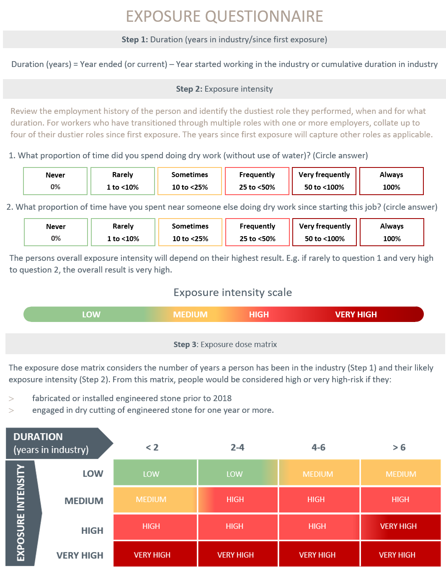

Appendix B: Shared decision making tool
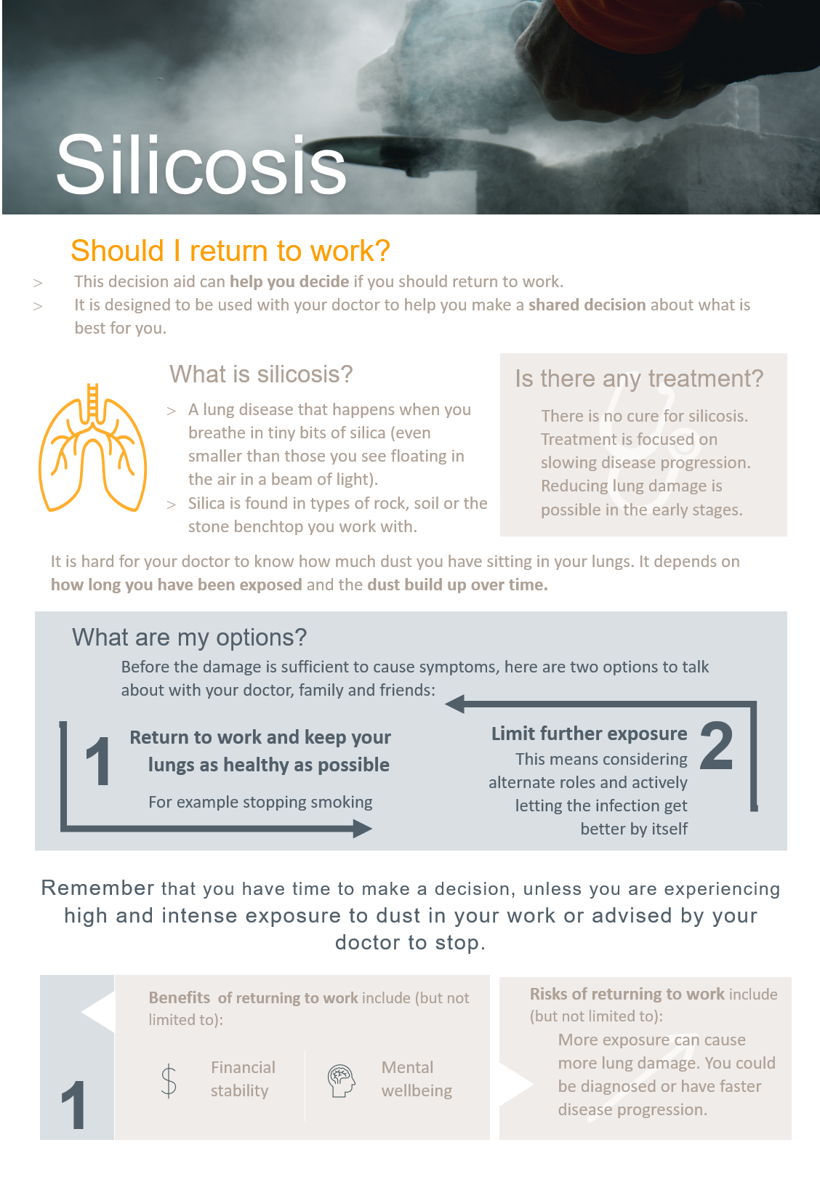

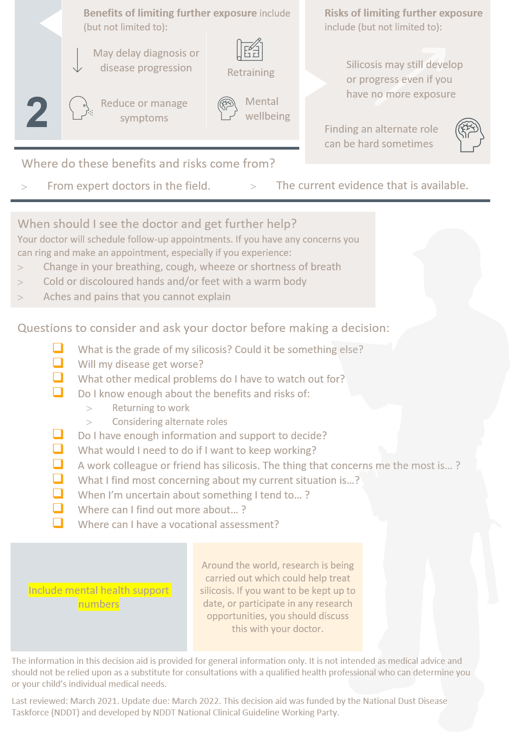

Appendix C: Form report example
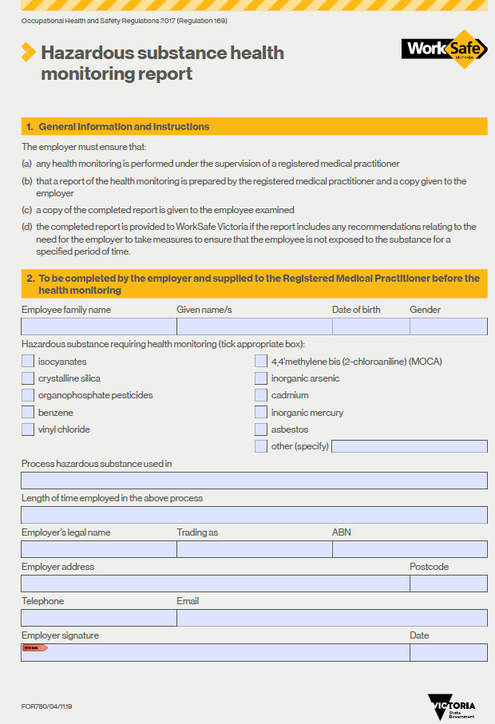

References

1. The Department of Health. National Dust Disease Taskforce 2021 [cited 3 March 2021]. Available from: https://www1.health.gov.au/internet/main/publishing.nsf/Content/ohp-nat-dust-disease-taskforce.htm?Open=&utm_source=health.gov.au&utm_medium=redirect&utm_campaign=digital_transformation&utm_content=dust.
2. Alif S, Glass D, Abramson M, Hoy R, AM MS. Occupational lung diseases in Australia.
3. Leso V, Fontana L, Romano R, Gervetti P, Iavicoli I. Artificial Stone Associated Silicosis: A Systematic Review. Int J Environ Res Public Health. 2019;16(4).
4. Balakrishnan B, Mehta S, Ouellette D, Talavera F, Mosenifar Z, Varkey B, et al. Silicosis 2019 [cited 12 March 2021]. Available from: https://emedicine.medscape.com/article/302027-overview.
5. WorkSafe Queensland Government. Silicosis: Workcover Screening Outcomes 2020 [cited 12 March 2020]. Available from: https://www.worksafe.qld.gov.au/claims-and-insurance/work-related-injuries/types-of-injury-or-illness/work-related-respiratory-diseases/silicosis.
6. Blanc PD, Annesi-Maesano I, Balmes JR, Cummings KJ, Fishwick D, Miedinger D, et al. The Occupational Burden of Nonmalignant Respiratory Diseases. An Official American Thoracic Society and European Respiratory Society Statement. American Journal of Respiratory and Critical Care Medicine. 2019;199(11):1312-34.
7. Occupational Safety and Health Administration (OSHA). Occupational Exposure to Respirable Crystalline Silica: Proposed Rule. Federal Register 78 (177), FR Doc No: 2013-20997. 2013 [cited 1 November 2020]. Available from: https://www.osha.gov/pls/oshaweb/owadisp.show_document?p_table=FEDERAL_REGISTER&p_id=23900.
8. Rose C, King T, Hollingsworth H. Silicosis: UpToDate 2020 [cited 2020 1 November]. Available from: https://www.uptodate.com/contents/silicosis?search=silicosis&source=search_result&selectedTitle=1~27&usage_type=default&display_rank=1%22%20%5Cl%20%22H288865219%22.
9. Álvarez RF, González CM, Martínez AQ, Pérez JJB, Fernández LC, Fernández AP. Guidelines for the diagnosis and monitoring of silicosis. Archivos de Bronconeumología (English Edition). 2015;51(2):86-93.
10. National Institute for Occupational Safety and Health (NIOSH). Work-related lung disease surveillance report 2007 [cited 1 November 2020]. Available from: https://www.cdc.gov/niosh/docs/2008-143/pdfs/2008-143.pdf?id=10.26616/NIOSHPUB2008143a.
11. Merget R, Bauer T, Küpper HU, Philippou S, Bauer HD, Breitstadt R, et al. Health hazards due to the inhalation of amorphous silica. Arch Toxicol. 2002;75(11-12):625-34.
12. Carrieri M, Guzzardo C, Farcas D, Cena LG. Characterization of Silica Exposure during Manufacturing of Artificial Stone Countertops. International journal of environmental research and public health. 2020;17(12):4489.
13. Ophir N, Shai AB, Korenstein R, Kramer MR, Fireman E. Functional, inflammatory and interstitial impairment due to artificial stone dust ultrafine particles exposure. Occupational and environmental medicine. 2019;76(12):875-9.
14. Hoy RF, Chambers DC. Silica‐related diseases in the modern world. Allergy. 2020;75(11):2805-17.
15. Rimal B, Greenberg AK, Rom WN. Basic pathogenetic mechanisms in silicosis: current understanding. Current opinion in pulmonary medicine. 2005;11(2):169-73.
16. Cohen R, Go L. November 9, personnel communications. DNRME industry workshop forum 2019.
17. Barnes H, Goh NS, Leong TL, Hoy R. Silica‐associated lung disease: An old‐world exposure in modern industries. Respirology. 2019;24(12):1165-75.
18. Lee S, Matsuzaki H, Kumagai-Takei N, Yoshitome K, Maeda M, Chen Y, et al. Silica exposure and altered regulation of autoimmunity. Environmental Health and Preventive Medicine. 2014;19(5):322-9.
19. Aran D, Looney AP, Liu L, Wu E, Fong V, Hsu A, et al. Reference-based analysis of lung single-cell sequencing reveals a transitional profibrotic macrophage. Nat Immunol. 2019;20(2):163-72.
20. International Labour Office. Guidelines for the use of the ILO international classification of radiographs of pneumoconiosis (Revised Edition 2011) International Labour Office, Geneva, Switzerland2011 [cited 4 Jan 2021]. Available from: https://www.ilo.org/safework/info/WCMS_108548/lang--en/index.htm.
21. Kusaka Y, Hering KG, Parker JE. International classification of HRCT for occupational and environmental respiratory diseases: Springer; 2005.
22. Perret JL, Miles S, Brims F, Newbigin K, Davidson M, Jersmann H, et al. Respiratory surveillance for coal mine dust and artificial stone exposed workers in Australia and New Zealand: A position statement from the Thoracic Society of Australia and New Zealand*. Respirology. 2020;25(11):1193-202.
23. Stansbury RC, Beeckman-Wagner LA, Wang ML, Hogg JP, Petsonk EL. Rapid decline in lung function in coal miners: evidence of disease in small airways. Am J Ind Med. 2013;56(9):1107-12.
24. Almberg K, Go L, Yates D, Waite T, Cohen R. Silicosis Return to Work review: Return to Work and Vocational Rehabilitation Support for Workers Suffering from Silicosis. WorkSafe Queensland 2020.
25. León-Jiménez A, Hidalgo-Molina A, Conde-Sánchez MÁ, Pérez-Alonso A, Morales-Morales JM, García-Gámez EM, et al. Artificial Stone Silicosis. Chest. 2020;158(3):1060-8.
26. Hertzberg VS, Rosenman KD, Reilly MJ, Rice CH. Effect of occupational silica exposure on pulmonary function. Chest. 2002;122(2):721-8.
27. Sircar K, Hnizdo E, Petsonk E, Attfield M. Decline in lung function and mortality: implications for medical monitoring. Occup Environ Med. 2007;64(7):461-6.
28. Carneiro AP, Barreto SM, Siqueira AL, Cavariani F, Forastiere F. Continued exposure to silica after diagnosis of silicosis in Brazilian gold miners. Am J Ind Med. 2006;49(10):811-8.
29. Hessel PA, Sluis-Cremer GK, Hnizdo E, Faure MH, Thomas RG, Wiles FJ. Progression of Silicosis in Relation to Silica Dust Exposure. The Annals of Occupational Hygiene. 1988;32(inhaled_particles_VI):689-96.
30. Lee HS, Phoon WH, Ng TP. Radiological progression and its predictive risk factors in silicosis. Occup Environ Med. 2001;58(7):467-71.
31. Almberg KS, Friedman LS, Rose CS, Go LH, Cohen RA. Progression of coal workers’ pneumoconiosis absent further exposure. Occupational and environmental medicine. 2020;77(11):748-51.
32. Dumavibhat N, Matsui T, Hoshino E, Rattanasiri S, Muntham D, Hirota R, et al. Radiographic progression of silicosis among Japanese tunnel workers in Kochi. Journal of occupational health. 2013:12-0258-OA.
33. Akgun M, Araz O, Ucar EY, Karaman A, Alper F, Gorguner M, et al. Silicosis appears inevitable among former denim sandblasters: a 4-year follow-up study. Chest. 2015;148(3):647-54.
34. Taylor A, Cullinan P, Blanc P, Pickering A. Parkes' Occupational Lung Disorders, Fourth Edition. 2016: Chapter 18, 187-205.
35. Mohebbi I, Zubeyri T. Radiological progression and mortality among silica flour packers: a longitudinal study. Inhal Toxicol. 2007;19(12):1011-7.
36. Safe Work Australia. Crystalline silica and silicosis [cited 12 March 2021]. Available from: https://www.safeworkaustralia.gov.au/silica.
37. Australian Commission on Safety and Quality in Healthcare. Shared decision making [cited 7 March 2021]. Available from: https://www.safetyandquality.gov.au/our-work/partnering-consumers/shared-decision-making.
38. Hoffmann TC, Legare F, Simmons MB, McNamara K, McCaffery K, Trevena LJ, et al. Shared decision making: what do clinicians need to know and why should they bother? Medical Journal of Australia. 2014;201(1):35-9.
39. Safe Work Australia. Crystalline silica health monitoring guide [cited 8 March 2021]. Available from: https://www.safeworkaustralia.gov.au/book/crystalline-silica-health-monitoring-guide.
40. Safe Work Australia. Insights report: Exploring dust exposure in the stone industry 2020 [cited 12 March 2021]. Available from: https://www.safeworkaustralia.gov.au/doc/insights-report-exploring-dust-exposure-stone-industry.
41. Hall & Partners. National Dust Disease Taskforce Consultation Synthesis Report. Department of Health 2021 [cited 2021 30 March]. Available from: https://www1.health.gov.au/internet/main/publishing.nsf/Content/562CF83B7AECFC8FCA2584420002B113/$File/Final-Report-Second-Phase-Consultation.pdf.
42. Perret JL, Miles S, Brims F, Newbigin K, Davidson M, Jersmann H, et al. Respiratory surveillance for coal mine dust and artificial stone exposed workers in Australia and New Zealand: A position statement from the Thoracic Society of Australia and New Zealand. Respirology. 2020;25(11):1193-202.
43. Safe Work Australia. Hazardous Chemicals Requiring Health Monitoring [cited 13 March 2021]. Available from: https://www.safeworkaustralia.gov.au/system/files/documents/1702/hazardous-chemicals-requiring-health-monitoring.pdf.
44. Quanjer PH, Stanojevic S, Cole TJ, Baur X, Hall GL, Culver BH, et al. Multi-ethnic reference values for spirometry for the 3–95-yr age range: the global lung function 2012 equations. Eur Respiratory Soc; 2012.
45. Kaminsky D, McCormack M, Hollingsworth H. Selecting reference values for pulmonary function tests 2020 [cited March 15 2021]. Available from: https://www.uptodate.com/contents/selecting-reference-values-for-pulmonary-function-tests?search=diffusion%20capacity&topicRef=6972&source=see_link#H2756544172.
46. Queensland Government. Guideline for assessing engineered stone workers exposed to silica [cited 5 March 2021]. Available from: https://www.worksafe.qld.gov.au/__data/assets/pdf_file/0014/25232/guideline-for-assessing-stone-workers-exposed-to-silica.pdf.
47. Graham BL, Brusasco V, Burgos F, Cooper BG, Jensen R, Kendrick A, et al. 2017 ERS/ATS standards for single-breath carbon monoxide uptake in the lung. European Respiratory Journal. 2017;49(1).
48. Gibson J. Respiratory function tests in occupational lung disorders. Pakes' Occupational Lung Disorders 4th ed. 2016.
49. Flaherty KR, Brown KK, Wells AU, Clerisme-Beaty E, Collard HR, Cottin V, et al. Design of the PF-ILD trial: a double-blind, randomised, placebo-controlled phase III trial of nintedanib in patients with progressive fibrosing interstitial lung disease. BMJ open respiratory research. 2017;4(1):e000212.
50. Maher TM, Corte TJ, Fischer A, Kreuter M, Lederer DJ, Molina-Molina M, et al. Pirfenidone in patients with unclassifiable progressive fibrosing interstitial lung disease: a double-blind, randomised, placebo-controlled, phase 2 trial. The Lancet Respiratory medicine. 2020;8(2):147-57.
51. Behr J, Neuser P, Prasse A, Kreuter M, Rabe K, Schade-Brittinger C, et al. Exploring efficacy and safety of oral Pirfenidone for progressive, non-IPF lung fibrosis (RELIEF)-a randomized, double-blind, placebo-controlled, parallel group, multi-center, phase II trial. BMC pulmonary medicine. 2017;17(1):1-9.
52. The Royal Australian and New Zealand College of Radiologists (RANZCR). Imaging of Occupational Lung Disease: Position Statement 2019 [Available from: file:///C:/Users/AiyaTaylor/Downloads/Silicosis%20Position%20Statement.pdf.
53. Prasad JD, Mahar A, Bleasel J, Ellis SJ, Chambers DC, Lake F, et al. The interstitial lung disease multidisciplinary meeting: A position statement from the Thoracic Society of Australia and New Zealand and the Lung Foundation Australia. Respirology. 2017;22(7):1459-72.
54. Department of Mines - Industry Regulation and Safety. Silica Dust (respirable crystalline) – Health Surveillance – Guide for medical practitioners: Government of Western Australia; 2020 [cited 4 March 2020]. Available from: https://www.commerce.wa.gov.au/worksafe/silica-dust-respirable-crystalline-health-surveillance-guide-medical-practitioners.
55. Ge C, Peters S, Olsson A, Portengen L, Schüz J, Almansa J, et al. Respirable Crystalline Silica Exposure, Smoking, and Lung Cancer Subtype Risks. A Pooled Analysis of Case–Control Studies. American journal of respiratory and critical care medicine. 2020;202(3):412-21.
56. Baldwin DR, Callister ME. The British Thoracic Society guidelines on the investigation and management of pulmonary nodules. Thorax. 2015;70(8):794-8.
57. WorkSafe Queensland Government. Silicosis 2020 [cited 29 March 2021]. Available from: https://www.worksafe.qld.gov.au/claims-and-insurance/work-related-injuries/types-of-injury-or-illness/work-related-respiratory-diseases/silicosis.
58. Monash University, WorkSafe Victoria. Silica-associated lung disease health screening research: Phase one final report WorkSafe Victoria2020 [cited 29 March 2021]. Available from: https://www.worksafe.vic.gov.au/resources/silica-associated-lung-disease-health-screening-research-phase-one-final-report.
59. Hoy RF, Glass DC, Dimitriadis C, Hansen J, Hore-Lacy F, Sim MR. Identification of early-stage silicosis through health screening of stone benchtop industry workers in Victoria, Australia. Occupational and environmental medicine. 2021;78(4):296-302.
60. Cottin V. Treatment of progressive fibrosing interstitial lung diseases: a milestone in the management of interstitial lung diseases. European Respiratory Review. 2019;28(153):190109.
61. WorkSafe Victoria. Hazardous substance health monitoring report 2020 [cited 3 March 2021]. Available from: https://www.worksafe.vic.gov.au/resources/hazardous-substance-health-monitoring-report.
62. Queensland Health. Notifiable dust lung disease register: Queensland Government; 2020 [cited 15 March 2021]. Available from: https://www.health.qld.gov.au/public-health/industry-environment/dust-lung-disease-register

The TWA’s are generally based on the chronic or sub chronic effect that occurs at the lowest airborne concentration of the chemical (the critical effect). The WES is derived on the assumption of protecting nearly all workers (noting natural biological variation and sensitive individuals) and a working lifetime of eight work-hours per day, five working days per week, 48 working weeks per year, and 40 working years per lifetime.
A list of consultant physicians in Occupational and Environmental Medicine can be accessed at https://www.racp.edu.au/about/college-structure/australasian-faculty-of-occupational-and-environmental-medicine/find-a-consultant
In Queensland, a list of Respiratory Physicians with a special interest in Coal Workers Pneumoconiosis which includes silicosis can be accessed at https://www.thoracic.org.au/information-public/register-of-physicians-in-queensland
A list of qualified technicians in credentialed facilities can be accessed at https://www.thoracic.org.au/respiratorylaboratoryaccreditation/list-of-accredited-labs
Guidelines for the use of the International Labour Organisation (ILO) International Classification of Radiographs of Pneumoconiosis (revised edition 2011) https://www.ilo.org/global/topics/safety-and-health-at-work/resources-library/publications/WCMS_168260/lang--en/index.htm

