Brief practice guide:
National Guidelines for doctors
managing workers exposed to
respirable crystalline silica
with specific reference to the occupational
respiratory diseases associated with engineered stone

Disclaimer
These Guidelines are a general guide to appropriate practice, to be followed subject to the medical practitioners’ judgements and the patient’s preference in each individual care. The Working Group acknowledges that debate in the literature on definitions is evolving. The role of the Working Group was to develop Guidelines that provide information to assist in decision-making, to create definitions on what we know and are seeing now as experts in the field and to bring the existing legislative framework and regulators up to the Working Group agreed standards. The recommendations included within these Guidelines are based on the best evidence available at the time of development.
Citation
Dust Disease Taskforce Working Group. National Guidelines for doctors managing workers exposed to respirable crystalline silica – with specific reference to the occupational respiratory diseases associated with engineered stone. Available on the Dust Taskforce Website (https://www1.health.gov.au/internet/main/publishing.nsf/Content/ohp-nat-dust-disease-taskforce.htm)

Table of Contents
Table of Contents 3
Tables 4
Figures 4
Guideline Summary 5
Occupational respiratory disease 5
What are occupational respiratory diseases? 5
What is silicosis? 5
Why are the Guidelines important? 5
Why is early diagnosis important? 6
What is the impact of exposure to RCS and silicosis? 6
How to prevent silicosis? 6
What are the statutory obligations of the PCBU? 7
What is health monitoring? 7
Guidelines 8
(i) Case identification practices 9
(ii) Ongoing health surveillance 9
Case Identification 10
Step 1: Identify a person of interest and refer them to an appropriate medical practitioner 10
Step 2: Initial investigation and assessment 12
Health Surveillance 15
Step 3: Ongoing health surveillance 15
Step 4: Notify 17
Appendices 18
Appendix A: Classification of silicosis 19
Appendix B: Prevention of silicosis 20
Appendix C: Baseline data to collect 21
Appendix D: Exposure dose questionnaire 22
Appendix E: Shared decision-making tool 23
Abbreviations 25
Glossary 26
References 28

Tables
Table 1: Surveillance schedule following first diagnosis based on risk of progression 15
Table 2: Surveillance schedule based on the Exposure Index of a person who has normal baseline results and has left the industry or has no predictable continuing exposure to RCS 16
Table 3: Prevention of silicosis 20

Figures
Figure 1: Identifying the appropriate referral pathway 10
Figure 2: Initial assessment of a person exposed to RCS 12

Guideline Summary
This summary has been developed from the National Guidelines for doctors managing workers exposed to respirable crystalline silica (RCS) (the Guidelines). The summary is to provide Australian medical practitioners including general practitioners (GPs), Consultant Physicians in Occupational and Environmental Medicine and Respiratory Medicine, Researchers and Radiologists, with key practice points to guide them when identifying people at-risk from RCS dust exposure and carrying out health surveillance. Key practice points presented are based upon the best available evidence and a consensus of expert clinicians. While these Guidelines are focused on RCS, it is structured as a framework for the assessment of any worker with occupational dust exposure.

Occupational respiratory disease

What are occupational respiratory diseases?
Occupational dust exposure is a significant cause of respiratory illness in Australia. People exposed to dust while at work can develop several diseases, many of which may not be detected until long after the original exposure has ceased.
The most widely studied dust disease is silicosis due to RCS exposure. However, the recent increase in artificial stone related silicosis has created an urgent need and opportunity to learn more about the disease.

What is silicosis?
Silicosis is an irreversible pneumoconiosis caused by the accumulative exposure to RCS dust. Silica, also known as silicon dioxide, is a naturally occurring and widely abundant mineral in most rocks and soils. Silica dust is generated in the workplace by mechanical processes such as crushing, cutting and drilling rock or rock products containing silica.
Inhalation of respirable silica dust particles (<10 μm aerodynamic diameter) are carried to the distal airways and alveoli. Once in the respirable zone of the lung, the silica particles are engulfed by alveolar macrophages and several pro-inflammatory and profibrotic pathways activated. Refer to the Guidelines for more information.

Why are the Guidelines important?
While millions of workers are estimated to be exposed to silica worldwide, the number of people who are at-risk and affected by silicosis is unknown. The available data from Queensland and Victorian cohorts suggests a 20-30% crude prevalence for all forms of silicosis in exposed stonemasons working with engineered stone. Unfortunately, a breakdown of those screened by exposure history, type of disease or the nature of any progression is not available.
Silicosis is associated with significant premature mortality among workers.
In the United States, between 1996 and 2005, 1746 deaths due to silica exposure resulted in 20 234 years of life lost, with an average of 11.6 years of life lost (3). For the same period, among 307 people who died before age 65, there were 3045 years of life lost, with an average of 9.9 years of life lost from a working life (4, 5).
In 2020, the Australian Government accepted the National Dust Disease Taskforce recommendation for the establishment of a National Occupational Respiratory Disease Registry. Learnings from the registry will inform future versions of this Guideline.

Why is early diagnosis important?
Identifying a patient early, before they clinically manifest the disease, provides the best options for delaying or stopping progression. Therefore, clinical manifestations, if present and physical examination findings provide evidence to support the diagnosis but are not required for a formal diagnosis.
The diagnosis of silicosis is a clinical conclusion based on:
- a clinical history of sufficient exposure to silica/silicates consistent with a cumulative lung burden capable of triggering the disease process, and
- lung parenchymal radiographic appearances more likely to be consistent with silicosis, and
- an absence of another more likely diagnoses that can simulate the radiographic abnormalities of silicosis.
See Appendix A for a summary of the different types of silicosis.
For GPs who would like to follow a learning course on diagnosis and management of silicosis: see the Royal Australian College of General Practitioners learning resource

What is the impact of exposure to RCS and silicosis?
Epidemiological studies have demonstrated a strong relationship between cumulative exposure to RCS dust, disease severity and the risk of progression.
Silicosis can develop in the previously exposed worker and in the absence of any further exposure, even if there is no evidence of disease when first seen. Continued caution is therefore required.
The risk of progression continues even after the worker is no longer exposed to RCS dust.
For a more detailed understanding on exposure to RCS and silicosis as well as the evidence available, refer to the Guidelines.

Continued exposure to RCS and disease progression
Once a worker has been diagnosed with silicosis, continued exposure to hazardous levels of RCS causes faster disease progression compared with those who left high exposure settings.
Progression is strongly associated with duration of exposure and the severity of disease status at the time of first diagnosis. Workers are at an increased risk of progression if they have large opacities on their initial imaging.
In theory, unintentional high short-term exposure to RCS could potentially convert an inactive disease process into an active progressive disease.

How to prevent silicosis?
There is currently no treatment for silicosis. Prevention of cumulative exposure that might trigger silicosis is therefore the highest priority.
See Appendix B for a summary of prevention strategies or refer to the Guidelines for more information.

What are the statutory obligations of the PCBU?
Under existing work health and safety laws, a “person conducting a business or undertaking” (PCBU) has specific duties. These include identifying hazards and managing the risks to health and safety when using, handling, generating and storing hazardous chemicals, including silica.
Consequently, PCBUs have a statutory duty to apply the primary prevention strategies and to fund and support the secondary prevention strategies for their at-risk workers.
As a medical practitioner, your patient, or sometimes your patient’s workplace insurer, may ask your advice concerning the risk of harm should your patient return to their place of work. This can be difficult when only limited information is available and is best undertaken by a consulting specialist physician in occupational and environmental medicine. Referral to an occupational or respiratory physician is highly recommended.
For a presenting patient, the exposure of concern could have been years ago, or with a former employer, not their current employment setting.

What is health monitoring?
Health surveillance is what you do in everyday practice.
Health monitoring is a formal program, instituted by a PCBU if a risk assessment or Code of Practice indicates it is needed.
The PCBU acquires a duty to engage a suitably qualified medical practitioner to supervise the health monitoring program.
While the supervising medical practitioner (SMP) has no statutory authority to decide which workers must undergo health monitoring, they can provide you with valuable insights into the workplace in which your patient works. As a result, it is important to identify who the workers SMP is.

Guidelines
There are several key principles in relation to the identification, investigation and ongoing management of individuals at-risk of RCS related disease that can be divided into (i) case identification and (ii) ongoing health surveillance. The following practice points are provided to establish a set of minimum standards to inform health practitioners undertaking case identification and health surveillance. These standards are also recommended for any statutory or government funded activity.

(i) Case identification practices
GP clinics and local community health centres are important resources to both identify and respond to the needs of workers.
For those who no longer work in an at-risk industry, GPs play an even more important role in identifying cases early, refering them to the appropriate specialists and providing support to the person, their family and friends.
Case identification is a strategy for targeting resources at individuals or groups who are suspected to be at high-risk for disease.
The purpose of case identification is to:
- Identify, educate and support workers with no early markers of disease but who remain at-risk.
- Identify people who have markers of possible early disease, but do not reach the threshold needed for active health surveillance.
- Provide counsel and support for people with early disease and apply interventions to minimise the risk of rapid progression.
- Identify people with established disease and refer them for specialist shared care.
The outcomes of case identification are:
- Baseline data collection
- Finding people with disease
- Risk stratification of those without disease but have been exposed.

(ii) Ongoing health surveillance
Health surveillance describes the purposeful and ongoing acquisition, interpretation and synthesis of patient data in a manner that informs clinical decision-making after a case has been identified.
Activities are undertaken within a schedule that reflects the pathophysiology of the disease, surveying for the earliest reliable indices of clinical significance. Consequently, health surveillance is informed by:
- Appropriate intervals to detect a change of significance, sensitive to the natural intra-individual and inter-individual variation.
- Detecting the more rapidly progressive forms of the disease as soon as practical.
- next best practice principles (what is anticipated to be best practice in the future) that have been endorsed by the medical profession for assessing and diagnosing occupational respiratory diseases.
Effective ongoing surveillance must:
- engage with and enhance existing jurisdictional resources including GP clinics, hospitals, specialist clinics, imaging, pathology and allied health care services; and
- be conducted within a quality-controlled continuity of care framework.

For additional information or a more detailed understanding of the practice points, refer to the Guidelines.

Case Identification

Step 1: Identify a person of interest and refer them to an appropriate medical practitioner
Additional resources required
- General medical questionnaire
- MRC respiratory questionnaire
- Descriptors of “at-risk roles” – Similar exposure groups (SEGs)
- Contact database for occupational physicians and suitably qualified medical practitioners.

Figure 1: Identifying the appropriate referral pathway
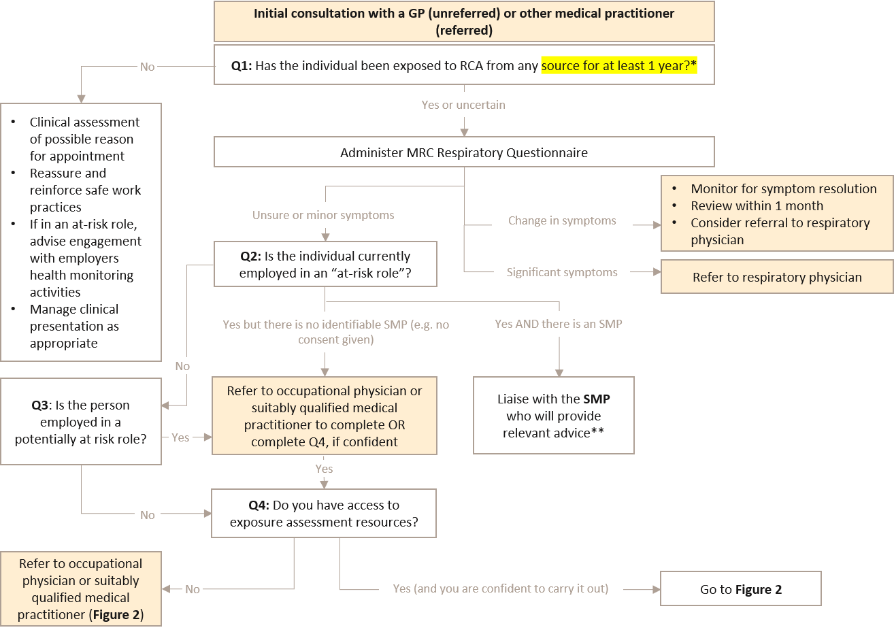
Abbreviations: GP, general practitioner; MRC, medical research council; RCS, respirable crystalline silica; SMP, supervising medical practitioner; Q, question
*To date if a person has worked less than 3 years in an “at-risk role” in Australia, there has not been a reported confirmed case. The National Occupational Respiratory Disease Registry will continue to monitor case experience and modify this threshold if necessary.
**The SMP and the PCBU has statutory responsibilities and can provide advice relevant to the person’s exposure risk setting
How to identify a person of interest and refer them to the appropriate medical practitioner?
- If your patient is employed in an “at-risk role”, contact the worker’s SMP (with their consent).
- Avoid duplication, obtain advice and support; health monitoring is funded by the PCBU.
- If your patient has significant symptoms or a persistent change in symptoms, refer to a respiratory physician.
- If your patient has unclear or minor symptoms, carry out an exposure assessment (see Step 2) if there is no SMP.
- Refer to an occupational physician or suitably qualified medical practitioner if you are not confident in exposure assessments.
- For patients who have been exposed for less than one year or have no early markers of disease, strongly reassure, reinforce safe work practices and address their clinical concerns, if necessary.
Supervising medical practitioner
- The SMP can coordinate health monitoring activities and facilitate the exposure assessment.

If you are not experienced or confident in occupational respiratory diseases, always refer your patient to an occupational physician or another qualified medical practitioner.

Step 2: Initial investigation and assessment
Additional resources required
- Exposure questionnaire (see Appendix D)
- Modified MRC dyspnoea questionnaire
- Spirometry (The Thoracic Society of Australia and New Zealand [TSANZ] standard)
- Mental health questionnaire (at-risk persons)

Figure 2: Initial assessment of a person exposed to RCS
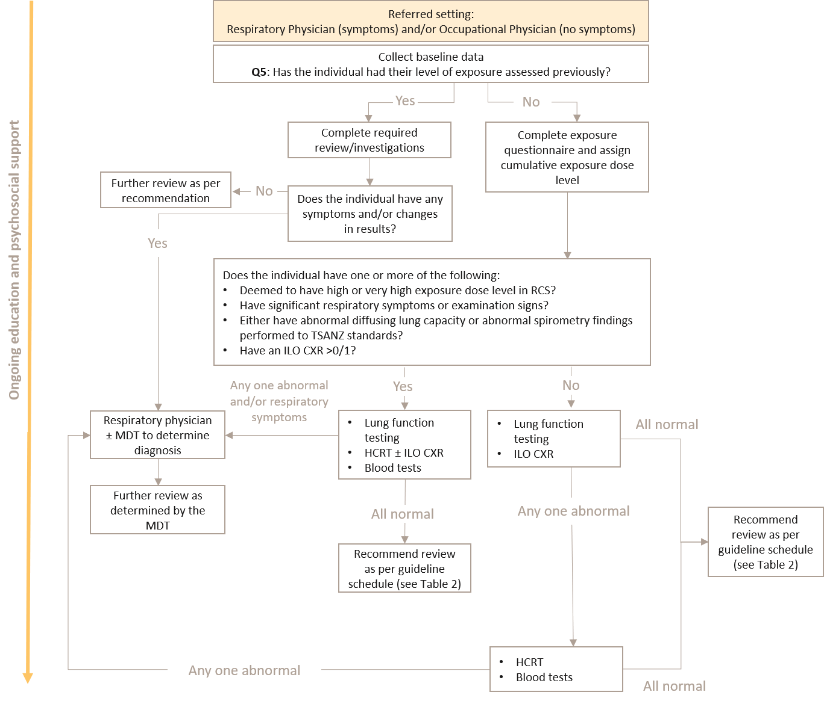
Abbreviations: CXR, chest X-ray; HCRT, high-resolution computed tomography; ILO, International Labour Organization; MDT, multidisciplinary team; RCS, respirable cystalline silica; TSANZ, The Thoracic Society of Australia and New Zealand

What baseline data should be collected?
- Collect baseline demographic, exposure and medical history, respiratory symptoms (if any) and physical examination findings (see Appendix C).
- Upload, with the person’s consent, the information to their My Health Record.
How should a person’s exposure risk be determined?
- If you are confident and have the appropriate experience, carry out the exposure assessment.
Respiratory physician and occupational physicians
- Use the exposure questionnaire (see Appendix D) for people who have been exposed to RCS for at least one year.

Who should receive lung function testing and how?
Respiratory physician and/or occupational physician
- Baseline spirometry testing should be performed to TSANZ standards for all workers exposed to RCS. In the specific setting or significant RCS exposure, the following thresholds require further review by a respiratory physician (± an MDT team):
- absolute FEV1 is less than the lower limit of the normal (LLN), or
- absolute FEV1 is less than 70% predicted from Global Lung Function Initiative (GLI) reference values, or
- an absolute reduction of FEV1 by more than 30mls in one year, or
- longitudinal decline of FEV1 is greater than 15% change reduction over any period of time.
Repeat every 6 to 12 months if results are below 80% of the GLI predictive values.
- Consider a test for diffusing capacity for carbon monoxide (DLCO) for all high-risk workers, and:
- Refer for a high-resolution computed tomography (HRCT) if a person has a change in DLCO of more than 15% between screenings.
- Refer to a respiratory physician if a person has a 10% reduction in DLCO in <1 year.

What imaging needs to be carried out?
Respiratory physician and/or occupational physician
- Request a HRCT for any of the following reasons:
- Has had high or very high exposure dose level as calculated in the exposure dose matrix
- Significant respiratory or other symptoms
- Abnormal spirometry or DLCO findings
- An ILO CXR >0/1.
- If a HRCT is consistent with the diagnosis, ILO classification of a CXR should not be used to exclude a diagnosis of silicosis or access to statutory entitlements.
- Consider a HRCT when respiratory function testing, symptomology or exposure history is suggestive of need for further investigations, even if the ILO CXR <1/0.
Specialist radiologist
- Perform the HRCT using as low a radiation dose as is practicable.
- The HRCT should be reported by the specialist radiologist. Recommend a MDT team review the HRCT if there is any diagnostic uncertainty.
What other tests should be carried?
- All people should have a blood test to exclude other diagnoses and assist in diagnosing RCS related diseases.

When should psychosocial support and education be provided?
- Offer psychological support to all workers at-risk or diagnosed with an occupational respiratory disease.
- Use the shared decision-making tool (see Appendix E) to discuss options on how to avoid further RCS exposure.
- Do not describe your patient’s workplace as an at-risk place of employment without a formal workplace assessment.
- Continue to support workers who choose to continue working in an “at-risk role” if:
- the worker is able and willing to comply with optimal safe systems of work, and
- their clinical state is able to be monitored more frequently – four monthly instead of six monthly, and
- adequate control measures are operational and compliance with workplace exposure standard (WES) based excursions is evident, and
- return to work is supported by their employer and the worker’s compensation insurer.
- Educate and reinforce safe behaviours at each visit for all workers at-risk or diagnosed with silicosis. Examples of important topics to be covered include:
- Complying with safe work practices.
- The possible adverse health effects related to significant exposure.
- The importance of personal hygiene and cleanliness.
- Correctly using PPE.
- Fit checking and fit testing for effective respiratory protection.
- Being clean-shaven if negative-pressure respirators are used.
- Using powered air purified respirators when tight fitting respirators are unsuitable.
- Stopping smoking if the worker is a regular smoker.

Health Surveillance

Step 3: Ongoing health surveillance
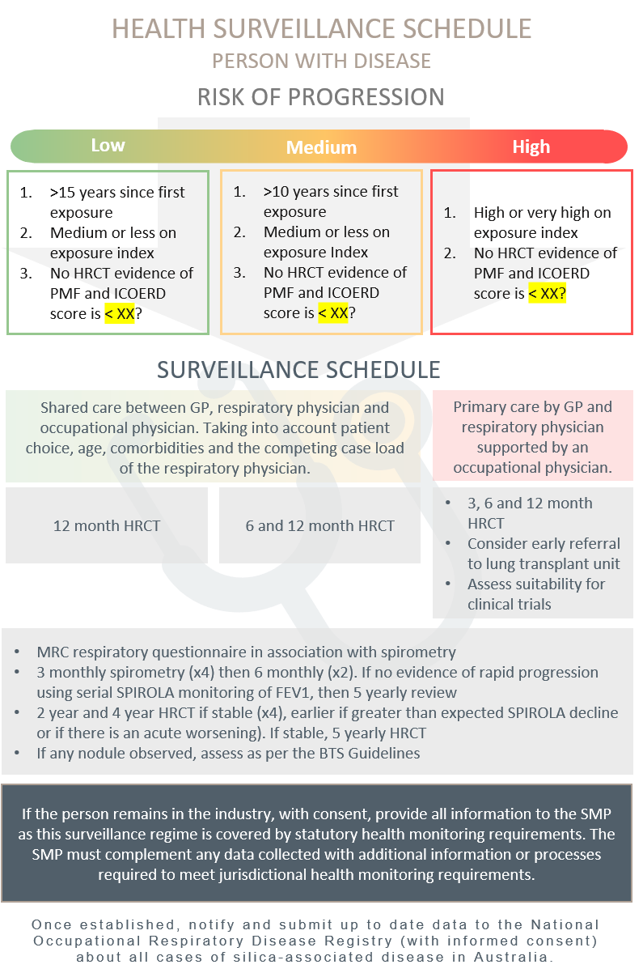
Table 1: Surveillance schedule following first diagnosis based on risk of progression

Abbreviations: BTS, British Thoracic Society; CT, computerised tomography; FEV1, forced expiratory volume in one second; HRCT, high-resolution computerised tomography; ICOERD, International Classification of high-resolution computed tomography for Occupational and Environmental Respiratory Diseases; MRC, Medical Research Council; PMF, progressive massive fibrosis; SMP, supervising medical practitioner; SPIROLA, Spirometry Longitudinal Data Analysis
Table 2: Surveillance schedule based on the Exposure Index of a person who has normal baseline results and has left the industry or has no predictable continuing exposure to RCS
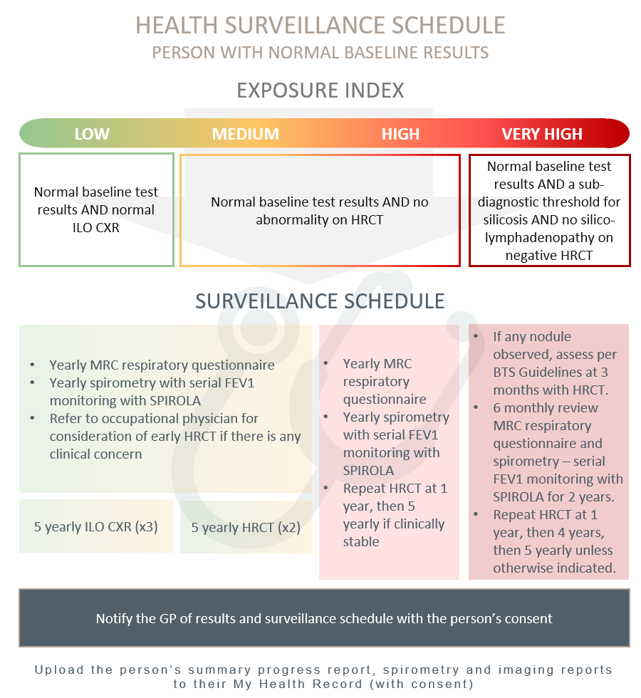
Note: HRCT must be capable of coronary angiography
Abbreviations: CXR, chest x-ray; FEV1, forced expiratory volume in one second; HRCT, high-resolution computed tomography; ILO, International Labour Organization; MRC, medical research council; SPIROLA, Spirometry Longitudinal Data Analysis Software

When should routine health surveillance be carried out?
- Carry out ongoing surveillance:
- for persons at low, medium and high-risk of disease progression, the recommended surveillance schedule (see Table 1) should be followed.
- for persons who have normal baseline test results and have normal ILO CXR or negative HRCT, the recommended surveillance schedule (see Table 2) should be followed.
- For all people with low-risk of exposure to RCS, they should be surveyed for no less than 20 years. If they were or are a smoker they should have lifelong health surveillance.

Who should carry out ongoing surveillance for the person?
- The same specialist who conducted the baseline assessment should ideally carry out surveillance.
- The GP, with the support of any former SMP, and respiratory or occupational physician involved in their patient’s care, should oversee any ongoing surveillance for an individual who is no longer employed in a role where there are no “predictable excursions” to the WES TWA.
Supervising medical practitioner
- The SMP must oversee any health monitoring activity, for as long as the person is employed in an “at-risk role”.
- All SMPs responsible for the statutory health monitoring of a workplace, should be publicly identifiable as supervising the health monitoring for that worksite. With the person’s consent, a GP can then contact the relevant SMP as and when needed.

Step 4: Notify
What are the notification requirements?
- With the person’s consent, provide the summary of findings, management plan and background description of the surveillance schedule to the person and their GP and SMP, uploading reports to the person’s My Health Record.
- Once established, notify and submit up to date data to the National Occupational Respiratory Disease Registry (with informed consent) about all cases of silica-associated disease in Australia.
Government
- Continue progressing the developement of a National Occupational Respiratory Disease Registry to collect data about all cases of silica-associated disease in Australia.

Appendices

Appendix A: Classification of silicosis
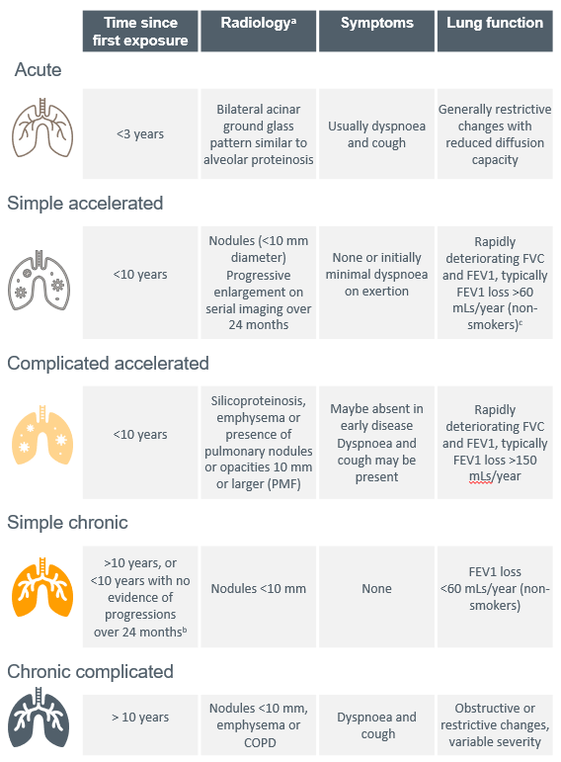
Source: Modified from Álvarez, González (8)
Abbreviations: FEV1, forced expiratory volume in one second; FVC, forced vital capacity; PMF, progressive massive fibrosis
a. The radiology and radiological progression is defined as a change in ILO (19) subclass or equivalent International Classiﬁcation of HRCT for Occupational and Environmental Respiratory Diseases (ICOERD) (20) classifications.
b. With screening that includes HRCT, we can detect parenchymal changes consistent with chronic silicosis before the elapsed 10 years since first exposure and at ILO profusion grades other than >1/1. This criterion is based on the absence of documented rapid progression. It is derived from and to be concordant with criteria defining the rapidly progressive pneumoconiosis seen with the spectrum of coal mine dust diseases (21). It has potential prognostic significance and defines a group of affected people with a <10-year exposure history and who appear less likely to progress to complicated manifestations of the disease. This characterisation can only be applied retrospectively, after there has been a demonstrated absence of rapid progression. The evidence suggests this cohort could be as high as two-thirds of those workers who would otherwise be labelled as suffering from accelerated silicosis.
c. A criterion for rapidly progressive pneumoconiosis seen in the spectrum of coal mine dust diseases (22).

Appendix B: Prevention of silicosis
Table 3: Prevention of silicosis
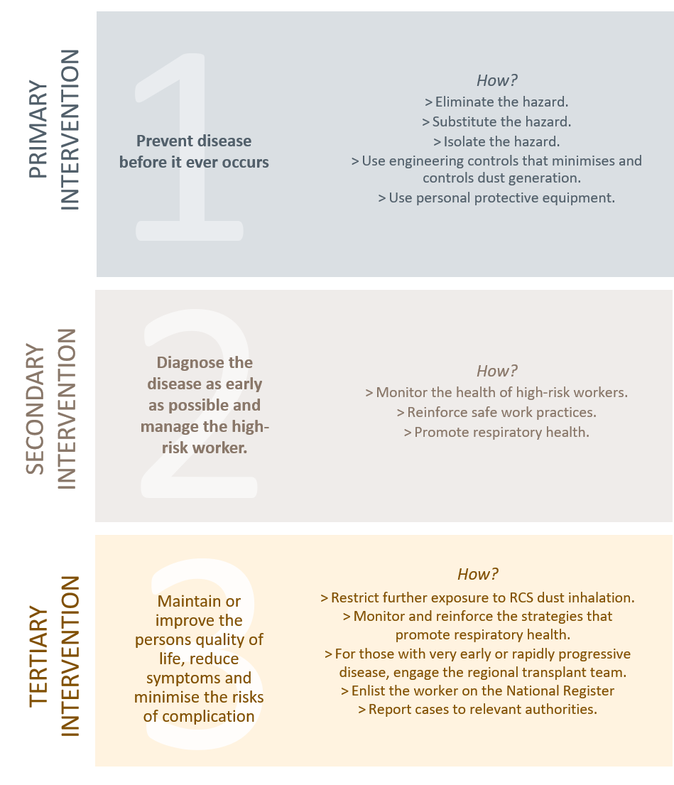
Abbreviations: RCS, respirable crystalline silica

Appendix C: Baseline data to collect
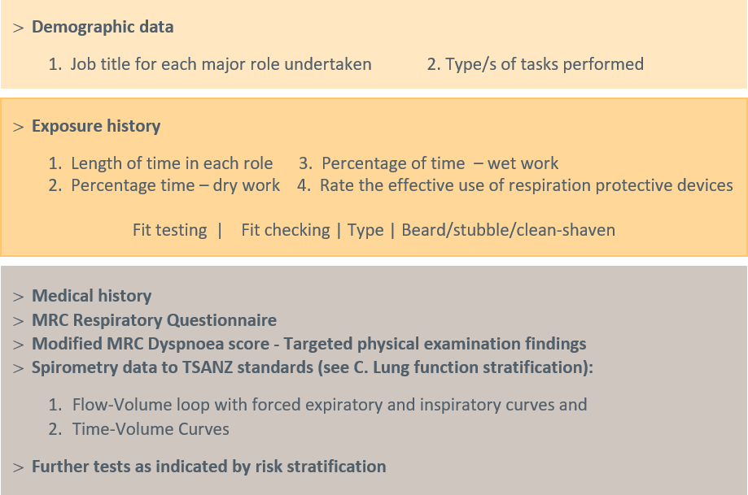
Abbreviations: MRC, medical research council; TSANZ, The Thoracic Society of Australia and New Zealand

Appendix D: Exposure dose questionnaire

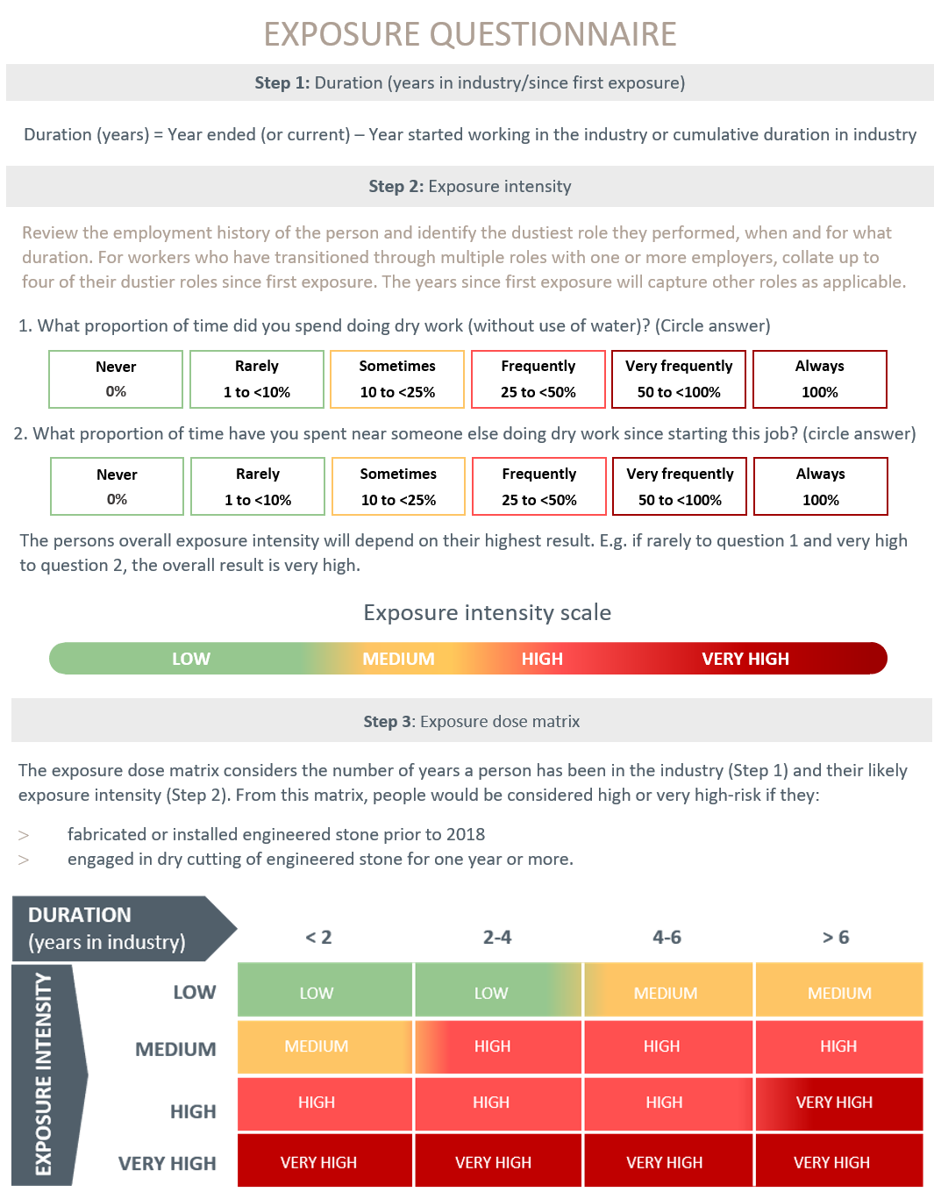

Appendix E: Shared decision-making tool
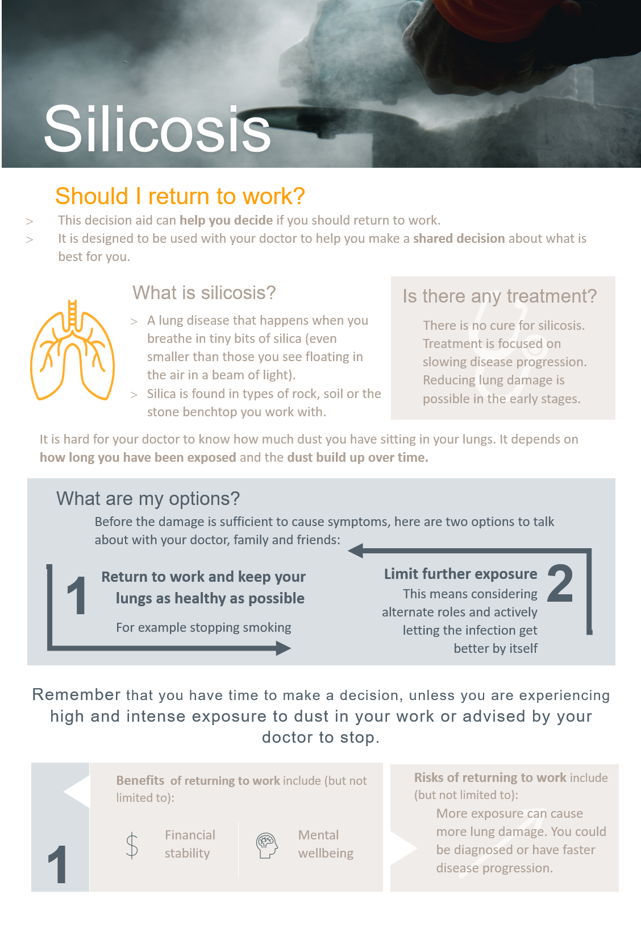
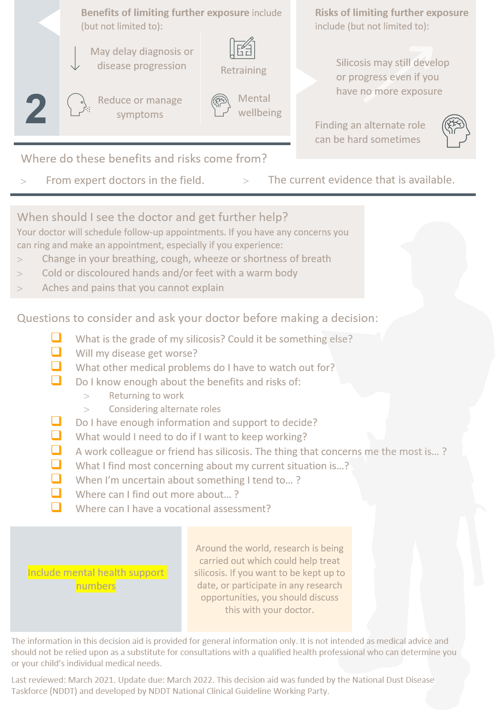

Abbreviations

CT | Computerised tomography
CXR | Chest X-ray
DLCO | Diffusion capacity of the lung for carbon monoxide
FVC1 | Forced vital capacity in one second
FVC | Forced vital capacity
GLI | Global Lung Function Initiative
GP | General Practitioners
HRCT | High-resolution computed tomography
ICORED | International Classiﬁcation of HRCT for Occupational and Environmental Respiratory Diseases
ILD | Interstitial lung disease
ILO | International Labour Organization
LLN | Lower limit of the normal
MDT | Multidisciplinary team
MRC | Medical Research Council
PCBU | Person conducting a business or undertaking
PMF | Progressive massive fibrosis
PPE | Personal Protective Equipment
RANZCR | Royal Australian and New Zealand College of Radiologists
RCS | Respirable crystalline silica
SPIROLA | Spirometry Longitudinal Data Analysis
TSANZ | Thoracic Society of Australia and New Zealand
WES | Workplace exposure standard
WHS | Work Health and Safety

Glossary
Artificial stone | A historic term used to describe the composite stone-like material created by a variety of manufacturing processes that includes crystalline silica and/or silicates. Also known as Engineered (the preferred term), Manufactured or Composite Stone.
“At-risk role” | The specific occupations of concern.
Best practice | The best standards of practice based on what others are already doing.
Case identification (also known as case finding) | A strategy for targeting resources at individuals or groups who are suspected to be at-risk for a particular disease. It involves actively searching systematically for at-risk people, rather than waiting for them to present with symptoms or signs of active disease.
Contact tracing | The process of identifying, assessing and managing people who have been similarly exposed to those people with diagnosable disease.
Occupational respiratory disease | A generic term used in this context to mean a disease associated with hazardous exposure via the respiratory system. While traditionally associated with the visible dusts, in this context it is used to describe any inhalable substance.
Engineered stone | The preferred term used to describe artificial stone.
Health-risk behaviour | Any behaviour or action with potentially negative effects on health.
Health monitoring | The monitoring of a worker to identify changes in their health status because of exposure to specific hazardous substances in the workplace. It is a statutory requirement where, in the Australian setting, the level of clinical and biological monitoring may be limited by law. It is separate from, but often overlaps with “health surveillance”.
Health (or medical) screening | A systematic method of detecting risk factors or suspicious abnormalities among people who are symptom-free, so that health problems can be either prevented or followed up, diagnosed and treated as early as possible.
Health surveillance | A broad concept which describes the ongoing surveillance in clinical practice after a case has been identified. When compared to health monitoring, it is more encompassing of a person’s health and wellbeing when compared to health monitoring. Health surveillance is not dependent on occupation related funding.
Informed consent | Informed consent is a person’s decision, given voluntarily, to agree to a health care treatment, procedure or other intervention that is proposed by their medical practitioner after receiving accurate and relevant information about the intervention, and understands the benefits and risks of the options available.
Lag | Time between first detectable disease and when the disease has progressed significantly to influence deployment and treatment options.
Latency | Diseases characterised by a long interval between first exposure and first detectable disease (clinically or by specific investigation).
Medical practitioner | Refers to any GP, respiratory specialists, occupational physician, thoracic surgeon or suitably qualified doctor.
Next best practice | The anticipated future next best practice; based on the trending of “best practice” and what is anticipated to be the next “best practice”. It requires a commitment to leadership, continued improvement based on the evolving body of evidence.
Respirable crystalline silica | A generic term to describe silica and silicate dust particles that can reach the alveoli region of gas exchange in the lung. They typically have an aerodynamic diameter less than 10micrometres. Their mean particle size is less than 5.0 um and significant toxicity is associated with particles less than 1-2 um.
Respiratory (health) surveillance | The process whereby a group of exposed workers are regularly tested to ensure that they are not developing respiratory diseases that are known to be associated with specific work exposures.
Silicosis | A parenchymal fibrotic lung condition caused by the inhalation of respirable crystalline silica dust.
WES Excursions | Periods when there is a transient exceedance of the WES for a short duration, cumulatively usually less than 30 minutes, that would not otherwise be detected by time weighted averaging.

References

1. Blanc PD, Annesi-Maesano I, Balmes JR, Cummings KJ, Fishwick D, Miedinger D, et al. The Occupational Burden of Nonmalignant Respiratory Diseases. An Official American Thoracic Society and European Respiratory Society Statement. American Journal of Respiratory and Critical Care Medicine. 2019;199(11):1312-34.
2. Occupational Safety and Health Administration (OSHA). Occupational Exposure to Respirable Crystalline Silica: Proposed Rule. Federal Register 78 (177), FR Doc No: 2013-20997. 2013 [cited 1 November 2020]. Available from: https://www.osha.gov/pls/oshaweb/owadisp.show_document?p_table=FEDERAL_REGISTER&p_id=23900.
3. Rose C, King T, Hollingsworth H. Silicosis: UpToDate 2020 [cited 2020 1 November]. Available from: https://www.uptodate.com/contents/silicosis?search=silicosis&source=search_result&selectedTitle=1~27&usage_type=default&display_rank=1%22%20%5Cl%20%22H288865219%22.
4. Álvarez RF, González CM, Martínez AQ, Pérez JJB, Fernández LC, Fernández AP. Guidelines for the diagnosis and monitoring of silicosis. Archivos de Bronconeumología (English Edition). 2015;51(2):86-93.
5. National Institute for Occupational Safety and Health (NIOSH). Work-related lung disease surveillance report 2007 [cited 1 November 2020]. Available from: https://www.cdc.gov/niosh/docs/2008-143/pdfs/2008-143.pdf?id=10.26616/NIOSHPUB2008143a.
6. Taylor A, Cullinan P, Blanc P, Pickering A. Parkes' Occupational Lung Disorders, Fourth Edition. 2016: Chapter 18, 187-205.
7. Almberg KS, Friedman LS, Rose CS, Go LH, Cohen RA. Progression of coal workers’ pneumoconiosis absent further exposure. Occupational and environmental medicine. 2020;77(11):748-51.
8. Hessel PA, Sluis-Cremer GK, Hnizdo E, Faure MH, Thomas RG, Wiles FJ. Progression of Silicosis in Relation to Silica Dust Exposure. The Annals of Occupational Hygiene. 1988;32(inhaled_particles_VI):689-96.
9. Carneiro AP, Barreto SM, Siqueira AL, Cavariani F, Forastiere F. Continued exposure to silica after diagnosis of silicosis in Brazilian gold miners. Am J Ind Med. 2006;49(10):811-8.
10. Lee HS, Phoon WH, Ng TP. Radiological progression and its predictive risk factors in silicosis. Occup Environ Med. 2001;58(7):467-71.
11. Dumavibhat N, Matsui T, Hoshino E, Rattanasiri S, Muntham D, Hirota R, et al. Radiographic progression of silicosis among Japanese tunnel workers in Kochi. Journal of occupational health. 2013:12-0258-OA.
12. Akgun M, Araz O, Ucar EY, Karaman A, Alper F, Gorguner M, et al. Silicosis appears inevitable among former denim sandblasters: a 4-year follow-up study. Chest. 2015;148(3):647-54.
13. International Labour Office. Guidelines for the use of the ILO international classification of radiographs of pneumoconiosis (Revised Edition 2011) International Labour Office, Geneva, Switzerland2011 [cited 4 Jan 2021]. Available from: https://www.ilo.org/safework/info/WCMS_108548/lang--en/index.htm.
14. Kusaka Y, Hering KG, Parker JE. International classification of HRCT for occupational and environmental respiratory diseases: Springer; 2005.
15. Perret JL, Miles S, Brims F, Newbigin K, Davidson M, Jersmann H, et al. Respiratory surveillance for coal mine dust and artificial stone exposed workers in Australia and New Zealand: A position statement from the Thoracic Society of Australia and New Zealand*. Respirology. 2020;25(11):1193-202.
16. Stansbury RC, Beeckman-Wagner LA, Wang ML, Hogg JP, Petsonk EL. Rapid decline in lung function in coal miners: evidence of disease in small airways. Am J Ind Med. 2013;56(9):1107-12.
17. Safe Work Australia. Crystalline silica and silicosis [cited 12 March 2021]. Available from: https://www.safeworkaustralia.gov.au/silica.
18. Safe Work Australia. Crystalline silica health monitoring guide [cited 8 March 2021]. Available from: https://www.safeworkaustralia.gov.au/book/crystalline-silica-health-monitoring-guide.
19. Perret JL, Miles S, Brims F, Newbigin K, Davidson M, Jersmann H, et al. Respiratory surveillance for coal mine dust and artificial stone exposed workers in Australia and New Zealand: A position statement from the Thoracic Society of Australia and New Zealand. Respirology. 2020;25(11):1193-202.
20. Prasad JD, Mahar A, Bleasel J, Ellis SJ, Chambers DC, Lake F, et al. The interstitial lung disease multidisciplinary meeting: A position statement from the Thoracic Society of Australia and New Zealand and the Lung Foundation Australia. Respirology. 2017;22(7):1459-72.

