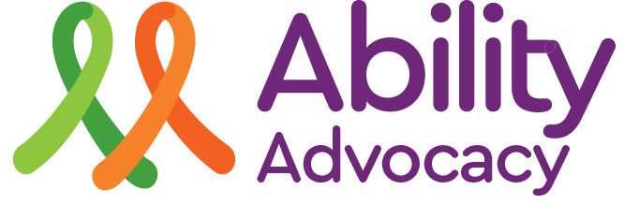**AIAS – GET-TOGETHER**

***14-17 September, 2018***



***Booking No. 541881(Sport & Rec)***

**FULL CONFERENCE COST, SHARED DORMITORY ACCOMMODATION** - **per person: $500.00**

**Includes all LINEN and activities**

**CARERS – All carers per person: are FREE, BUT MUST PROVIDE OWN Linen(sleeping bag/pillow/towel)**

* Do not bring jewellery and other valuables to the conference as rooms will not be locked.
* All meals will be provided. You must tell us of any special needs.
* Sports & Recreation Medical Form must be completed **online** prior to each person attending. www.sportandrecreation.nsw.gov.au.
* **BYO Alcohol:** No alcohol will be sold or supplied on the premises. You will need to supply your own alcohol (if you would like to have an alcoholic drink in the evening).
* **Buses** (Country Link & Private) stop at Lennox Head and we will send transport to pick you up on arrival and drop you back at the bus stop for your return trip home. Let us know your travel details so we can help.
* Payments to be made to Ability Inc BSB 722-744 A/C 52998

RETURN THE REGISTRATION FORM TO:

**ABILITY INCORPORATED ADVOCACY SERVICE**

**PO BOX 417 ALSTONVILLE NSW 2477**

REGISTRATION CLOSES ON FRIDAY 31st August, 2018

Or Fax: 0266 288 199, Or email to admin@abilityadvocacy.org.au

**A**

**A.I.A.S.**

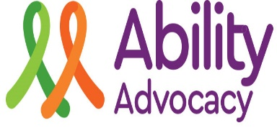**GET-TOGETHER**

**REGISTRATION FORM 14-17 September 2018**

**RETURN THIS COMPLETED FORM BY**

**Friday 31st August, 2018.**

**Please complete a Sports & Recreation Medical Form online for each person attending the conference (found at www.sportandrecreation.nsw.gov.au)**

Booking No.: 541881

**ORGANISATION**:

**NAME**: Male Female

Consumer Support Worker

**PREFERRED ACCOMMODATION**:

For Support workers – Do you want to share with your consumers: Yes No

Can you sleep on a bunk? Yes No

SPECIAL NEEDS:

(if nothing is listed you will be put into a dorm room and may have a top bunk)

**DIET:** Normal Diabetic Gluten Free Vegetarian

Other (Please provide specific requirements)

Specific Dietary Requirements:_________________________________________________

**TRANSPORT** Bus Plane Private

Arrival Time: Departure Time:

Do you need to be picked up or dropped off?________________________________________

**PAYMENT:** Method: Cheque EFT

Amount $______________________

*Office use only: Date rec’d: Date in bank:*

*Entered on spreadsheet:*

**Ability Incorporated Advocacy Service**

P O Box 417, Alstonville. NSW 2477 Phone: 02 66288188 Fax: 66288199

Email: admin@abilityadvocacy.org.au